UNITED STATES

SECURITIES AND EXCHANGE COMMISSION

Washington, D.C. 20549

FORM 10-Q

- QUARTERLY REPORT PURSUANT TO SECTION 13 OR 15(d) OF THE SECURITIES EXCHANGE ACT OF 1934 For the quarterly period ended September 30, 2023

OR

- TRANSITION REPORT PURSUANT TO SECTION 13 OR 15(d) OF THE SECURITIES EXCHANGE ACT OF 1934

For the transition period from to

Priority Technology Holdings, Inc.

Commission file number: 001-37872


 | Priority Technology Holdings, Inc.
 | (Exact name of registrant as specified in its charter)
Delaware |  |  |  | 47-4257046
(State or other jurisdiction of |  |  |  | (I.R.S. Employer
incorporation or organization) |  |  |  | Identification No.)
2001 Westside Parkway
Suite 155
Alpharetta, |  | Georgia |  | 30004
(Address of principal executive offices) |  |  |  | (Zip Code)
Registrant's telephone number, including area code: (404) 952-2107
 |  | Not applicable
(Former name, former address and former fiscal year, if changed since last report)
Securities registered pursuant to Section 12(b) of the Act:
Title of each class |  | Trading Symbol |  | Name of each exchange on which registered
Common Stock, par value $0.001 |  | PRTH |  | Nasdaq Global Market

Indicate by check mark whether the registrant (1) has filed all reports required to be filed by Section 13 or 15(d) of the Securities Exchange Act of 1934 during the preceding 12 months (or for such shorter period that the registrant was required to file such reports), and (2) has been subject to such filing requirements for the past 90 days. Yes ☒ No ☐

Indicate by check mark whether the registrant has submitted electronically every Interactive Data File required to be submitted

pursuant to Rule 405 of Regulation S-T (§232.405 of this chapter) during the preceding 12 months (or for such shorter period that the registrant was required to submit such files). Yes ☒ No ☐

Indicate by check mark whether the registrant is a large accelerated filer, an accelerated filer, a non-accelerated filer, a smaller

reporting company, or an emerging growth company. See the definitions of "large accelerated filer," "accelerated filer," "smaller reporting company," and "emerging growth company" in Rule 12b-2 of the Exchange Act.

Large accelerated filer | ☐ | Accelerated filer | ☐
Non-accelerated filer | ☒ | Smaller reporting company | ☒
 |  | Emerging growth company | ☐

If an emerging growth company, indicate by check mark if the registrant has elected not to use the extended transition period for complying with any new or revised financial accounting standards provided pursuant to Section 13(a) of the Exchange Act. ☐

Indicate by check mark whether the registrant is a shell company (as defined in Rule 12b-2 of the Exchange Act).

Yes ☐ No ☒

As of November 3, 2023, the number of the registrant's Common Stock outstanding was 76,722,581.

 |  |  |  |  |  |  |  |  |  |  |  |  |  |  |  |  |  |  |  |  |  |  |  |  | Table of Contents
 |  |  |  |  |  |  |  |  |  |  |  |  |  |  |  |  |  |  |  |  |  |  |  |  |  |  | Page
Commonly Used or Defined Terms |  |  |  |  |  |  |  |  |  |  |  |  |  |  |  |  |  |  |  |  |  |  |  |  |  |  |  | ii
PART I. FINANCIAL INFORMATION |  |  |  |  |  |  |  |  |  |  |  |  |  |  |  |  |  |  |  |  |  |  |  |  |  |  |  | 1
 | Item 1. Financial Statements |  |  |  |  |  |  |  |  |  |  |  |  |  |  |  |  |  |  |  |  |  |  |  |  |  | 1
 | Unaudited Consolidated Balance Sheets |  |  |  |  |  |  |  |  |  |  |  |  |  |  |  |  |  |  |  |  |  |  |  |  |  | 1
 | Unaudited Consolidated Statements of Operations and Comprehensive Loss |  |  |  |  |  |  |  |  |  |  |  |  |  |  |  |  |  |  |  |  |  |  |  |  |  |  | 2
 | Unaudited Consolidated Statements of Changes in Stockholders' Deficit and Non-Controlling Interest |  |  |  |  |  |  |  |  |  |  |  |  |  |  |  |  |  |  |  |  |  |  |  |  |  | 3
 | Unaudited Consolidated Statements of Cash Flows |  |  |  |  |  |  |  |  |  |  |  |  |  |  |  |  |  |  |  |  |  |  |  |  |  |  | 6
 | Notes to Unaudited Consolidated Financial Statements: |  |  |  |  |  |  |  |  |  |  |  |  |  |  |  |  |  |  |  |  |  |  |  |  |  | 8
 | 1. | Basis of Presentation and Significant Accounting Policies |  |  |  |  |  |  |  |  |  |  |  |  |  |  |  |  |  |  |  |  |  |  |  |  |  | 8
 | 2. | Acquisitions |  |  |  |  |  |  |  |  |  |  |  |  |  |  |  |  |  |  |  |  |  |  |  |  |  | 9
 | 3. | Revenues |  |  |  |  |  |  |  |  |  |  |  |  |  |  |  |  |  |  |  |  |  |  |  |  | 12
 | 4. | Settlement Assets and Customer/Subscriber Account Obligations |  |  |  |  |  |  |  |  |  |  |  |  |  |  |  |  |  |  |  |  |  |  |  |  | 14
 | 5. | Notes Receivable |  |  |  |  |  |  |  |  |  |  |  |  |  |  |  |  |  |  |  |  |  |  |  |  | 15
 | 6. | Property, Equipment and Software |  |  |  |  |  |  |  |  |  |  |  |  |  |  |  |  |  |  |  |  |  |  |  |  | 16
 | 7. | Goodwill and Other Intangible Assets |  |  |  |  |  |  |  |  |  |  |  |  |  |  |  |  |  |  |  |  |  |  |  |  | 17
 | 8. | Debt Obligations |  |  |  |  |  |  |  |  |  |  |  |  |  |  |  |  |  |  |  |  |  |  |  |  | 18
 | 9. | Redeemable Senior Preferred Stock and Warrants |  |  |  |  |  |  |  |  |  |  |  |  |  |  |  |  |  |  |  |  |  |  |  |  | 20
 | 10. Income Taxes |  |  |  |  |  |  |  |  |  |  |  |  |  |  |  |  |  |  |  |  |  |  |  |  |  | 21
 | 11. Stockholders' Deficit |  |  |  |  |  |  |  |  |  |  |  |  |  |  |  |  |  |  |  |  |  |  |  |  |  | 21
 | 12. Stock-based Compensation |  |  |  |  |  |  |  |  |  |  |  |  |  |  |  |  |  |  |  |  |  |  |  |  |  | 22
 | 13. Commitments and Contingencies |  |  |  |  |  |  |  |  |  |  |  |  |  |  |  |  |  |  |  |  |  |  |  |  |  | 22
 | 14. Fair Value |  |  |  |  |  |  |  |  |  |  |  |  |  |  |  |  |  |  |  |  |  |  |  |  |  | 24
 | 15. Segment Information |  |  |  |  |  |  |  |  |  |  |  |  |  |  |  |  |  |  |  |  |  |  |  |  |  | 24
 | 16. Loss per Common Share |  |  |  |  |  |  |  |  |  |  |  |  |  |  |  |  |  |  |  |  |  |  |  |  |  | 26
 | 17. Subsequent Events |  |  |  |  |  |  |  |  |  |  |  |  |  |  |  |  |  |  |  |  |  |  |  |  |  | 27
 | Item 2. Management's Discussion and Analysis of Financial Condition and Results of Operations |  |  |  |  |  |  |  |  |  |  |  |  |  |  |  |  |  |  |  |  |  |  |  |  |  | 28
 | Item 3. Qualitative and Quantitative Disclosures about Market Risk |  |  |  |  |  |  |  |  |  |  |  |  |  |  |  |  |  |  |  |  |  |  |  |  |  | 39
 | Item 4. Controls and Procedures |  |  |  |  |  |  |  |  |  |  |  |  |  |  |  |  |  |  |  |  |  |  |  |  |  | 39
PART II. OTHER INFORMATION |  |  |  |  |  |  |  |  |  |  |  |  |  |  |  |  |  |  |  |  |  |  |  |  |  |  | 40
 | Item 1. Legal Proceedings |  |  |  |  |  |  |  |  |  |  |  |  |  |  |  |  |  |  |  |  |  |  |  |  |  | 40
 | Item 1A. Risk Factors |  |  |  |  |  |  |  |  |  |  |  |  |  |  |  |  |  |  |  |  |  |  |  |  |  | 40
 | Item 2. Unregistered Sales of Equity Securities and Use of Proceeds |  |  |  |  |  |  |  |  |  |  |  |  |  |  |  |  |  |  |  |  |  |  |  |  |  | 40
 | Item 3. Defaults Upon Senior Securities |  |  |  |  |  |  |  |  |  |  |  |  |  |  |  |  |  |  |  |  |  |  |  |  |  | 40
 | Item 4. Mine Safety Disclosures |  |  |  |  |  |  |  |  |  |  |  |  |  |  |  |  |  |  |  |  |  |  |  |  |  | 40
 | Item 5. Other Information |  |  |  |  |  |  |  |  |  |  |  |  |  |  |  |  |  |  |  |  |  |  |  |  |  | 41
 | Item 6. Exhibits |  |  |  |  |  |  |  |  |  |  |  |  |  |  |  |  |  |  |  |  |  |  |  |  |  | 41
Signatures |  |  |  |  |  |  |  |  |  |  |  |  |  |  |  |  |  |  |  |  |  |  |  |  |  |  | 43

i

Table of Contents

Commonly Used or Defined Terms

Term |  | Definition
2018 Plan |  | 2018 Equity Incentive Plan
2021 Stock Purchase Plan |  | Priority Technology Holdings, Inc. 2021 Employee Stock Purchase Plan
2021 Share Repurchase Program |  | Priority Technology Holdings, Inc. 2021 Share Repurchase Program
AOCI |  | Accumulated other comprehensive income/loss
AP |  | Accounts payable
ASC |  | Accounting Standards Codification
APIC |  | Additional paid-in capital
Amended Certificate of Designation |  | Amended and Restated Certificate of Designation of Senior Preferred Stock effective as of June 30, 2023
ASU |  | Accounting Standards Update
B2B |  | Business-to-business
B2C |  | Business-to-consumer
CEO |  | Chief Executive Officer
CFO |  | Chief Financial Officer
Common Stock |  | The Company's Common Stock, par value $0.001
Credit Agreement |  | Credit and Guaranty Agreement with Truist Bank dated as of April 27, 2021 (as amended)
EAETR |  | Estimated annual effective tax rate
ESPP |  | Employee Stock Purchase Plan
Exchange Act |  | Securities Exchange Act of 1934
FASB |  | Financial Accounting Standards Board
FDIC |  | Federal Deposit Insurance Corporation
FBO |  | For the benefit of
FI |  | Financial institution
Finxera |  | Finxera Holdings, Inc.
GAAP |  | U.S. Generally Accepted Accounting Principles
IRA |  | Inflation Reduction Act, enacted by the U.S. Federal Government on August 16, 2022
ISO |  | Independent sales organization
ISV |  | Independent software vendor
LIBOR |  | London Interbank Offered Rate
NCI |  | Non-controlling interests in consolidated subsidiaries
Revolving credit facility |  | $65.0 million line issued under the Credit Agreement
Plastiq |  | Acquisition of Plastiq, Inc. and certain of its affiliates
PRTH |  | Priority Technology Holdings, Inc.
SEC |  | Securities and Exchange Commission
SOFR |  | Secured Overnight Financing Rate
SMB |  | Small to medium-sized businesses
Term facility |  | $620.0 million senior secured term loan facility issued under the Credit Agreement (including $320.0 million delayed draw facility)

ii

Table of Contents

Priority Technology Holdings, Inc.

Unaudited Consolidated Balance Sheets

(in thousands, except share data)

PART I. FINANCIAL INFORMATION

Item 1. Financial Statements

 |  |  |  | September 30, 2023 |  |  | December 31, 2022
Assets
Current assets:
Cash and cash equivalents |  |  | $ | 24,595 |  | $ | 18,454
Restricted cash |  |  |  | 13,890 |  |  | 10,582
Accounts receivable, net of allowances of $1,281 and $1,143, respectively |  |  |  | 61,134 |  |  | 78,113
Prepaid expenses and other current assets |  |  |  | 13,274 |  |  | 11,832
Current portion of notes receivable, net of allowance of $0 and $0, respectively |  |  |  | 1,561 |  |  | 1,471
Settlement assets and customer/subscriber account balances |  |  |  | 712,170 |  |  | 532,018
Total current assets |  |  |  | 826,624 |  |  | 652,470
Notes receivable, less current portion |  |  |  | 3,616 |  |  | 3,191
Property, equipment and software, net |  |  |  | 41,851 |  |  | 34,687
Goodwill |  |  |  | 375,794 |  |  | 369,337
Intangible assets, net |  |  |  | 285,490 |  |  | 288,794
Deferred income taxes, net |  |  |  | 18,879 |  |  | 16,447
Other noncurrent assets |  |  |  | 11,145 |  |  | 8,437
Total assets |  |  | $ | 1,563,399 |  | $ | 1,373,363
Liabilities, Redeemable Senior Preferred Stock and Stockholders' Deficit
Current liabilities:
Accounts payable and accrued expenses |  |  | $ | 56,107 |  | $ | 51,864
Accrued residual commissions |  |  |  | 31,023 |  |  | 35,979
Customer deposits and advance payments |  |  |  | 6,634 |  |  | 2,618
Current portion of long-term debt |  |  |  | 6,200 |  |  | 6,200
Settlement and customer/subscriber account obligations |  |  |  | 710,068 |  |  | 533,340
Total current liabilities |  |  |  | 810,032 |  |  | 630,001
Long-term debt, net of current portion, discounts and debt issuance costs |  |  |  | 616,781 |  |  | 598,926
Other noncurrent liabilities |  |  |  | 18,545 |  |  | 11,643
Total noncurrent liabilities |  |  |  | 635,326 |  |  | 610,569
Total liabilities |  |  |  | 1,445,358 |  |  | 1,240,570
Commitments and contingencies (Note 13)
Redeemable senior preferred stock, net of discounts and issuance costs:
Redeemable senior preferred stock, $0.001 par value; 250,000 shares authorized; 225,000 issued and outstanding at
September 30, 2023 and December 31, 2022 |  |  |  | 252,923 |  |  | 235,579
Stockholders' deficit:
Preferred stock, $0.001; 100,000,000 shares authorized; 0 issued or outstanding at September 30, 2023 and December 31,
2022 |  |  |  | — |  |  | —
Common Stock, $0.001 par value; 1,000,000,000 shares authorized; 79,197,600 and 78,385,685 shares issued at September 30,
2023 and December 31, 2022, respectively; and 76,633,517 and 76,044,629 shares outstanding at September 30, 2023 and
December 31, 2022, respectively |  |  |  | 77 |  |  | 76
Treasury stock at cost, 2,564,083 and 2,341,056 shares at September 30, 2023 and December 31, 2022, respectively |  |  |  | (12,577) |  |  | (11,559)
Additional paid-in capital |  |  |  | — |  |  | 9,650
Accumulated other comprehensive loss |  |  |  | (34) |  |  | —
Accumulated deficit |  |  |  | (123,714) |  |  | (102,208)
Total stockholders' deficit attributable to stockholders of PRTH |  |  |  | (136,248) |  |  | (104,041)
Non-controlling interests in consolidated subsidiaries |  |  |  | 1,366 |  |  | 1,255
Total stockholders' deficit |  |  |  | (134,882) |  |  | (102,786)
Total liabilities, redeemable senior preferred stock and stockholders' deficit |  |  | $ | 1,563,399 |  | $ | 1,373,363

See Notes to Unaudited Consolidated Financial Statements

1

Table of Contents

Priority Technology Holdings, Inc.

Unaudited Consolidated Statements of Operations and Comprehensive Loss

(in thousands, except per share amounts)

 |  | Three Months Ended |  |  |  |  |  | Nine Months Ended
 |  | September 30, |  |  |  |  |  | September 30,
 |  | 2023 |  |  | 2022 |  |  | 2023 |  |  | 2022
Revenues | $ | 189,015 |  | $ | 166,417 |  | $ | 556,333 |  | $ | 486,086
Operating expenses
Cost of revenue (excludes depreciation and amortization) |  | 116,682 |  |  | 107,958 |  |  | 353,929 |  |  | 320,187
Salary and employee benefits |  | 20,129 |  |  | 16,384 |  |  | 58,286 |  |  | 48,231
Depreciation and amortization |  | 17,275 |  |  | 17,817 |  |  | 53,303 |  |  | 52,675
Selling, general and administrative |  | 11,423 |  |  | 10,178 |  |  | 31,328 |  |  | 27,027
Total operating expenses |  | 165,509 |  |  | 152,337 |  |  | 496,846 |  |  | 448,120
Operating income |  | 23,506 |  |  | 14,080 |  |  | 59,487 |  |  | 37,966
Other (expense) income
Interest expense |  | (19,997) |  |  | (13,412) |  |  | (55,461) |  |  | (37,282)
Other income, net |  | 732 |  |  | 231 |  |  | 1,319 |  |  | 311
Total other expense, net |  | (19,265) |  |  | (13,181) |  |  | (54,142) |  |  | (36,971)
Income before income taxes |  | 4,241 |  |  | 899 |  |  | 5,345 |  |  | 995
Income tax expense |  | 4,328 |  |  | 1,691 |  |  | 6,550 |  |  | 1,833
Net loss |  | (87) |  |  | (792) |  |  | (1,205) |  |  | (838)
Less: Dividends and accretion attributable to redeemable senior preferred stockholders |  | (12,192) |  |  | (9,466) |  |  | (35,252) |  |  | (26,415)
Net loss attributable to common stockholders |  | (12,279) |  |  | (10,258) |  |  | (36,457) |  |  | (27,253)
Other comprehensive loss
Foreign currency translation adjustments |  | (65) |  |  | — |  |  | (34) |  |  | —
Comprehensive loss | $ | (12,344) |  | $ | (10,258) |  | $ | (36,491) |  | $ | (27,253)
Loss per common share:
Basic and diluted | $ | (0.16) |  | $ | (0.13) |  | $ | (0.47) |  | $ | (0.35)
Weighted-average common shares outstanding:
Basic and diluted |  | 78,381 |  |  | 77,984 |  |  | 78,270 |  |  | 78,392

See Notes to Unaudited Consolidated Financial Statements

2

Table of Contents

December 31, 2022

Equity-classified stock-based compensation

ESPP compensation and vesting of stock-based compensation
Shares withheld for taxes

Dividends on redeemable senior preferred stock

Accretion of redeemable senior preferred stock

Adjustment to NCI

Foreign currency translation adjustment

Net loss

March 31, 2023

Equity-classified stock-based compensation

ESPP compensation and vesting of stock-based compensation
Shares withheld for taxes

Dividends on redeemable senior preferred stock

Accretion of redeemable senior preferred stock

Foreign currency translation adjustment

Reclassification of negative additional paid-in capital

Net loss

June 30, 2023

Priority Technology Holdings, Inc.

Unaudited Consolidated Statements of Changes in Stockholders' Deficit and Non-Controlling Interest

(in thousands)

Common |  |  | Treasury
Stock |  |  | Stock |  |  |  |  |  |  |  |  | Deficit Attributable
Shares |  | $ | Shares |  | $ |  | APIC |  | AOCI | Accumulated Deficit |  |  | to Stockholders |  | NCIs |  | Total
76,044 | $ | 76 | 2,341 | $ | (11,559) | $ | 9,650 | $ | — | $ | (102,208) | $ | (104,041) | $ | 1,255 | $ | (102,786)
— |  | — | — |  | — |  | 1,936 |  | — |  | — |  | 1,936 |  | — |  | 1,936
517 |  | — | — |  | — |  | 37 |  | — |  | — |  | 37 |  | — |  | 37
(157) |  | — | 157 |  | (777) |  | — |  | — |  | — |  | (777) |  | — |  | (777)
— |  | — | — |  | — |  | (10,477) |  | — |  | — |  | (10,477) |  | — |  | (10,477)
— |  | — | — |  | — |  | (818) |  | — |  | — |  | (818) |  | — |  | (818)
— |  | — | — |  | — |  | — |  | — |  | — |  | — |  | (403) |  | (403)
— |  | — | — |  | — |  | — |  | 24 |  | — |  | 24 |  | — |  | 24
— |  | — | — |  | — |  | — |  | — |  | (506) |  | (506) |  | — |  | (506)
76,404 | $ | 76 | 2,498 | $ | (12,336) | $ | 328 | $ | 24 | $ | (102,714) | $ | (114,622) | $ | 852 | $ | (113,770)
— |  | — | — |  | — |  | 1,746 |  | — |  | — |  | 1,746 |  | — |  | 1,746
192 |  | — | — |  | — |  | 43 |  | — |  | — |  | 43 |  | — |  | 43
(65) |  | — | 65 |  | (241) |  | — |  | — |  | — |  | (241) |  | — |  | (241)
— |  | — | — |  | — |  | (10,934) |  | — |  | — |  | (10,934) |  | — |  | (10,934)
— |  | — | — |  | — |  | (831) |  | — |  | — |  | (831) |  | — |  | (831)
— |  | — | — |  | — |  | — |  | 7 |  | — |  | 7 |  | — |  | 7
— |  | — | — |  | — |  | 9,648 |  | — |  | (9,648) |  | — |  | — |  | —
— |  | — | — |  | — |  | — |  | — |  | (612) |  | (612) |  | — |  | (612)
76,531 | $ | 76 | 2,563 | $ | (12,577) | $ | — | $ | 31 | $ | (112,974) | $ | (125,444) | $ | 852 | $ | (124,592)

3

Table of Contents

Equity-classified stock-based compensation

ESPP compensation and vesting of stock-based compensation
Shares withheld for taxes

Dividends on redeemable senior preferred stock

Accretion of redeemable senior preferred stock

Issuance of profit interests/common equity in subsidiaries

Foreign currency translation adjustment

Reclassification of negative additional paid-in capital

Net loss

September 30, 2023

Priority Technology Holdings, Inc.

Unaudited Consolidated Statements of Changes in Stockholders' Deficit and Non-Controlling Interest

(in thousands)

Common |  |  | Treasury
Stock |  |  | Stock |  |  |  |  |  |  |  | Deficit Attributable
Shares |  | $ | Shares |  | $ |  | APIC | AOCI | Accumulated Deficit |  |  | to Stockholders |  | NCIs |  | Total
— |  | — | — |  | — |  | 1,501 | — |  | — |  | 1,501 |  | — |  | 1,501
103 |  | 1 | — |  | — |  | 38 | — |  | — |  | 39 |  | — |  | 39
— |  | — | 1 |  | — |  | — | — |  | — |  | — |  | — |  | —
— |  | — | — |  | — |  | (11,348) | — |  | — |  | (11,348) |  | — |  | (11,348)
— |  | — | — |  | — |  | (844) | — |  | — |  | (844) |  | — |  | (844)
— |  | — | — |  | — |  | — | — |  | — |  | — |  | 514 |  | 514
— |  | — | — |  | — |  | — | (65) |  | — |  | (65) |  | — |  | (65)
— |  | — | — |  | — |  | 10,653 | — |  | (10,653) |  | — |  | — |  | —
— |  | — | — |  | — |  | — | — |  | (87) |  | (87) |  | — |  | (87)
76,634 | $ | 77 | 2,564 | $ | (12,577) | $ | — $ | (34) | $ | (123,714) | $ | (136,248) | $ | 1,366 | $ | (134,882)

4

Table of Contents

December 31, 2021

Equity-classified stock-based compensation

Vesting of stock-based compensation

Share repurchases and shares withheld for taxes

Dividends on redeemable senior preferred stock

Accretion of redeemable senior preferred stock

Net loss

March 31, 2022

Equity-classified stock-based compensation

ESPP compensation and vesting of stock-based compensation
Share repurchases and shares withheld for taxes

Dividends on redeemable senior preferred stock

Accretion of redeemable senior preferred stock

Net income

June 30, 2022

Equity-classified stock-based compensation

ESPP compensation and vesting of stock-based compensation
Share repurchases and shares withheld for taxes

Dividends on redeemable senior preferred stock

Accretion of redeemable senior preferred stock

Net income

September 30, 2022

Priority Technology Holdings, Inc.

Unaudited Consolidated Statements of Changes in Stockholders' Deficit and Non-Controlling Interest

(in thousands)

Common |  |  | Treasury
Stock |  |  | Stock |  |  |  |  |  |  |  |  | Deficit Attributable
Shares |  | $ | Shares |  | $ |  | APIC |  | AOCI | Accumulated Deficit |  |  | to Stockholders |  | NCIs |  | Total
76,740 | $ | 77 | 720 | $ | (4,091) | $ | 39,835 | $ | — | $ | (100,058) | $ | (64,237) | $ | — | $ | (64,237)
— |  | — | — |  | — |  | 1,558 |  | — |  | — |  | 1,558 |  | — |  | 1,558
129 |  | — | — |  | — |  | — |  | — |  | — |  | — |  | — |  | —
(27) |  | 1 | 27 |  | (157) |  | (1) |  | — |  | — |  | (157) |  | — |  | (157)
— |  | — | — |  | — |  | (7,595) |  | — |  | — |  | (7,595) |  | — |  | (7,595)
— |  | — | — |  | — |  | (805) |  | — |  | — |  | (805) |  | — |  | (805)
— |  | — | — |  | — |  | — |  | — |  | (333) |  | (333) |  | — |  | (333)
76,842 | $ | 78 | 747 | $ | (4,248) | $ | 32,992 | $ | — | $ | (100,391) | $ | (71,569) | $ | — | $ | (71,569)
— |  | — | — |  | — |  | 1,542 |  | — |  | — |  | 1,542 |  | — |  | 1,542
157 |  | — | — |  | — |  | 57 |  | — |  | — |  | 57 |  | — |  | 57
(431) |  | — | 431 |  | (1,922) |  | — |  | — |  | — |  | (1,922) |  | — |  | (1,922)
— |  | — | — |  | — |  | (7,732) |  | — |  | — |  | (7,732) |  | — |  | (7,732)
— |  | — | — |  | — |  | (817) |  | — |  | — |  | (817) |  | — |  | (817)
— |  | — | — |  | — |  | — |  | — |  | 287 |  | 287 |  | — |  | 287
76,568 | $ | 78 | 1,178 | $ | (6,170) | $ | 26,042 | $ | — | $ | (100,104) | $ | (80,154) | $ | — | $ | (80,154)
— |  | — | — |  | — |  | 1,104 |  | — |  | — |  | 1,104 |  | — |  | 1,104
43 |  | — | — |  | — |  | 39 |  | — |  | — |  | 39 |  | — |  | 39
(630) |  | — | 630 |  | (2,595) |  | — |  | — |  | — |  | (2,595) |  | — |  | (2,595)
— |  | — | — |  | — |  | (8,636) |  | — |  | — |  | (8,636) |  | — |  | (8,636)
— |  | — | — |  | — |  | (830) |  | — |  | — |  | (830) |  | — |  | (830)
— |  | — | — |  | — |  | — |  | — |  | (792) |  | (792) |  | — |  | (792)
75,981 | $ | 78 | 1,808 | $ | (8,765) | $ | 17,719 | $ | — | $ | (100,896) | $ | (91,864) | $ | — | $ | (91,864)

See Notes to Unaudited Consolidated Financial Statements

5

Table of Contents

Priority Technology Holdings, Inc.

Unaudited Consolidated Statements of Cash Flows

(in thousands)

 | Nine Months Ended September 30,
 | 2023 |  |  | 2022
Cash flows from operating activities:
Net loss | $ | (1,205) |  | $ | (838)
Adjustments to reconcile net loss to net cash provided by operating activities:
Depreciation and amortization of assets |  | 53,303 |  |  | 52,675
Stock-based compensation |  | 5,183 |  |  | 4,204
Amortization of debt issuance costs and discounts |  | 2,812 |  |  | 2,613
Deferred income tax |  | (2,432) |  |  | (3,567)
Change in contingent consideration |  | 906 |  |  | —
Other non-cash items, net |  | (169) |  |  | (154)
Change in operating assets and liabilities:
Accounts receivable |  | 17,931 |  |  | (11,265)
Prepaid expenses and other current assets |  | (2,630) |  |  | (2,575)
Income taxes (receivable) payable |  | 498 |  |  | 1,003
Notes receivable |  | (668) |  |  | 569
Accounts payable and other accrued liabilities |  | 302 |  |  | 13,711
Customer deposits and advance payments |  | 3,802 |  |  | (1,910)
Other assets and liabilities, net |  | (4,953) |  |  | (3,908)
Net cash provided by operating activities |  | 72,680 |  |  | 50,558
Cash flows from investing activities:
Acquisition of business, net of cash acquired |  | (28,182) |  |  | —
Additions to property, equipment and software |  | (15,268) |  |  | (11,380)
Notes receivable, net |  | 151 |  |  | (3,250)
Acquisitions of assets and other investing activities |  | (7,925) |  |  | (6,465)
Net cash used in investing activities |  | (51,224) |  |  | (21,095)
Cash flows from financing activities:
Debt issuance and modification costs paid |  | (807) |  |  | —
Repayments of long-term debt |  | (4,650) |  |  | (4,650)
Borrowings under revolving credit facility |  | 44,000 |  |  | 23,000
Repayments of borrowings under revolving credit facility |  | (23,500) |  |  | (32,000)
Repurchases of Common Stock and shares withheld for taxes |  | (1,018) |  |  | (4,674)
Dividends paid to redeemable senior preferred stockholders |  | (17,908) |  |  | (11,478)
Settlement and customer/subscriber accounts obligations, net |  | 165,610 |  |  | 25,695
Payment of contingent consideration related to business combination |  | (4,698) |  |  | (3,992)
Net cash provided by (used in) financing activities |  | 157,029 |  |  | (8,099)
Net change in cash and cash equivalents and restricted cash:
Net increase in cash and cash equivalents, and restricted cash |  | 178,485 |  |  | 21,364
Cash and cash equivalents and restricted cash at beginning of period |  | 560,610 |  |  | 518,093
Cash and cash equivalents and restricted cash at end of period | $ | 739,095 |  | $ | 539,457

6

Table of Contents

Priority Technology Holdings, Inc.

Unaudited Consolidated Statements of Cash Flows

(in thousands)

 |  |  | Nine Months Ended September 30,
 |  |  | 2023 |  |  | 2022
Reconciliation of cash and cash equivalents, and restricted cash:
Cash and cash equivalents |  |  | $ | 24,595 |  | $ | 12,707
Restricted cash |  |  |  | 13,890 |  |  | 11,624
Cash and cash equivalents included in settlement assets and customer/subscriber account balances (see Note 4) |  |  |  | 700,610 |  |  | 515,126
Total cash and cash equivalents, and restricted cash |  |  | $ | 739,095 |  | $ | 539,457
Supplemental cash flow information:
Cash paid for interest |  |  | $ | 54,670 |  | $ | 33,023
Non-cash investing and financing activities:
Treasury stock purchases settled after the balance sheet date |  |  | $ | — |  | $ | 651
Contingent consideration accrual |  |  | $ | — |  | $ | 4,825
Non-cash additions to other noncurrent assets for right-of-use operating leases |  |  | $ | — |  | $ | 166
Adjustment to value of profit interest units |  |  | $ | 596 |  | $ | —
Acquisition of intangible asset |  |  | $ | 193 |  | $ | —
Measurement period adjustment to purchase price |  |  | $ | 110 |  | $ | —
Cash portion of dividend payable for redeemable senior preferred stock⁽¹⁾ |  |  | $ | 6,810 |  | $ | —
Issuance of NCI |  |  | $ | 184 |  | $ | —

- Paid on October 2, 2023

See Notes to Unaudited Consolidated Financial Statements

7

Table of Contents

Priority Technology Holdings, Inc.

Notes to Unaudited Consolidated Financial Statements

1. Basis of Presentation and Significant Accounting Policies

Business, Consolidation and Presentation

Priority Technology Holdings, Inc. and its consolidated subsidiaries are referred to herein collectively as "Priority," "PRTH," the "Company," "we," "our" or "us," unless the context requires otherwise. Priority is a provider of merchant acquiring, integrated payment software, money transmission services and commercial payments solutions.

The Company operates on a calendar year ending each December 31 and on four calendar quarters ending on March 31, June 30, September 30 and December 31 of each year. Results of operations reported for interim periods are not necessarily indicative of results for the entire year.

The accompanying Unaudited Consolidated Financial Statements include the accounts of the Company and its majority-owned subsidiaries. All material intercompany balances and transactions have been eliminated in consolidation. These Unaudited Consolidated Financial Statements have been prepared in accordance with GAAP for interim financial information pursuant to the rules and regulations of the SEC. The Consolidated Balance Sheet as of December 31, 2022 was derived from the audited financial statements included in the Company's Annual Report on Form 10-K for the year ended December 31, 2022 but does not include all disclosures required by GAAP for annual financial statements.

NCI represents the equity interest in certain consolidated entities in which the Company owns less than 100% of the profit interests. Changes in the Company's ownership interest while the Company retains its controlling interest are accounted for as equity transactions. As of September 30, 2023, there was no income or loss attributable to NCI in accordance with the applicable operating agreements.

In the opinion of the Company's management, all known adjustments necessary for a fair presentation of the Unaudited Consolidated Financial Statements for interim periods have been made. These adjustments consist of normal recurring accruals and estimates that affect the carrying amounts of assets and liabilities. These Unaudited Consolidated Financial Statements should be read in conjunction with the Consolidated Financial Statements and notes thereto included in the Company's Annual Report on Form 10-K for the year ended December 31, 2022.

The results for the quarter and nine months ended September, 30, 2023 include the results of the Plastiq business acquired through Chapter 11 bankruptcy process on July 31, 2023.

Use of Estimates

The preparation of Unaudited Consolidated Financial Statements in conformity with GAAP requires management to make estimates and assumptions that affect the reported amounts of assets and liabilities and the disclosure of contingent assets and liabilities at the date of the Unaudited Consolidated Financial Statements and the reported amounts of revenues and expenses during the reported period. Actual results could materially differ from those estimates.

Revenue Recognition

For the Plastiq business that was acquired on July 31, 2023 (refer to Note 2. Acquisitions,) the Company accepts card payments from its customers and processes disbursements to their vendors. For these transactions, the Company acts as merchant of record, therefore, considered as the principal and accordingly presents its revenue on a gross basis. The Company also offers

8

Table of Contents

volume rebates as an incentive to increase business and customer engagement. These rebates are presented as net of revenue. Transaction processing costs, including interchange fees, are presented as costs of revenue.

Accounts Receivable, net

Accounts receivables include dues from the Company's sponsor banks (for revenues earned, net of related interchange and processing fees, and do not bear interest), agents, merchants and other customers, stated net of allowance for current expected credit losses for any uncollectible amounts.

Foreign Currency

The Company's reporting currency is the U.S. dollar. The functional currency of the Indian subsidiary of the Company is Indian Rupee (i.e. local currency of Republic of India). The functional currency of the Canadian subsidiary of the Company is the Canadian Dollar. Accordingly, assets and liabilities denominated in a foreign currency are translated into U.S. dollars at the current exchange rate on the last day of the reporting period. Revenues and expenses are translated using the average exchange rate in effect during the reporting period. Translation adjustments are reported as a component of accumulated other comprehensive income (loss).

Recently Adopted Accounting Standards

Credit Losses

In June 2016, the FASB issued ASU 2016-13, Measurement of Credit Losses on Financial Instruments ("ASU 2016-13"). This new guidance changes how entities account for credit impairment for trade and other receivables, as well as for certain financial assets and other instruments. ASU 2016-13 replaces the current "incurred loss" model with an "expected loss" model. Under the "incurred loss" model, a loss (or allowance) is recognized only when an event has occurred (such as a payment delinquency) that causes the entity to believe that a loss is probable (i.e., that it has been "incurred"). Under the "expected loss" model, a loss (or allowance) is recognized upon initial recognition of the asset that reflects all future events that leads to a loss being realized, regardless of whether it is probable that the future event will occur. The Company adopted ASU 2016-13 effective January 1, 2023 using the modified-retrospective approach. The implementation of ASU 2016-13 did not have a material impact on the Company's Unaudited Consolidated Financial Statements. Additionally, the Company modified its accounting policy to conform with the requirements of the adoption of this standard.

Reference Rate Reform

In March 2020, the FASB issued ASU 2020-04, Facilitation of the Effects of Reference Rate Reform on Financial Reporting, which provides temporary optional expedients and exceptions to the GAAP guidance on contract modifications and hedge accounting to ease the financial reporting burdens of the expected market transition from the LIBOR and other interbank offered rates to alternative reference rates, such as the SOFR. An entity that makes this election would not have to remeasure the contract at the modification date or reassess a previous accounting determination. In January 2021, the FASB issued ASU 2021-01, Reference Rate Reform (Topic 848), Scope ASU 2021-01, which clarifies that certain optional expedients and exceptions in Topic 848 for contract modifications and hedge accounting apply to derivatives that are affected by the discounting transition. The Company adopted the optional expedients of Topic 848 on June 30, 2023 upon the amendments of its Credit Agreement (see Note 8. Debt Obligations) and the Certificate of Designation (see Note 9. Redeemable Senior Preferred Stock and Warrants), which transitioned the Company's reference rates from LIBOR to SOFR. The adoption of this standard did not have a material impact on the Company's Unaudited Consolidated Financial Statements.

- Acquisitions Plastiq Acquisition

On May 23, 2023, PRTH’s subsidiary, Plastiq, Powered by Priority, LLC (the "acquiring entity"), entered into a stalking horse equity and asset purchase agreement (the "Purchase Agreement") with Plastiq, Inc. and certain of its affiliates ("Plastiq") to acquire substantially all of the assets of Plastiq, including the equity interest in Plastiq Canada, Inc. Plastiq is a buyer funded

9

Table of Contents

B2B payments platform offering bill pay and instant access to working capital to its customers and will complement the Company's existing supplier-funded B2B payments business. On May 24, 2023, Plastiq filed voluntary petitions for relief under Chapter 11 of Title 11 of the United States Code in the United States Bankruptcy Court for the District of Delaware.

The purchase was completed on July 31, 2023 for a total purchase consideration of approximately $37.3 million. The total purchase consideration included $28.5 million in cash and the remaining consideration is in the nature of deferred or contingent consideration and certain equity interest in the acquiring entity. The cash consideration for the purchase was funded by borrowings from the Company's revolving credit facility.

The acquisition was accounted for as a business combination using the acquisition method of accounting, under which the acquired assets and assumed liabilities were recognized at their fair values as of July 31, 2023, with the excess of the fair value of consideration transferred over the fair value of the net assets acquired recognized as goodwill. The fair values of the acquired assets and assumed liabilities as of July 31, 2023 were estimated by management using the discounted cash flow method and other factors specific to certain assets and liabilities. The preliminary purchase price allocation is set forth in the table below and expected to be finalized as soon as practicable but no later than one year from the closing date.

(in thousands)

Consideration:
Cash

Contingent consideration payments ⁽¹⁾
Common equity of acquiring entity

Less: cash and restricted cash acquired

Total purchase consideration, net of cash and restricted cash acquired

Recognized amounts of assets acquired and liabilities assumed:

Accounts receivable
Prepaid expenses

Settlement assets
Equipment, net

Goodwill
Intangible assets⁽²⁾
Accounts payable and accrued expenses

Customer deposits

Settlement obligations

Total purchase consideration

$ | 28,500
 | 8,419
 | 330
 | (318)
$ | 36,931
$ | 881
 | 423
 | 8,277
 | 47
 | 6,943
 | 30,460
 | (1,607)
 | (214)
 | (8,279)
$ | 36,931

- The fair value of the contingent consideration payments issued was determined utilizing a Monte Carlo simulation. The contingent consideration payments were calculated based on the path for the simulated metrics and the contractual terms of the contingent consideration payments and were discounted to present value at a rate reflecting the risk associated with the payoffs. The fair value was estimated to be the average present value of the contingent consideration payments over all iterations of the simulation.

- The intangible assets acquired consist of $13.0 million for customer relationships, $7.0 million for referral partner relationships, $6.5 million for technology and $3.9 million for trade name.

10

Table of Contents

This business is reported within the Company's B2B Payments reportable segment. The Company's Unaudited Consolidated Financial Statements for three and nine months ended September 30, 2023 include the operating results of Plastiq from August 1, 2023 through September 30, 2023 as noted in the table below:

 |  | Three Months Ended September 30, 2023
(in thousands)
Revenues | $ | 9,932
Operating loss⁽¹⁾ | $ | (699)

- Excluding acquisition related costs of $1.3 million

For the three and nine months ended September 30, 2023, the Company incurred $1.3 million and $1.7 million respectively, in acquisition related costs, which primarily consisted of consulting, legal and accounting and valuation expenses. These expenses were recorded in selling, general and administrative expenses in the Company's Unaudited Consolidated Statements of Operations and Comprehensive Loss. Based on the purchase consideration and pre-acquisition operating results, this business combination did not meet the materiality requirements for pro forma disclosures.

Ovvi Acquisition

On November 18, 2022, the Company completed its acquisition of certain assets and assumption of a certain liability of Ovvi, LLC, under an asset purchase agreement through its wholly-owned subsidiary, Priority Ovvi, LLC ("Ovvi"). The acquisition was accounted for as a business combination using the acquisition method of accounting. Prior to this acquisition, the business operated as a SaaS proprietary platform for the restaurant, hospitality and retail industries by providing complete all-in-one point of sale software and hardware systems, comprehensive ancillary services including fraud detection and mitigation, and processing services for various types of cards including credit cards, debit cards, private label cards and prepaid cards. This business is reported within the Company's SMB Payments reportable segment. Transaction costs were not material and were expensed. The non-voting incentive shares issued to the seller will be evaluated at each reporting period to determine whether or not profit or loss should be allocated to NCI based on the subsidiary's operating agreement. The preliminary purchase price allocation is set forth in the table below and is expected to be finalized as soon as practicable, but no later than one year from the acquisition date.

(in thousands)
Consideration:
Cash⁽¹⁾ | $ | 5,026
Total purchase consideration |  | 5,026
Fair value of class B shares issued in Ovvi (NCI)⁽³⁾ |  | 659
Total enterprise value of business acquired⁽³⁾ | $ | 5,685

Recognized amounts of assets acquired and liabilities assumed:

Accounts receivable⁽⁴⁾
Inventory⁽⁴⁾
Property, equipment and software, net
Goodwill⁽³⁾⁽⁴⁾
Intangible assets⁽²⁾
Other non-current asset

Other non-current liability

Total enterprise value of business acquired⁽³⁾

$ | 43
 | 98
 | 20
 | 3,504
 | 2,021
 | 152
 | (153)
$ | 5,685

- Includes $50,000 withheld for inventory acquired which was subsequently released in March 2023.

11

Table of Contents

- The intangible assets consist of $1.3 million for technology, $0.4 million for customer relationships and $0.3 million for trade names.

- During the three months ended March 31, 2023, the Company recorded measurement period adjustments due to additional information received related to the valuation of the Class B shares. This measurement period adjustment resulted in a decrease of $0.6 million in goodwill and NCI.
- During the three months ended September 30, 2023, the Company recorded measurement period adjustments due to additional information received related to accounts receivable and inventory. This measurement period adjustment resulted in a decrease of $0.1 million in accounts receivable and inventory, offset by an increase in goodwill of $0.1 million.

Other Acquisition

The Company also completed another acquisition during 2022 for approximately $1.2 million, which was not material. The acquisition did not meet the definition of a business, therefore it was accounted for as an asset acquisition under which the cost of acquisition was allocated to the technology asset acquired.

3. Revenues

Disaggregation of Revenues

The following table presents a disaggregation of our consolidated revenues by type:

 |  | Three Months Ended September 30, |  |  |  |  |  | Nine Months Ended September 30,
(in thousands) |  | 2023 |  |  | 2022 |  |  | 2023 |  |  | 2022
Revenue Type:
Merchant card fees | $ | 146,974 |  | $ | 137,659 |  | $ | 441,142 |  | $ | 405,404
Money transmission services |  | 25,831 |  |  | 18,291 |  |  | 70,955 |  |  | 51,757
Outsourced services and other services |  | 13,181 |  |  | 7,933 |  |  | 34,768 |  |  | 21,917
Equipment |  | 3,029 |  |  | 2,534 |  |  | 9,468 |  |  | 7,008
Total revenues^{(1),(2)} | $ | 189,015 |  | $ | 166,417 |  | $ | 556,333 |  | $ | 486,086

- Includes contracts with an original duration of one year or less and variable consideration under a stand-ready series of distinct days of service. The aggregate fixed consideration portion of customer contracts with an initial contract duration greater than one year is not material.
- Approximately $9.7 million and $21.9 million of interest income for the three and nine months ended September 30, 2023 and $2.0 million and $3.4 million for the three and nine months ended September 30, 2022, respectively, is included in outsourced services and other services revenue in the table above. Approximately $0.5 million and $1.1 million of interest income for the three and nine months ended September 30, 2023, and $0.2 million and $0.4 million three and nine months ended September 30, 2022, respectively, is included in other income, net on the Company's Unaudited Consolidated Statements of Operations and Comprehensive Loss and not reflected in the table above.

12

Table of Contents

The following table presents a disaggregation of our consolidated revenues by segment:

 |  |  |  |  |  |  | Three Months Ended September 30, 2023
 |  |  |  |  |  |  | Money Transmission |  |  |  |  | Outsourced and Other
(in thousands) |  |  | Merchant Card Fees |  |  |  | Services |  |  |  |  | Services |  |  |  |  | Equipment |  |  |  |  | Total
Segment
SMB Payments | $ |  | 136,086 |  | $ |  | — |  |  | $ |  | 994 |  |  | $ |  | 3,029 |  | $ |  |  | 140,109
B2B Payments |  |  | 10,837 |  |  |  | — |  |  |  |  | 2,911 |  |  |  |  | — |  |  |  |  | 13,748
Enterprise Payments |  |  | 51 |  |  |  | 25,831 |  |  |  |  | 9,276 |  |  |  |  | — |  |  |  |  | 35,158
Total revenues |  | $ | 146,974 |  |  | $ | 25,831 |  |  |  | $ | 13,181 |  |  |  | $ | 3,029 |  |  |  | $ | 189,015
 |  |  |  |  |  |  | Nine months ended September 30, 2023
 |  |  |  |  |  |  | Money Transmission |  |  |  |  | Outsourced and Other
(in thousands) |  |  | Merchant Card Fees |  |  |  | Services |  |  |  |  | Services |  |  |  |  | Equipment |  |  |  |  | Total
Segment
SMB Payments | $ |  | 428,318 |  | $ |  | — |  |  | $ |  | 5,151 |  |  | $ |  | 9,468 |  | $ |  |  | 442,937
B2B Payments |  |  | 12,718 |  |  |  | — |  |  |  |  | 6,787 |  |  |  |  | — |  |  |  |  | 19,505
Enterprise Payments |  |  | 106 |  |  |  | 70,955 |  |  |  |  | 22,830 |  |  |  |  | — |  |  |  |  | 93,891
Total revenues |  | $ | 441,142 |  |  | $ | 70,955 |  |  |  | $ | 34,768 |  |  |  | $ | 9,468 |  |  |  | $ | 556,333
 |  |  |  |  |  |  | Three Months Ended September 30, 2022
 |  |  |  |  |  |  | Money Transmission |  |  |  |  | Outsourced and Other
(in thousands) |  |  | Merchant Card Fees |  |  |  | Services |  |  |  |  | Services |  |  |  |  | Equipment |  |  |  |  | Total
Segment
SMB Payments | $ |  | 136,340 |  | $ |  | — |  |  | $ |  | 1,018 |  |  | $ |  | 2,534 |  | $ |  |  | 139,892
B2B Payments |  |  | 1,319 |  |  |  | — |  |  |  |  | 3,549 |  |  |  |  | — |  |  |  |  | 4,868
Enterprise Payments |  |  | — |  |  |  | 18,291 |  |  |  |  | 3,366 |  |  |  |  | — |  |  |  |  | 21,657
Total revenues | $ |  | 137,659 |  | $ |  | 18,291 |  |  | $ |  | 7,933 |  |  | $ |  | 2,534 |  | $ |  |  | 166,417
 |  |  |  |  |  |  | Nine Months Ended September 30, 2022
 |  |  |  |  |  |  | Money Transmission |  |  |  |  | Outsourced and Other
(in thousands) |  |  | Merchant Card Fees |  |  |  | Services |  |  |  |  | Services |  |  |  |  | Equipment |  |  |  |  | Total
Segment
SMB Payments | $ |  | 402,890 |  | $ |  | — |  |  | $ |  | 2,459 |  |  | $ |  | 7,008 |  | $ |  |  | 412,357
B2B Payments |  |  | 2,514 |  |  |  | — |  |  |  |  | 13,574 |  |  |  |  | — |  |  |  |  | 16,088
Enterprise Payments |  |  | — |  |  |  | 51,757 |  |  |  |  | 5,884 |  |  |  |  | — |  |  |  |  | 57,641
Total revenues | $ |  | 405,404 |  | $ |  | 51,757 |  |  | $ |  | 21,917 |  |  | $ |  | 7,008 |  | $ |  |  | 486,086

Deferred revenues were not material for the three and nine months ended September 30, 2023 and 2022.

Contract Assets and Contract Liabilities

Material contract assets and liabilities are presented net at the individual contract level in the Unaudited Consolidated Balance Sheets and are classified as current or noncurrent based on the nature of the underlying contractual rights and obligations.

13

Table of Contents

Contract liabilities were $0.4 million and $0.2 million as of September 30, 2023 and December 31, 2022, respectively. Substantially all of these balances are recognized as revenue within 12 months.

Net contract assets were not material for any period presented.

Impairment losses recognized on receivables or contract assets arising from the Company's contracts with customers were not material for the three and nine months ended September 30, 2023 and September 30, 2022.

4. Settlement Assets and Customer/Subscriber Account Balances and Related Obligations

SMB Payments Segment

In the Company's SMB Payments reportable segment, funds settlement refers to the process of transferring funds for sales and credits between card issuers and merchants. The standards of the card networks require possession of funds during the settlement process by a member bank which controls the clearing transactions. Since settlement funds are required to be in the possession of a member bank until the merchant is funded, these funds are not assets of the Company and the associated obligations are not liabilities of the Company. Therefore, neither is recognized in the Company's Unaudited Consolidated Balance Sheets. Member banks held merchant funds of $102.9 million and $110.3 million at September 30, 2023 and December 31, 2022, respectively.

Exception items that become the liability of the Company are recorded as merchant losses, a component of cost of revenue in the Company's Unaudited Consolidated Statements of Operations and Comprehensive Loss. Exception items that the Company is still attempting to collect from the merchants through the funds settlement process or merchant reserves are recognized as settlement assets and customer/subscriber account balances in the Company's Unaudited Consolidated Balance Sheets, with an offsetting reserve for those amounts the Company estimates it will not be able to recover. Expenses for merchant losses for the three and nine months ended September 30, 2023 were $1.6 million and $3.7 million, respectively. Expenses for merchant losses for the three and nine months ended September 30, 2022 were $0.7 million and $2.8 million, respectively.

B2B Payments Segment

In the Company's B2B Payments segment, the Company earns revenues by processing transactions for FIs and other business customers. Customers transfer funds to the Company, which are held in either company-owned bank accounts controlled by the Company or bank-owned FBO accounts controlled by the banks, until such time that the transactions are settled with the customer payees. Amounts due to customer payees that are held by the Company in company-owned bank accounts are included in restricted cash. Amounts due to customer payees that are held in bank-owned FBO accounts are not assets of the Company, and the associated obligations are not liabilities of the Company. Therefore, neither is recognized in the Company's Unaudited Consolidated Balance Sheets. Bank-owned FBO accounts held funds of $93.4 million and $42.7 million at September 30, 2023 and December 31, 2022, respectively. Company-owned bank accounts held $9.5 million and $1.8 million at September 30, 2023 and December 31, 2022, respectively, which are included in restricted cash and settlement and customer/subscriber account obligations in the Company's Unaudited Consolidated Balance Sheets.

For the Plastiq business, the Company accepts card payments from its customers and processes disbursements to their vendors. The time lag between authorization and settlement of card transactions creates certain receivables (from card networks) and payables (to the vendors of customers). These receivables and payables arise from the settlement activities that the Company performs on the behalf of its customers and therefore, are presented as Settlement assets and related obligations.

Enterprise Payments Segment

In the Company's Enterprise Payments segment revenue is derived primarily from enrollment fees, monthly subscription fees and transaction-based fees from licensed money transmission services. As part of its licensed money transmission services, the Company accepts deposits from consumers and subscribers which are held in bank accounts maintained by the Company on behalf of consumers and subscribers. After accepting deposits, the Company is allowed to invest available balances in these accounts in certain permitted investments, and the return on such investments contributes to the Company's net cash inflows. These balances are payable on demand. As such, the Company recorded these balances and related obligations as current assets

14

Table of Contents

and current liabilities. The nature of these balances are cash and cash equivalents, but they are not available for day-to-day operations of the Company. Therefore, the Company has classified these balances as settlement assets and customer/subscriber account balances and the related obligations as settlement and customer/subscriber account obligations in the Company's Unaudited Consolidated Balance Sheets.

In certain states, the Company accepts deposits under agency arrangement with member banks wherein accepted deposits remain under the control of the member banks. Therefore, the Company does not record assets for the deposits accepted and liabilities for the associated obligation. Agency owned accounts held $8.6 million and $6.1 million at September 30, 2023 and December 31, 2022, respectively.

The Company's consolidated settlement assets and customer/subscriber account balances and settlement and customer/subscriber account obligations were as follows:

(in thousands) |  | September 30, 2023 |  |  | December 31, 2022
Settlement Assets, net of estimated losses⁽¹⁾:
Card settlements due from merchants | $ | 4,768 |  | $ | 444
Card settlements due from networks |  | 6,792 |  |  | —
Customer/Subscriber Account Balances:
Cash and cash equivalents |  | 700,610 |  |  | 531,574
Total settlement assets and customer/subscriber account balances | $ | 712,170 |  | $ | 532,018
Settlement and Customer/Subscriber Account Obligations:
Customer account obligations | $ | 672,183 |  | $ | 516,086
Subscriber account obligations |  | 28,427 |  |  | 15,488
Total customer/subscriber account obligations |  | 700,610 |  |  | 531,574
Due to customers' payees⁽²⁾ |  | 9,458 |  |  | 1,766
Total settlement and customer/subscriber account obligations | $ | 710,068 |  | $ | 533,340

  - Allowance for estimated losses was $5.6 million and $5.0 million as of September 30, 2023 and December 31, 2022, respectively

  - Card settlements due from networks includes $6.8 million of related assets and remainder are included in restricted cash on our Unaudited Consolidated Balance Sheets.

- Notes Receivable

The Company had notes receivable of $5.2 million and $4.7 million as of September 30, 2023 and December 31, 2022, respectively, which are reported as current portion of notes receivable and notes receivable less current portion on the Company's Unaudited Consolidated Balance Sheets. The notes receivable carried weighted-average interest rates of 18.2% and 15.4% as of September 30, 2023 and December 31, 2022. The notes receivable are comprised of notes receivable from ISOs, and under the terms of the agreements the Company preserves the right to hold back residual payments due to the ISOs and to apply such residuals against future payments due to the Company. As of September 30, 2023 and December 31, 2022, the Company had no allowance for doubtful notes receivable.

15

Table of Contents

As of September 30, 2023, the principal payments for the Company's notes receivable are due as follows:

(in thousands)

Twelve months ending September 30,

2024 |  |  |  |  |  |  |  | $ |  |  |  |  |  | 1,561
2025 |  |  |  |  |  |  |  |  |  |  |  |  |  | 1,350
2026 |  |  |  |  |  |  |  |  |  |  |  |  |  | 827
2027 |  |  |  |  |  |  |  |  |  |  |  |  |  | 909
After 2027 |  |  |  |  |  |  |  |  |  |  |  |  |  | 530
Total |  |  |  |  |  |  |  |  | $ |  |  |  |  | 5,177
6. Property, Equipment and Software
A summary of property, equipment and software, net was as follows:
(in thousands) |  |  |  |  |  | September 30, 2023 |  |  |  |  |  |  |  | December 31, 2022
Computer software |  |  |  |  | $ |  |  | 71,463 |  |  | $ |  |  | 64,197
Equipment |  |  |  |  |  |  |  | 10,027 |  |  |  |  |  | 13,302
Leasehold improvements |  |  |  |  |  |  |  | 1,535 |  |  |  |  |  | 6,990
Furniture and fixtures |  |  |  |  |  |  |  | 1,442 |  |  |  |  |  | 2,909
Property, equipment and software |  |  |  |  |  |  |  | 84,467 |  |  |  |  |  | 87,398
Less: Accumulated depreciation |  |  |  |  |  |  |  | (53,208) |  |  |  |  |  | (58,409)
Capital work in-progress |  |  |  |  |  |  |  | 10,592 |  |  |  |  |  | 5,698
Property, equipment and software, net |  |  |  |  | $ |  |  | 41,851 |  |  | $ |  |  | 34,687
 |  | Three Months Ended September 30, |  |  |  |  |  | Nine Months Ended September 30,
(in thousands) |  | 2023 |  | 2022 |  |  |  | 2023 |  |  |  |  |  | 2022
Depreciation expense | $ | 2,763 |  | $ | 2,365 |  | $ | 8,335 |  |  |  |  | $ | 6,902

Computer software represents purchased software and internally developed software that is used to provide the Company's services to its customers.

Fully depreciated assets are retained in property, equipment and software, net, until removed from service. During the quarter ended September 30, 2023, certain fully depreciated assets were removed from service.

16

Table of Contents
7. Goodwill and Other Intangible Assets
Goodwill
The Company's goodwill relates to the following reporting units:
(in thousands) |  |  | September 30, 2023 |  |  | December 31, 2022
SMB Payments |  | $ | 124,139 |  | $ |  | 124,625
Enterprise Payments |  |  | 244,712 |  |  |  | 244,712
Plastiq (B2B Payments) |  |  | 6,943 |  |  |  | —
Total |  | $ | 375,794 |  | $ |  | 369,337
The following table summarizes the changes in the carrying value of goodwill:
(in thousands) |  |  |  |  |  |  | Amount
Balance at December 31, 2022 |  |  |  |  |  | $ | 369,337
Purchase price adjustment for Ovvi |  |  |  |  |  |  | (486)
Plastiq acquisition |  |  |  |  |  |  | 6,943
Balance at September 30, 2023 |  |  |  |  |  | $ | 375,794

As of September 30, 2023, the Company is not aware of any triggering events for impairment that have occurred since the last annual impairment test.

Other Intangible Assets
Other intangible assets consisted of the following:
 |  |  |  |  | September 30, 2023 |  |  |  |  | Weighted-average
(in thousands, except weighted-average data) |  | Gross Carrying Value |  | Accumulated Amortization |  |  |  | Net Carrying Value |  | Useful Life
Other intangible assets:
ISO and referral partner relationships | $ | 182,339 |  | $ | (33,764) |  | $ | 148,575 | 14.7
Residual buyouts |  | 136,064 |  |  | (90,121) |  |  | 45,943 | 6.3
Customer relationships |  | 109,017 |  |  | (91,619) |  |  | 17,398 | 8.4
Merchant portfolios |  | 83,350 |  |  | (52,711) |  |  | 30,639 | 6.5
Technology |  | 57,639 |  |  | (21,525) |  |  | 36,114 | 9.0
Trade names |  | 7,104 |  |  | (2,383) |  |  | 4,721 | 10.6
Non-compete agreements |  | 3,390 |  |  | (3,390) |  |  | — | 0.0
Money transmission licenses⁽¹⁾ |  | 2,100 |  |  | — |  |  | 2,100
Total | $ | 581,003 |  | $ | (295,513) |  | $ | 285,490 | 9.7

- These assets have an indefinite useful life.

17

Table of Contents

 |  |  |  |  |  |  | December 31, 2022 |  |  |  |  |  |  |  |  |  |  |  |  |  | Weighted-average
(in thousands, except weighted-average data) |  | Gross Carrying Value |  |  |  |  | Accumulated Amortization |  |  |  |  |  |  |  | Net Carrying Value |  |  |  |  |  | Useful Life
Other intangible assets:
ISO and referral partner relationships |  | $ | 175,300 |  |  |  | $ | (24,021) |  |  |  |  |  | $ | 151,279 |  |  |  |  | 14.8
Residual buyouts |  |  | 132,325 |  |  |  |  | (76,316) |  |  |  |  |  |  |  | 56,009 |  |  |  | 6.6
Customer relationships |  |  | 96,000 |  |  |  |  | (83,298) |  |  |  |  |  |  |  | 12,702 |  |  |  | 8.2
Merchant portfolios |  |  | 76,423 |  |  |  |  | (43,170) |  |  |  |  |  |  |  | 33,253 |  |  |  | 6.7
Technology |  |  | 50,963 |  |  |  |  | (18,566) |  |  |  |  |  |  |  | 32,397 |  |  |  | 8.4
Trade names |  |  | 3,183 |  |  |  |  | (2,129) |  |  |  |  |  |  |  | 1,054 |  |  |  | 11.6
Non-compete agreements |  |  | 3,390 |  |  |  |  | (3,390) |  |  |  |  |  |  |  |  |  | — |  | 0.0
Money transmission licenses⁽¹⁾ |  |  | 2,100 |  |  |  |  |  |  | — |  |  |  |  |  | 2,100
Total |  | $ | 539,684 |  |  |  | $ | (250,890) |  |  |  |  |  | $ | 288,794 |  |  |  |  | 9.7
⁽¹⁾ These assets have an indefinite useful life.
 |  | Three Months Ended September 30, |  |  |  |  |  |  |  |  |  |  |  |  | Nine Months Ended September 30,
(in thousands) |  | 2023 |  |  |  |  | 2022 |  |  |  |  |  |  |  | 2023 |  |  |  |  | 2022
Amortization expense | $ | 14,512 |  |  | $ |  |  | 15,452 |  |  |  | $ |  |  | 44,968 |  |  |  | $ | 45,773
As of September 30, 2023, there were no impairment indicators present.
8. Debt Obligations
Outstanding debt obligations consisted of the following:
(in thousands) |  |  |  |  |  |  |  |  |  |  | September 30, 2023 |  |  |  |  |  |  |  |  | December 31, 2022
Term facility - matures April 27, 2027, interest rates of 11.43% and 9.82% at September 30, 2023 and December 31, 2022,
respectively |  |  |  |  |  |  |  | $ |  |  |  |  |  |  | 606,050 | $ |  |  |  | 610,700
Revolving credit facility - $65.0 million line as of September 30, 2023 and $40.0 million as of December 31, 2022, matures
April 27, 2026, interest rates of 10.20% and 8.82% at September 30, 2023 and December 31, 2022, respectively |  |  |  |  |  |  |  |  |  |  |  |  |  |  | 33,000 |  |  |  |  | 12,500
Total debt obligations |  |  |  |  |  |  |  |  |  |  |  |  |  |  | 639,050 |  |  |  |  | 623,200
Less: current portion of long-term debt |  |  |  |  |  |  |  |  |  |  |  |  |  |  | (6,200) |  |  |  |  | (6,200)
Less: unamortized debt discounts and deferred financing costs |  |  |  |  |  |  |  |  |  |  |  |  |  |  | (16,069) |  |  |  |  | (18,074)
Long-term debt, net |  |  |  |  |  |  |  |  | $ |  |  |  |  |  | 616,781 |  | $ |  |  | 598,926

Interest Expense and Amortization of Deferred Loan Costs and Discounts

Deferred financing costs and debt discounts are amortized using the effective interest method over the remaining term of the respective debt and are recorded as a component of interest expense.

Unamortized deferred financing costs and debt discounts are included in long-term debt on the Company's Unaudited Consolidated Balance Sheets.

Interest expense for outstanding debt, including fees for undrawn amounts and amortization of deferred financing costs and debt discounts was as follows:

 | Three Months Ended September 30, |  |  |  |  |  |  | Nine Months Ended September 30,
(in thousands) | 2023 |  |  | 2022 |  |  |  | 2023 |  |  | 2022
Interest expense^{(1),(2)} | $ | 19,997 |  | $ | 13,412 |  | $ | 55,461 |  | $ | 37,282

18

Table of Contents

- Included in interest expense is $0.6 million and $0.8 million related to the accretion of contingent consideration from acquisitions for the three and nine months ended September 30, 2023, respectively, $0.1 million and $0.7 million for the three and nine months ended September 30, 2022, respectively.

- Interest expense included amortization of deferred financing costs and debt discounts of $1.0 million and $2.8 million for the three and nine months ended September 30, 2023, respectively, and $0.9 million and $2.6 million for the three and nine months ended September 30, 2022, respectively.

Third Amendment to the April 2021 Credit Agreement

On June 30, 2023, the Credit Agreement of the Company was amended to incorporate the following:

- Reference rate: The reference rate for the calculation of interest on the Company’s term loan and revolving credit facility was amended from LIBOR to SOFR effective June 30, 2023. Per the amended terms, the outstanding borrowings under the Credit Agreement interest will accrue using the SOFR rate plus a term SOFR adjustment plus an applicable margin per year, subject to a SOFR floor of 1.00% per year. The applicable interest rate as of September 30, 2023, for the revolving credit facility based on one-month SOFR was 10.20% and for the term facility based on three-month SOFR was 11.43%.

- Increase in the revolving credit facility: The amendments also resulted in an increase in the Company’s revolving credit facility from $40 million to $65 million.

Debt Covenants

The Credit Agreement contains representations and warranties, financial and collateral requirements, mandatory payment events, events of default and affirmative and negative covenants, including without limitation, covenants that restrict among other things, the ability to create liens, pay dividends or distribute assets from the loan parties to the Company, merge or consolidate, dispose of assets, incur additional indebtedness, make certain investments or acquisitions, enter into certain transactions (including with affiliates) and to enter into certain leases.

If the aggregate principal amount of outstanding revolving loans and letters of credit under the Credit Agreement exceeds 35% of the total revolving credit facility thereunder, the loan parties are required to comply with certain restrictions on its Total Net Leverage Ratio. If applicable, the maximum permitted Total Net Leverage Ratio is: 1) 6.50:1.00 at each fiscal quarter ended September 30, 2021 through June 30, 2022; 2) 6.00:1.00 at each fiscal quarter ended September 30, 2022 through June 30, 2023; and 3) 5.50:1.00 at each fiscal quarter ended September 30, 2023 each fiscal quarter thereafter. As of September 30, 2023, the Company was in compliance with the covenants in the Credit Agreement.

19

Table of Contents
9. Redeemable Senior Preferred Stock and Warrants
The following table provides the redemption value of the redeemable senior preferred stock for the periods presented:
(in thousands) |  |  | September 30, 2023 |  |  | December 31, 2022
Redeemable senior preferred stock |  | $ | 225,000 |  | $ | 225,000
Accumulated unpaid dividend |  |  | 38,880 |  |  | 25,498
Dividend payable |  |  | 6,810 |  |  | 5,341
Redemption value |  |  | 270,690 |  |  | 255,839
Less: unamortized discounts and issuance costs |  |  | (17,767) |  |  | (20,260)
Redeemable senior preferred stock, net of discounts and issuance costs: |  | $ | 252,923 |  | $ | 235,579

The following table provides a reconciliation of the beginning and ending carrying amounts of the redeemable senior preferred stock for the periods presented:

(in thousands) |  |  |  |  |  |  |  | Shares |  |  |  |  |  | Amount
December 31, 2022 |  |  |  |  |  |  |  | 225 |  |  |  |  | $ | 235,579
Payment of cash portion of dividend and ticking fee outstanding at December 31, 2022 |  |  |  |  |  |  |  |  | — |  |  |  |  | (5,341)
Unpaid dividend on redeemable senior preferred stock |  |  |  |  |  |  |  |  | — |  |  |  |  | 4,383
Accretion of discounts and issuance costs |  |  |  |  |  |  |  |  | — |  |  |  |  | 818
March 31, 2023 |  |  |  |  |  |  |  | 225 |  |  |  |  |  | 235,439
Unpaid dividend on redeemable senior preferred stock |  |  |  |  |  |  |  |  | — |  |  |  |  | 4,461
Accretion of discounts and issuance costs |  |  |  |  |  |  |  |  | — |  |  |  |  | 831
June 30, 2023 |  |  |  |  |  |  |  | 225 |  |  |  |  | $ | 240,731
Unpaid dividend on redeemable senior preferred stock |  |  |  |  |  |  |  |  | — |  |  |  |  | 4,538
Accretion of discounts and issuance cost |  |  |  |  |  |  |  |  | — |  |  |  |  | 844
Cash portion of dividend outstanding at September 30, 2023 |  |  |  |  |  |  |  |  |  |  |  |  |  | 6,810
September 30, 2023 |  |  |  |  |  |  |  | 225 |  |  |  |  | $ | 252,923
The dividend rate as of September 30, 2023 and December 31, 2022, was 17.5% and 15.7% respectively.
The following table provides a summary of the dividends for the period presented:
 |  | Three Months Ended September 30, |  |  |  |  |  | Nine Months Ended September 30,
(in thousands) |  | 2023 |  |  | 2022 |  |  | 2023 |  |  |  |  |  | 2022
Dividends paid in cash⁽¹⁾ | $ | 6,810 |  | $ | 4,402 |  | $ | 19,377 |  |  | $ |  |  | 11,478
Accumulated dividends accrued as part of the carrying value of redeemable senior |  | 4,538 |  |  | 4,234 |  |  | 13,382 |  |  |  |  |  | 12,485
preferred stock |  | 4,538 |  |  | 4,234 |  |  | 13,382 |  |  |  |  |  | 12,485
Dividends declared | $ | 11,348 |  | $ | 8,636 |  | $ | 32,759 |  |  | $ |  |  | 23,963

- Dividend payable for the three months ended September 30, 2023 paid on October 2, 2023.

On June 30, 2023, the Company amended the Certificate of Designation of its redeemable senior preferred stock to transition the reference rate used for the calculation of dividends from LIBOR to SOFR. Under the Amended Certificate of Designation, the dividend rate (capped at 22.50%) will be equal to the three-month term SOFR (minimum of 1.00%), plus the three-month term SOFR spread adjustment of 0.26% plus the applicable margin of 12.00%. All other terms in the agreement were unchanged. For the three months ended September 30, 2023, SOFR is the reference rate for calculation of the dividend. The dividend rate is subject to future increases if the Company doesn't comply with the minimum cash payment requirements outlined in the agreement, which includes required payments of dividends, required payments related to redemption or required

20

Table of Contents

prepayments. The dividend rate may also increase if the Company fails to obtain the required stockholder approval for a forced sale transaction triggered by investors or if an event of default as outlined in the agreement occurs.

In 2021, the Company issued warrants to purchase up to 1,803,841 shares of the Common Stock, at an exercise price of $0.001. As of September 30, 2023, none of the warrants have been exercised. The warrants are considered to be equity contracts indexed in the Company's own shares and therefore were recorded at their inception date relative fair value and are included in additional paid-in capital on the Company's Unaudited Consolidated Balance Sheets.

10. Income Taxes

The Company's consolidated effective income tax rate for the three and nine months ended September 30, 2023, was 102.1% and 122.5%, respectively, compared to a consolidated effective income tax rate of 188.1% and 184.2% for the three and nine months ended September 30, 2022, respectively. The effective rates differed from the statutory rate of 21.0% primarily due to an increase in the valuation allowance against certain business interest carryover deferred tax assets.

Valuation Allowance for Deferred Income Tax Assets

The Company considers all available positive and negative evidence to determine whether sufficient taxable income will be generated in the future to permit realization of the existing deferred tax assets. In accordance with the provisions of ASC 740, Income Taxes, the Company is required to provide a valuation allowance against deferred income tax assets when it is "more likely than not" that some portion or all of the deferred tax assets will not be realized.

Based on management's assessment, as of September 30, 2023, the Company continues to record a full valuation allowance against non-deductible interest expense. The Company will continue to evaluate the realizability of the net deferred tax asset on a quarterly basis and, as a result, the valuation allowance may change in future periods.

- Stockholders' Deficit

The Company is authorized to issue 100,000,000 shares of preferred stock with such designations, voting and other rights and preferences as may be determined from time to time by the Board of Directors. As of September 30, 2023 and December 31, 2022, the Company has not issued any shares of preferred stock.

Share Repurchase Program

During the second quarter of 2022, PRTH's Board of Directors authorized a general share repurchase program under which the Company may purchase up to 2.0 million shares of its outstanding Common Stock for a total of up to $10.0 million. Under the terms of this plan, the Company may purchase shares through open market purchases, unsolicited or solicited privately negotiated transactions, or in another manner so long as it complies with applicable rules and regulations.

in thousands, except share data, which is in whole units |  | September 30, 2023 |  |  | December 31, 2022
Number of shares purchased⁽¹⁾ |  | — |  |  | 1,309,374
Average price paid per share | $ | — |  | $ | 4.42
Total Investment⁽¹⁾ | $ | — |  | $ | 5,791

- These amounts may differ from the repurchases of Common Stock amounts in the Unaudited Statements of Cash Flows due to shares withheld for taxes and unsettled share repurchases at the end of the quarter.

21

Table of Contents
12. Stock-based Compensation
Stock-based compensation expense was as follows:
 |  |  | Three Months Ended September 30, |  |  |  |  |  | Nine Months Ended September 30,
(in thousands) |  |  | 2023 |  |  | 2022 |  |  | 2023 |  |  | 2022
Stock-based compensation expense |  | $ | 1,501 |  | $ | 1,104 |  | $ | 5,183 |  | $ | 4,204

Income tax benefit for stock-based compensation was immaterial for the three and nine months ended September 30, 2023 and 2022. No stock-based compensation has been capitalized.

2018 Plan

The Company's 2018 Plan initially provided for the issuance of up to 6,685,696 shares of the Company's Common Stock. On March 17, 2022, the Company's Board of Directors unanimously approved an amendment to the 2018 Plan, which was subsequently approved by our shareholders, to increase the number of shares authorized for issuance under the plan by 2,500,000 shares, resulting in 9,185,696 shares of the Company's Common Stock authorized for issuance under the plan.

2021 Stock Purchase Plan

The 2021 Stock Purchase Plan provides for up to 200,000 shares to be purchased under the plan. Shares issued under the plan may be authorized but unissued or reacquired shares of Common Stock.

All employees of the Company who work more than 20 hours per week and have been employed by the Company for at least 30 days may participate in the 2021 Stock Purchase Plan.

Under the 2021 Stock Purchase Plan, participants are offered, on the first day of the offering period, the option to purchase shares of Common Stock at a discount on the last day of the offering period. The offering period shall be for a period of three months, and the first offering period began on January 10, 2022. The 2021 Stock Purchase Plan provides eligible employees the opportunity to purchase shares of the Company's Common Stock on a quarterly basis through payroll deductions at a price equal to 95% of the lesser of the fair value on the first and last trading day of each offering period. The compensation expense for the three and nine months ended September 30, 2023, was immaterial and is included in stock-based compensation in the table above.

13. Commitments and Contingencies

Minimum Annual Commitments with Third-party Processors

The Company has multi-year agreements with third parties to provide certain payment processing services to the Company. The Company pays processing fees under these agreements. Based on existing contracts in place, the Company is committed to pay minimum processing fees under these agreements of approximately $19.4 million in 2023 and $22.0 million in 2024.

Annual Commitment with Vendor

Effective January 1, 2022, the Company entered into a three year business cooperation agreement with a vendor to resell its services. Under the agreement, the Company purchased vendor services worth $0.7 million for the year ended December 31, 2022, and is committed to purchase vendor services worth $1.5 million in 2023 and $2.3 million in 2024.

Capital Commitments

The Company committed to capital contributions to fund the operations of certain subsidiaries totaling $26.0 million and $22.0 million as September 30, 2023 and December 31, 2022, respectively. The Company is obligated to make the

22

Table of Contents

contributions within 10 business days of receiving notice for such contribution from the subsidiary. As of September 30, 2023 and December 31, 2022, the Company has contributed $11.6 million and $6.9 million, respectively.

Merchant Reserves

See Note 4. Settlement Assets and Customer/Subscriber Account Balances and Related Obligations, for information about merchant reserves.

Contingent Consideration

The following table provides a reconciliation of the beginning and ending balance of the Company's contingent consideration liabilities related to completed acquisitions:

(in thousands) |  | Contingent Consideration Liabilities
December 31, 2022 | $ | 8,079
Addition of contingent consideration (related to asset acquisition) |  | 2,100
Accretion of contingent consideration |  | 113
Fair value adjustments due to changes in estimates of future payments |  | 116
Payment of contingent consideration |  | (4,059)
March 31, 2023 |  | 6,349
Addition of contingent consideration due to resolution of contingency |  | 7,000
Adjustment for receivable due to residual shortfall |  | (2,053)
Accretion of discount on contingent consideration |  | 117
June 30, 2023 |  | 11,413
Addition of contingent consideration (related to business combination) |  | 8,682
Accretion of discount on contingent consideration |  | 560
Payment of contingent consideration |  | (7,949)
September 30, 2023 | $ | 12,706

Legal Proceedings

The Company is involved in certain legal proceedings and claims which arise in the ordinary course of business. In the opinion of the Company and based on consultations with internal and external counsel, the results of any of these matters, individually and in the aggregate, are not expected to have a material effect on the Company's results of operations, financial condition or cash flows. As more information becomes available, and the Company determines that an unfavorable outcome is probable on a claim and that the amount of probable loss that the Company will incur on that claim is reasonably estimable, the Company will record an accrued expense for the claim in question. If and when the Company records such an accrual, it could be material and could adversely impact the Company's results of operations, financial condition and cash flows.

Concentration of Risks

The Company's revenue is substantially derived from processing Visa and Mastercard bankcard transactions. Because the Company is not a member bank, in order to process these bankcard transactions, the Company maintains sponsorship agreements with member banks which require, among other things, that the Company abide by the by-laws and regulations of the card associations.

As of September 30, 2023, the Company's customer account balances of $672.2 million are maintained in FDIC insured accounts with certain FIs (refer to Note 4. Settlement Assets and Customer/Subscriber Account Balances and Related

23

Table of Contents

Obligations) A majority of the Company's cash and restricted cash is held in certain FIs, substantially all of which is in excess of FDIC limits. The Company does not believe it is exposed to any significant credit risk from these transactions.

14. Fair Value

Fair Value Measurements

Contingent consideration related to the Company's business combinations is estimated based on the present value of a weighted payout probability at the measurement date, which falls within Level 3 on the fair value hierarchy. The current portion of contingent consideration is included in accounts payable and accrued expenses on the Company's Unaudited Consolidated Balance Sheets and the noncurrent portion of contingent consideration is included in other noncurrent liabilities on the Company's Unaudited Consolidated Balance Sheets.

Liabilities measured at fair value on a recurring basis consisted of the following:
(in thousands) | Fair Value Hierarchy |  |  | September 30, 2023 |  |  | December 31, 2022
Contingent consideration, current portion | Level 3 |  | $ | 3,789 |  | $ | 6,079
Contingent consideration, noncurrent portion | Level 3 |  |  | 8,917 |  |  | 2,000
Total contingent consideration |  |  | $ | 12,706 |  | $ | 8,079

During the three and nine months ended September 30, 2023, there were no transfers into, out of, or between levels of the fair value hierarchy.

Fair Value Disclosures

Notes Receivable

Notes receivable are carried at amortized cost. Substantially all of the Company's notes receivable are secured, and the Company provides for allowances when it believes that certain notes receivable may not be collectible. The carrying value of the Company's notes receivable, net approximates fair value and was approximately $5.2 million and $4.7 million at September 30, 2023 and December 31, 2022, respectively. On the fair value hierarchy, Level 3 inputs are used to estimate the fair value of these notes receivable.

Debt Obligations

Outstanding debt obligations (see Note 8. Debt Obligations) are reflected in the Company's Unaudited Consolidated Balance Sheets at carrying value since the Company did not elect to remeasure debt obligations to fair value at the end of each reporting period.

The fair value of the term facility was estimated to be $603.0 million and $606.1 million at September 30, 2023 and December 31, 2022, respectively, and was estimated using binding and non-binding quoted prices in an active secondary market, which considers the credit risk and market related conditions, and is within Level 3 of the fair value hierarchy.

The carrying values of the other long-term debt obligations approximate fair value due to mechanisms in the credit agreements that adjust the applicable interest rates and the lack of a market for these debt obligations.

15. Segment Information

The Company has three reportable segments:

- SMB Payments – provides full-service acquiring and payment-enabled solutions for B2C transactions, leveraging the Company's proprietary software platform, distributed through ISOs, direct sales and vertically focused ISV channels.

24

Table of Contents

- B2B Payments – provides AP automation to corporations, software partners and FIs, and, working capital solutions to other business customers.

- Enterprise Payments – provides embedded payment and banking solutions to enterprise customers that modernize legacy platforms and accelerate modern software partners looking to monetize payments.

Corporate includes costs of corporate functions and shared services not allocated to our reportable segments.

Information on reportable segments and reconciliations to consolidated revenues, consolidated depreciation and amortization, and consolidated operating income are as follows:

(in thousands) |  | Three Months Ended September 30, |  |  |  |  |  | Nine Months Ended September 30,
 |  | 2023 |  |  | 2022 |  |  | 2023 |  |  | 2022
Revenues:
SMB Payments | $ | 140,109 |  | $ | 139,892 |  | $ | 442,937 |  | $ | 412,357
B2B Payments |  | 13,748 |  |  | 4,868 |  |  | 19,505 |  |  | 16,088
Enterprise Payments |  | 35,158 |  |  | 21,657 |  |  | 93,891 |  |  | 57,641
Consolidated revenues | $ | 189,015 |  | $ | 166,417 |  | $ | 556,333 |  | $ | 486,086
Depreciation and amortization:
SMB Payments | $ | 9,858 |  | $ | 11,040 |  | $ | 31,473 |  | $ | 32,844
B2B Payments |  | 772 |  |  | 295 |  |  | 1,024 |  |  | 441
Enterprise Payments |  | 6,154 |  |  | 6,203 |  |  | 19,557 |  |  | 18,599
Corporate |  | 491 |  |  | 279 |  |  | 1,249 |  |  | 791
Consolidated depreciation and amortization | $ | 17,275 |  | $ | 17,817 |  | $ | 53,303 |  | $ | 52,675
Operating (loss) income:
SMB Payments | $ | 11,821 |  | $ | 13,447 |  | $ | 35,374 |  | $ | 39,928
B2B Payments |  | 78 |  |  | 217 |  |  | (790) |  |  | 1,289
Enterprise Payments |  | 21,339 |  |  | 9,312 |  |  | 50,081 |  |  | 19,504
Corporate |  | (9,732) |  |  | (8,896) |  |  | (25,178) |  |  | (22,755)
Consolidated operating income | $ | 23,506 |  | $ | 14,080 |  | $ | 59,487 |  | $ | 37,966

A reconciliation of total operating income of reportable segments to the Company's net (loss) income is provided in the following table:

(in thousands) |  | Three Months Ended September 30, |  |  |  |  |  | Nine Months Ended September 30,
 |  | 2023 |  |  | 2022 |  |  | 2023 |  |  | 2022
Total operating income of reportable segments | $ | 33,238 |  | $ | 22,976 |  | $ | 84,665 |  | $ | 60,721
Corporate |  | (9,732) |  |  | (8,896) |  |  | (25,178) |  |  | (22,755)
Interest expense |  | (19,997) |  |  | (13,412) |  |  | (55,461) |  |  | (37,282)
Other income, net |  | 732 |  |  | 231 |  |  | 1,319 |  |  | 311
Income tax benefit (expense) |  | (4,328) |  |  | (1,691) |  |  | (6,550) |  |  | (1,833)
Net loss | $ | (87) |  | $ | (792) |  | $ | (1,205) |  | $ | (838)

25

Table of Contents
16. Loss per Common Share
The following tables set forth the computation of the Company's basic and diluted loss per common share:
 |  |  | Three Months Ended September 30, |  |  |  |  |  | Nine Months Ended September 30,
(in thousands except per share amounts) |  |  | 2023 |  |  | 2022 |  |  | 2023 |  |  | 2022
Numerator:
Net loss |  | $ | (87) |  | $ | (792) |  | $ | (1,205) |  | $ | (838)
Less: Dividends and accretion attributable to redeemable senior preferred stockholders |  |  | (12,192) |  |  | (9,466) |  |  | (35,252) |  |  | (26,415)
Net loss attributable to common stockholders |  | $ | (12,279) |  | $ | (10,258) |  | $ | (36,457) |  | $ | (27,253)
Denominator:
Basic and diluted:
Weighted-average common shares outstanding⁽¹⁾ |  |  | 78,381 |  |  | 77,984 |  |  | 78,270 |  |  | 78,392
Loss per common share |  | $ | (0.16) |  | $ | (0.13) |  | $ | (0.47) |  | $ | (0.35)

- The weighted-average common shares outstanding includes 1,803,841 warrants (refer to Note 9. Redeemable Senior Preferred Stock and Warrants).

For the three and nine months ended September 30, 2023 and 2022, all potentially dilutive securities were anti-dilutive, so diluted net loss per share was equivalent to basic net loss per share.

Potentially anti-dilutive securities that were excluded from the Company's loss per common share are as follows:

 | Three Months Ended September 30, |  |  |  | Nine Months Ended September 30,
(in thousands) | 2023 |  | 2022 |  | 2023 |  | 2022
Outstanding warrants on Common Stock⁽¹⁾ | — |  | 3,557 |  | — |  | 3,557
Outstanding options and warrants issued to adviser⁽²⁾ | — |  | 600 |  | — |  | 600
Restricted stock awards⁽³⁾ | 1,109 |  | 2,680 |  | 1,297 |  | 1,126
Outstanding stock option awards⁽³⁾ | 918 |  | 1,034 |  | 909 |  | 2,292
Total | 2,027 |  | 7,871 |  | 2,206 |  | 7,575

- The warrants were issued in 2018 and were exercisable at $11.50 per share. These warrants expired on August 24, 2023.

- The warrants were issued in 2018 and were exercisable at $12.00 per share. These warrants expired on August 24, 2023.

- Granted under the 2018 Plan.

26

Table of Contents

17. Subsequent Events

On October 2, 2023, the Company entered into the fourth amendment to its Credit Agreement to increase its term loan facility by $50.0 million. All other terms remained unchanged. The proceeds of the increase was used to repay the outstanding balance of the revolving credit facility and other general corporate needs. The accounting evaluation of the amendment is in process.

27

Table of Contents

Item 2. Management's Discussion and Analysis of Financial Condition and Results of Operations

The following discussion and analysis of our financial condition and results of operations should be read in conjunction with our Audited Consolidated Financial Statements and related Notes and the section entitled "Management's Discussion and Analysis of Financial Condition and Results of Operations," included in the Company's Annual Report on Form 10-K for the year ended December 31, 2022. Certain amounts in this section may not add mathematically due to rounding.

Cautionary Note Regarding Forward-looking Statements

Some of the statements made in this Quarterly Report on Form 10-Q constitute forward-looking statements within the meaning of the federal securities laws. Such forward-looking statements include, but are not limited to, statements regarding our management's expectations, hopes, beliefs, intentions or strategies regarding the future. In addition, any statements that refer to projections, forecasts or other characterizations of future events or circumstances, such as statements about our future financial performance, including any underlying assumptions, are forward-looking statements. The words "anticipate," "believe," "continue," "could," "estimate," "expect," "future," "goal," "intend," "likely," "may," "might," "plan," "possible," "potential," "predict," "project," "seek," "should," "would," "will," "approximately," "shall" and similar expressions may identify forward-looking statements, but the absence of these words does not mean that a statement is not forward-looking. Forward-looking statements contained in this Quarterly Report on Form 10-Q include, but are not limited to, statements about:

- negative economic and political conditions that adversely affect the general economy, consumer confidence and consumer and commercial spending habits, which may, among other things, negatively impact our business, financial condition and results of operations;
- competition in the payment processing industry;

- the use of distribution partners;

- any unauthorized disclosures of merchant or cardholder data, whether through breach of our computer systems, computer viruses or otherwise;

- any breakdowns in our processing systems;

- government regulation, including regulation of consumer information;

- the use of third-party vendors;

- any changes in card association and debit network fees or products;

- any failure to comply with the rules established by payment networks or standards established by third-party processors;

- any proposed acquisitions or dispositions or any risks associated with completed acquisitions or dispositions; and

- other risks and uncertainties set forth in the "Item 1A - Risk Factors" section of this Quarterly Report on Form 10-Q or our Annual Report on Form 10-K.

We caution you that the foregoing list may not contain all of the forward-looking statements made in this Quarterly Report on Form 10-Q.

The forward-looking statements contained in this Quarterly Report on Form 10-Q are based on our current expectations and beliefs concerning future developments and their potential effects on us. You should not place undue reliance on these forward-looking statements in deciding whether to invest in our securities. We cannot assure you that future developments affecting us will be those that we have anticipated. These forward-looking statements involve a number of risks, uncertainties (some of which are beyond our control) or other assumptions, including the risk factors set forth in the "Item 1A - Risk Factors" section of this Quarterly Report on Form 10-Q or our Annual Report on Form 10-K, that may cause our actual results or performance to be materially different from those expressed or implied by these forward-looking statements. Should one or more of these risks or uncertainties materialize, or should any of our assumptions prove incorrect, actual results may vary in material respects from those projected in these forward-looking statements.

In addition, statements that "we believe" and similar statements reflect our beliefs and opinions on the relevant subject. These statements are based upon information available to us as of the date of this Quarterly Report on Form 10-Q, and while we believe such information forms a reasonable basis for such statements, such information may be limited or incomplete, and our statements should not be read to indicate that we have conducted an exhaustive inquiry into, or review of, all potentially

28

Table of Contents

available relevant information. These statements are inherently uncertain, and investors are cautioned not to unduly rely upon these statements.

You should read this Quarterly Report on Form 10-Q with the understanding that our actual future results, levels of activity, performance and achievements may be materially different from what we expect. We qualify all of our forward-looking statements by these cautionary statements.

Forward-looking statements speak only as of the date they were made. We undertake no obligation to update or revise any forward-looking statements, whether as a result of new information, future events or otherwise, except as may be required under applicable securities laws.

Terms Used in this Quarterly Report on Form 10-Q

As used in this Quarterly Report on Form 10-Q, unless the context otherwise requires, references to the terms "Company," "Priority," "we," "us" and "our" refer to Priority Technology Holdings, Inc.

and its consolidated subsidiaries.

29

Table of Contents

Results of Operations

This section includes certain components of our results of operations for the three and nine months ended September 30, 2023, compared to the three and nine months ended September 30, 2022. We have derived this data, except the key indicators, from our Unaudited Consolidated Financial Statements included elsewhere in this Quarterly Report on Form 10-Q and our Audited Consolidated Financial Statements included in our Annual Report on Form 10-K for the year ended December 31, 2022.

Revenue

For the three months ended September 30, 2023, our consolidated revenue of $189.0 million increased by $22.6 million, or 13.6%, from $166.4 million for the three months ended September 30, 2022. This overall increase was mainly driven by an increase in new enrollments and higher interest income in our Enterprise Payments segment and revenue from the Plastiq business acquired during the quarter in our B2B Payments segment.

For the nine months ended September 30, 2023, our consolidated revenue of $556.3 million increased by $70.2 million, or 14.4%, from $486.1 million for the nine months ended September 30, 2022. The overall increase was driven by increases in merchant card fee rates, offset by a decrease in certain fee based revenue in our SMB Payments segment, an increase in new enrollments and higher interest income in our Enterprise Payments segment and revenue from the Plastiq business acquired during the quarter in our B2B Payments segment. These increases were partially offset by a decrease in revenue in B2B Payments segment due to wind down of certain managed services programs.

The following table presents our revenues by type:
(in thousands) |  | Three Months Ended September 30, |  |  |  |  |  |  |  |  | Nine Months Ended September 30,
 |  | 2023 |  |  | 2022 |  |  | $ Change |  |  | 2023 |  |  | 2022 |  |  | $ Change
Revenue Type:
Merchant card fees | $ | 146,974 |  | $ | 137,659 |  | $ | 9,315 |  | $ | 441,142 |  | $ | 405,404 |  | $ | 35,738
Money transmission services |  | 25,831 |  |  | 18,291 |  |  | 7,540 |  |  | 70,955 |  |  | 51,757 |  |  | 19,198
Outsourced services and other services |  | 13,181 |  |  | 7,933 |  |  | 5,248 |  |  | 34,768 |  |  | 21,917 |  |  | 12,851
Equipment |  | 3,029 |  |  | 2,534 |  |  | 495 |  |  | 9,468 |  |  | 7,008 |  |  | 2,460
Total revenues | $ | 189,015 |  | $ | 166,417 |  | $ | 22,598 |  | $ | 556,333 |  | $ | 486,086 |  | $ | 70,247

Merchant card fees

Merchant card fees revenue for the three months ended September 30, 2023 was $147.0 million an increase of $9.3 million, or 6.8%, from $137.7 million for the three months ended September 30, 2022. This increase was primarily driven by revenue from the Plastiq business that was acquired during the quarter and rate increases. These increases were partially offset by a decrease in volume due to diversification of merchant portfolio by one of our referral partners.

Merchant card fees revenue for the nine months ended September 30, 2023 was $441.1 million an increase of $35.7 million, or 8.8%, from $405.4 million for the nine months ended September 30, 2022. This increase was primarily driven by the Plastiq business that was acquired in the quarter ended September 30, 2023 and rate increases. These increases were partially offset by a decrease in volume due to diversification of merchant portfolio by one of our referral partners.

30

Table of Contents

Money transmission services

Money transmission services for the three months ended September 30, 2023 was $25.8 million an increase of $7.5 million, or 41.0%, from $18.3 million for the three months ended September 30, 2022. This increase was primarily driven by an increase in customer enrollments.

Money transmission services for the nine months ended September 30, 2023 was $71.0 million an increase of $19.2 million, or 37.1%, from $51.8 million for the nine months ended September 30, 2022. This increase was primarily driven by an increase in customer enrollments.

Outsourced services and other services revenue

Outsourced services and other services revenue of $13.2 million for the three months ended September 30, 2023 increased by $5.3 million, or 67.1%, from $7.9 million for the three months ended September 30, 2022, primarily due to growth in interest income due to higher interest rates and deposit balances offset by decreased managed services revenue due to wind down of certain programs.

Outsourced services and other services revenue of $34.8 million for the nine months ended September 30, 2023 increased by $12.9 million, or 58.9%, from $21.9 million for the nine months ended September 30, 2022, primarily due to growth in interest income due to higher interest rates and deposit balances offset by decreased managed services revenue due to wind down of certain programs.

Equipment

Equipment revenue of $3.0 million for the three months ended September 30, 2023 increased by $0.5 million, or 20.0%, from $2.5 million for the three months ended September 30, 2022. The increase was primarily due to increased sales of point of sale equipment.

Equipment revenue of $9.5 million for the nine months ended September 30, 2023 increased by $2.5 million, or 35.7%, from $7.0 million for the nine months ended September 30, 2022. The increase was primarily due to increased sales of point of sale equipment.

Operating expenses were as follows:
(in thousands) |  | Three Months Ended September 30, |  |  |  |  |  |  |  |  | Nine Months Ended September 30,
 |  | 2023 |  |  | 2022 |  |  | $ Change |  |  | 2023 |  |  | 2022 |  |  | $ Change
Operating expenses
Cost of services (excludes depreciation and amortization) | $ | 116,682 |  | $ | 107,958 |  | $ | 8,724 |  | $ | 353,929 |  | $ | 320,187 |  | $ | 33,742
Salary and employee benefits |  | 20,129 |  |  | 16,384 |  |  | 3,745 |  |  | 58,286 |  |  | 48,231 |  |  | 10,055
Depreciation and amortization |  | 17,275 |  |  | 17,817 |  |  | (542) |  |  | 53,303 |  |  | 52,675 |  |  | 628
Selling, general and administrative |  | 11,423 |  |  | 10,178 |  |  | 1,245 |  |  | 31,328 |  |  | 27,027 |  |  | 4,301
Total operating expenses | $ | 165,509 |  | $ | 152,337 |  | $ | 13,172 |  | $ | 496,846 |  | $ | 448,120 |  | $ | 48,726

Cost of services (excludes depreciation and amortization)

Cost of services (excludes depreciation and amortization) of $116.7 million for the three months ended September 30, 2023 increased by $8.7 million, or 8.1%, from $108.0 million for the three months ended September 30, 2022, primarily due to corresponding increase in revenues.

Cost of services (excludes depreciation and amortization) of $353.9 million for the nine months ended September 30, 2023, increased by $33.7 million, or 10.5%, from $320.2 million for the nine months ended September 30, 2022, primarily due to the corresponding increase in revenues.

31

Table of Contents

Salary and employee benefits

Salary and employee benefits expense of $20.1 million for the three months ended September 30, 2023 increased by $3.7 million, or 22.6%, from $16.4 million for the three months ended September 30, 2022, primarily due to merit increases, an increase in stock-based compensation and increased headcount from the acquisition of the Plastiq business and to support overall growth of the Company.

Salary and employee benefits expense of $58.3 million for the nine months ended September 30, 2023 increased by $10.1 million, or 21.0%, from $48.2 million for the nine months ended September 30, 2022, primarily due to merit increases, an increase in stock-based compensation and increased headcount from the acquisition of the Plastiq business and to support overall growth of the Company.

Depreciation and amortization expense

Depreciation and amortization expense of $17.3 million for the three months ended September 30, 2023 decreased by $0.5 million, or 2.8%, from $17.8 million for the three months ended September 30, 2022, primarily due to full amortization of certain intangible assets, partially offset by the depreciation of new assets placed in service.

Depreciation and amortization expense of $53.3 million for the nine months ended September 30, 2023 increased by $0.6 million, or 1.1%, from $52.7 million for the nine months ended September 30, 2022, primarily due to the depreciation of new assets placed in service, partially offset by full amortization of certain intangible assets.

Selling, general and administrative

Selling, general and administrative expenses of $11.4 million for the three months ended September 30, 2023 increased by $1.2 million, or 11.8%, from $10.2 million for the three months ended September 30, 2022, primarily due to certain nonrecurring expenses related to the acquisition of the Plastiq business and other expenses to support overall growth of the Company.

Selling, general and administrative expenses of $31.3 million for the nine months ended September 30, 2023 increased by $4.3 million, or 15.9%, from $27.0 million for the nine months ended September 30, 2022, primarily due to certain nonrecurring expenses related to the acquisition of the Plastiq business and other expenses to support overall growth of the Company.

Other Expense, net
Other expenses, net were as follows:
(in thousands) |  | Three Months Ended September 30, |  |  |  |  |  |  |  |  | Nine Months Ended September 30,
 |  | 2023 |  |  | 2022 |  |  | $ Change |  |  | 2023 |  |  | 2022 |  |  | $ Change
Other (expense) income
Interest expense | $ | (19,997) |  | $ | (13,412) |  | $ | (6,585) |  | $ | (55,461) |  | $ | (37,282) |  | $ | (18,179)
Other income, net |  | 732 |  |  | 231 |  |  | 501 |  |  | 1,319 |  |  | 311 |  |  | 1,008
Total other expense, net | $ | (19,265) |  | $ | (13,181) |  | $ | (6,084) |  | $ | (54,142) |  | $ | (36,971) |  | $ | (17,171)

Interest expense

Interest expense of $20.0 million for the three months ended September 30, 2023 increased by $6.6 million, or 49.3%, from $13.4 million for the three months ended September 30, 2022, due to increased interest rates and increased outstanding balance in the revolving credit facility used for the acquisition of the Plastiq business in the three months ended September 30, 2023.

Interest expense of $55.5 million for the nine months ended September 30, 2023 increased by $18.2 million, or 48.8%, from $37.3 million for the nine months ended September 30, 2022, due to increased interest rates and increased outstanding balance in the revolving credit facility used for the acquisition of the Plastiq business in the nine months ended September 30, 2023.

32

Table of Contents
Income tax (benefit) expense
Income tax expense was as follows:
(in thousands) |  |  | Three Months Ended September 30, |  |  |  |  |  |  |  |  | Nine Months Ended September 30,
 |  |  | 2023 |  |  | 2022 |  | $ | Change |  |  | 2023 |  |  | 2022 |  | $ | Change
Income before income taxes |  | $ | 4,241 |  | $ | 899 |  | $ | 3,342 |  | $ | 5,345 |  | $ | 995 |  | $ | 4,350
Income tax expense |  | $ | 4,328 |  | $ | 1,691 |  | $ | 2,637 |  | $ | 6,550 |  | $ | 1,833 |  | $ | 4,717
Effective tax rate |  |  | 102.1 % |  |  | 188.1 % |  |  |  |  |  | 122.5 % |  |  | 184.2 %

We compute our interim period income tax expense or benefit by using a forecasted EAETR and adjust for any discrete items arising during the interim period and any changes in our projected full-year business interest expense and taxable income. The EAETR for 2023 is 117.6% and includes the income tax provision on pre-tax income and a tax provision related to establishment of a valuation allowance for deferred income tax on the future portion of the Section 163(j) limitation created by additional 2023 interest expense. The effective tax rate for 2023 changed primarily due to an increase in the valuation allowance against certain business interest carryover deferred tax assets.

Our consolidated effective income tax rates differ from the statutory rate due to timing and permanent differences between amounts calculated under accounting principles GAAP and the U.S. tax code. The consolidated effective income tax rate for 2023 may not be indicative of our effective tax rate for future periods.

On August 16, 2022, the U.S. government enacted the Inflation Reduction Act into law. The IRA, among other provisions, implements a 15% corporate alternative minimum tax based on global adjusted financial statement income and a 1% excise tax on share repurchases, which shall take effect in tax years beginning after December 31, 2022. We do not expect the enactment of the IRA will have a material effect on our reported results, cash flows, or financial position. If applicable, we expect to reflect the excise tax within equity as part of the repurchase price of common stock.

Segment Results
SMB Payments
(in thousands) |  | Three Months Ended September 30, |  |  |  |  |  |  |  |  | Nine Months Ended September 30,
 |  | 2023 |  |  | 2022 |  |  | $ Change |  |  | 2023 |  |  | 2022 |  |  | $ Change
Revenue | $ | 140,109 |  | $ | 139,892 |  | $ | 217 |  | $ | 442,937 |  | $ | 412,357 |  | $ | 30,580
Operating expenses |  | 128,288 |  |  | 126,445 |  |  | 1,843 |  |  | 407,563 |  |  | 372,429 |  |  | 35,134
Operating income | $ | 11,821 |  | $ | 13,447 |  | $ | (1,626) |  | $ | 35,374 |  | $ | 39,928 |  | $ | (4,554)
Operating margin
Operating margin |  | 8.4 % |  |  | 9.6 % |  |  |  |  |  | 8.0 % |  |  | 9.7 %
Depreciation and amortization | $ | 9,858 |  | $ | 11,040 |  | $ | (1,182) |  | $ | 31,473 |  | $ | 32,844 |  | $ | (1,371)
Key Indicators:
Merchant bankcard processing dollar value | $ | 14,150,995 |  | $ | 15,098,450 |  | $ | (947,455) |  | $ | 44,483,491 |  | $ | 44,577,857 |  | $ | (94,366)
Merchant bankcard transaction count |  | 178,721 |  |  | 165,796 |  |  | 12,925 |  |  | 522,470 |  |  | 476,084 |  |  | 46,386

Revenue

Revenue from our SMB Payments segment of $140.1 million for the three months ended September 30, 2023, remained consistent to $139.9 million for the three months ended September 30, 2022. The Company experienced a decline in its processed merchant bankcard volume due to diversification of merchant portfolio by one of its referral partners. The decrease in revenue due to decline in volume was partially offset by increased transaction count and merchant card fee rate increases. The Company's revenue from the SMB Payments segment as a percentage of merchant bankcard processing dollar value during

33

Table of Contents

2023 increased to 0.98% from 0.93% during 2022. The increase was primarily driven by a rate increase and changes in the merchant mix.

Revenue from our SMB Payments segment was $442.9 million for the nine months ended September 30, 2023, compared to $412.4 million for the nine months ended September 30, 2022. The increase of $30.5 million, or 7.4%, was primarily driven by increased transaction count, merchant card fee rate increases and accrual of certain incentives, offset by a decrease in certain fee-based revenue, a true up of an invoice from one of the partner banks for certain services provided in Q1 2022 and a decline in processed merchant bankcard volume due to diversification of merchant portfolio by one of its referral partners. The Company's revenue from the SMB Payments segment as a percentage of merchant bankcard processing dollar value during 2023 increased to 1.0% from 0.92% during 2022. The increase was primarily driven by an increase in incentive revenue and changes in the merchant mix.

Operating Income

Operating income from our SMB Payments segment was $11.8 million for the three months ended September 30, 2023, compared to $13.4 million for the three months ended September 30, 2022. The decrease of $1.6 million, or 11.9%, was primarily driven by the timing of certain billing adjustments in the three months ended September 30, 2022, the mix related margin compression, a $1.3 million increase in salary and employee benefits due to higher headcount, higher stock-based compensation and annual pay raises, and a $0.3 million increase in selling, general and administrative expenses driven by higher software and travel and other operating costs. The increase in headcount and selling, general and administrative expenses are mainly attributable to growth initiatives.

Operating income from our SMB Payments segment was $35.4 million for the nine months ended September 30, 2023, compared to $39.9 million for the nine months ended September 30, 2022. The decrease of $4.5 million, or 11.3%, was primarily driven by the timing of certain billing adjustments in the three months ended September 30, 2022, the mix related margin compression, a $4.9 million increase in salary and employee benefits due to higher headcount, higher stock-based compensation and annual pay raises, and a $2.2 million increase in selling, general and administrative expenses driven by higher software and travel and other operating costs. The increase in headcount and selling, general and administrative expenses are mainly attributable to growth initiatives.

Depreciation and Amortization

Depreciation and amortization expense of our SMB Payments segment was $9.9 million for the three months ended September 30, 2023, compared to $11.0 million for the three months ended September 30, 2022. The decrease of $1.1 million is due to full amortization of certain intangible assets.

Depreciation and amortization expense of our SMB Payments segment was $31.5 million for the nine months ended September 30, 2023, compared to $32.8 million for the nine months ended September 30, 2022. The decrease of $1.3 million is due to full amortization of certain intangible assets.

34

Table of Contents
B2B Payments
(in thousands) |  |  | Three Months Ended September 30, |  |  |  |  |  |  |  |  | Nine Months Ended September 30,
 |  |  | 2023 |  |  | 2022 |  |  | $ Change |  |  | 2023 |  |  | 2022 |  |  | $ Change
Revenue |  | $ | 13,748 |  | $ | 4,868 |  | $ | 8,880 |  | $ | 19,505 |  | $ | 16,088 |  | $ | 3,417
Operating expenses |  |  | 13,670 |  |  | 4,651 |  |  | 9,019 |  |  | 20,295 |  |  | 14,799 |  |  | 5,496
Operating income (loss) |  | $ | 78 |  | $ | 217 |  | $ | (139) |  | $ | (790) |  | $ | 1,289 |  | $ | (2,079)
Operating margin
 |  |  | 0.6 % |  |  | 4.5 % |  |  |  |  |  | (4.1)% |  |  | 8.0 %
Depreciation and amortization |  | $ | 772 |  | $ | 295 |  | $ | 477 |  | $ | 1,024 |  | $ | 441 |  | $ | 583
Key Indicators:
B2B issuing dollar volume |  | $ | 221,456 |  | $ | 214,085 |  | $ | 7,371 |  | $ | 636,361 |  | $ | 597,665 |  | $ | 38,696
B2B issuing transaction count |  |  | 267 |  |  | 247 |  |  | 20 |  |  | 829 |  |  | 683 |  |  | 146

Revenue

Revenue from our B2B Payments segment was $13.7 million for the three months ended September 30, 2023, compared to $4.9 million for the three months ended September 30, 2022. The increase of $8.8 million, or 179.6%, was primarily driven by revenue from the Plastiq business that was acquired during the quarter.

Revenue from our B2B Payments segment was $19.5 million for the nine months ended September 30, 2023, compared to $16.1 million for the nine months ended September 30, 2022. The increase of $3.4 million, or 21.1%, was primarily driven by revenue from the Plastiq business that was acquired during the quarter, partially offset by a decrease in managed services business due to wind down of certain programs and recognition of certain revenues during 2022 related to a contract termination.

Operating Income (Loss)

Operating income from our B2B Payments segment was $0.1 million for the three months ended September 30, 2023 compared to an operating income of $0.2 million for the three months ended September 30, 2022. The decrease of $0.1 million was primarily attributable to the Plastiq business that was acquired during the quarter and currently being stabilized.

Operating loss from our B2B Payments segment was $0.8 million for the nine months ended September 30, 2023 compared to an operating income of $1.3 million for the nine months ended September 30, 2022. The decrease of $2.1 million was primarily attributable to decreases in revenue from managed services business business and the Plastiq business that was acquired during the quarter and currently being stabilized.

Depreciation and Amortization

Depreciation and amortization from our B2B Payments segment was $0.8 million for the three months ended September 30, 2023, compared to $0.3 million depreciation and amortization expense for the three months ended September 30, 2022.

Depreciation and amortization from our B2B Payments segment was $1.0 million for the three months ended September 30, 2023, compared to $0.4 million depreciation and amortization expense for the three months ended September 30, 2022.

35

Table of Contents
Enterprise Payments
(in thousands) |  |  | Three Months Ended September 30, |  |  |  |  |  |  |  |  | Nine Months Ended September 30,
 |  |  | 2023 |  |  | 2022 |  |  | $ Change |  |  | 2023 |  |  | 2022 |  |  | $ Change
Revenue |  | $ | 35,158 |  | $ | 21,657 |  | $ | 13,501 |  | $ | 93,891 |  | $ | 57,641 |  | $ | 36,250
Operating expenses |  |  | 13,819 |  |  | 12,345 |  |  | 1,474 |  |  | 43,810 |  |  | 38,137 |  |  | 5,673
Operating income |  | $ | 21,339 |  | $ | 9,312 |  | $ | 12,027 |  | $ | 50,081 |  | $ | 19,504 |  | $ | 30,577
Operating margin
 |  |  | 60.7 % |  |  | 43.0 % |  |  |  |  |  | 53.3 % |  |  | 33.8 %
Depreciation and amortization |  | $ | 6,154 |  | $ | 6,203 |  | $ | (49) |  | $ | 19,557 |  | $ | 18,599 |  | $ | 958
Key Indicators:
Average billed clients |  |  | 590,578 |  |  | 387,384 |  |  | 203,194 |  |  | 525,274 |  |  | 364,766 |  |  | 160,508
Average new enrollments |  |  | 56,269 |  |  | 37,746 |  |  | 18,523 |  |  | 51,864 |  |  | 29,813 |  |  | 22,051

Revenue

Revenue from our Enterprise Payments segment was $35.2 million for the three months ended September 30, 2023, compared to $21.7 million for the three months ended September 30, 2022. The increase of $13.5 million or 62.2%, was primarily driven by an increase in billed clients and customer enrollments, and growth in interest income due to higher interest rates and deposit balances.

Revenue from our Enterprise Payments segment was $93.9 million for the nine months ended September 30, 2023, compared to $57.6 million for the nine months ended September 30, 2022. The increase of $36.3 million or 63.0%, was primarily driven by an increase in billed clients and customer enrollments, and growth in interest income due to higher interest rates and deposit balances.

Operating Income

Operating income from our Enterprise Payments segment was $21.3 million for the three months ended September 30, 2023, compared to $9.3 million for the three months ended September 30, 2022. The increase of $12.0 million or 129.0%, was primarily driven by increases in revenues.

Operating income from our Enterprise Payments segment was $50.1 million for the nine months ended September 30, 2023, compared to $19.5 million for the nine months ended September 30, 2022. The increase of $30.6 million or 156.9%, was primarily driven by increases in revenues.

Depreciation and Amortization

Depreciation and amortization from our Enterprise Payments segment was $6.2 million for the three months ended September 30, 2023, which was consistent with $6.2 million depreciation and amortization expense for the three months ended September 30, 2022.

Depreciation and amortization from our Enterprise Payments segment was $19.6 million for the nine months ended September 30, 2023, compared to $18.6 million depreciation and amortization expense for the nine months ended September 30, 2022. The increase of $1.0 million or 5.4%, was primarily driven by the amortization of additional capitalized internal use software.

Critical Accounting Policies and Estimates

Our Unaudited Consolidated Financial Statements have been prepared in accordance with GAAP for interim periods, which often require the judgment of management in the selection and application of certain accounting principles and methods. Our critical accounting policies and estimates are discussed in "Management's Discussion and Analysis of Financial Condition and

36

Table of Contents

Results of Operations" in our Annual Report on Form 10-K for the year ended December 31, 2022. There have been no material changes to these critical accounting policies and estimates as of September 30, 2023.

Liquidity and Capital Resources

Liquidity and capital resource management is a process focused on providing the funding we need to meet our short-term and long-term cash and working capital needs. We have used our funding sources to build our merchant portfolio, for technology solutions and to make acquisitions with the expectation that such investments will generate cash flows sufficient to cover our working capital and other anticipated needs, including our acquisition strategy. We anticipate that cash on hand, funds generated from operations and available borrowings under our revolving credit facility are sufficient to meet our working capital requirements for at least the next 12 months.

During the second quarter of 2022, PRTH's Board of Directors authorized the Company to implement a general share repurchase program under which the Company may purchase up to 2.0 million shares of its outstanding Common Stock for a total of up to $10.0 million. Under the terms of this plan, the Company may purchase shares through open market purchases, unsolicited or solicited privately negotiated transactions, or in another manner so long as it complies with applicable rules and regulations. The Company had repurchased shares of $5.7 million during the year ended December 31, 2022.

Our principal uses of cash are to fund business operations and administrative costs, and to service our debt.

Our working capital, defined as current assets less current liabilities, was $16.6 million at September 30, 2023 and $18.6 million at September 30, 2022. As of September 30, 2023, we had cash totaling $24.6 million compared to $12.7 million at September 30, 2022. These cash balances do not include restricted cash of $13.9 million and $11.6 million at September 30, 2023 and September 30, 2022, respectively, which reflects cash accounts holding customer settlement funds and cash reserves for potential losses. The current portion of long-term debt included in current

liabilities was $6.2 million at September 30, 2023 and September 30, 2022. At September 30, 2023, we had availability of approximately $32.0 million under our revolving credit facility.

The following table and discussion reflect our changes in cash flows for the comparative nine month periods.
 |  | Nine Months Ended September 30,
(in thousands) |  | 2023 |  |  | 2022
Net cash provided by (used in):
Operating activities | $ | 72,680 |  | $ | 50,558
Investing activities |  | (51,224) |  |  | (21,095)
Financing activities |  | 157,029 |  |  | (8,099)
Net increase in cash and cash equivalents and restricted cash | $ | 178,485 |  | $ | 21,364

Cash Provided by Operating Activities

Net cash provided by operating activities was $72.7 million for the nine months ended September 30, 2023 compared to $50.6 million for the nine months ended September 30, 2022. The $22.1 million increase in 2023 was primarily driven by changes in the operating assets and liabilities.

Cash Used in Investing Activities

Net cash used in investing activities was $51.2 million and $21.1 million for the nine months ended September 30, 2023 and 2022, respectively. For the nine months ended September 30, 2023, net cash used in investing activities included the acquisition of business of $28.2 million, additions to property, equipment and software of $15.3 million, and, acquisitions of intangible assets of $7.9 million, which was offset by $0.2 million related to the net payments received on loans to ISOs. For the nine months ended September 30, 2022, net cash used in investing activities included $6.5 million of cash used to fund acquisitions

37

Table of Contents

of intangible assets, $3.3 million related to the funding of new loans to ISOs and $11.4 million of cash used to acquire property, equipment and software.

Cash Provided by Financing Activities

Net cash provided by financing activities was $157.0 million for the nine months ended September 30, 2023, compared to $8.1 million of cash used in financing activities for the nine months ended September 30, 2022. The net cash provided by financing activities for the nine months ended September 30, 2023 included changes in the net obligations for funds held on the behalf of customers of $165.6 million and $44.0 million in borrowings under the revolving credit facility, offset by $28.2 million of cash used for the repayment of debt, $17.9 million of cash dividends paid to redeemable senior preferred stockholders, $1.0 million of cash used for shares withheld for taxes, $4.7 million of payments of contingent consideration for business combinations and $0.9 million of debt modification costs . The net cash used in financing activities for the nine months ended September 30, 2022 included $36.7 million of cash used for the repayment of debt, $11.5 million of cash dividends paid to redeemable senior preferred stockholders and $4.7 million of cash used for shares withheld for taxes and share repurchases, and $4.0 million of payments of contingent consideration for business combinations, offset by changes in the net obligations for funds held on the behalf of customers of $25.7 million and borrowings under the revolving credit facility of $23.0 million.

Long-term Debt

As of September 30, 2023, we had outstanding debt obligations, including the current portion and net of unamortized debt discount of $623.0 million, compared to $605.1 million at December 31, 2022, resulting in a increase of $17.9 million. The debt balance at September 30, 2023 consisted of $606.1 million outstanding under the term facility and $33.0 million outstanding under the revolving credit facility, offset by $16.1 million of unamortized debt discounts and issuance costs. Minimum amortization of the term facility are equal quarterly installments in aggregate annual amounts equal to 1.0% of the original principal, with the balance paid upon maturity. The term facility matures in April 2027 and the revolving credit facility expires in April 2026.

The Credit Agreement contains representations and warranties, financial and collateral requirements, mandatory payment events, events of default and affirmative and negative covenants, including without limitation, covenants that restrict among other things, the ability to create liens, pay dividends or distribute assets from the loan parties to the Company, merge or consolidate, dispose of assets, incur additional indebtedness, make certain investments or acquisitions, enter into certain transactions (including with affiliates) and to enter into certain leases.

If the aggregate principal amount of outstanding revolving loans and letters of credit under the Credit Agreement exceeds 35% of the total revolving credit facility thereunder, the loan parties are required to comply with certain restrictions on its Total Net Leverage Ratio. If applicable, the maximum permitted Total Net Leverage Ratio is: 1) 6.50:1.00 at each fiscal quarter ended September 30, 2021 through June 30, 2022; 2) 6.00:1.00 at each fiscal quarter ended September 30, 2022 through June 30, 2023; and 3) 5.50:1.00 at each fiscal quarter ended September 30, 2023 each fiscal quarter thereafter. As of September 30, 2023, the Company was in compliance with the covenants in the Credit Agreement.

Effect of New Accounting Pronouncements and Recently Issued Accounting Pronouncements Not Yet Adopted

From time to time, new accounting pronouncements are issued by the FASB or other standards setting bodies that may affect our current and/or future financial statements. See Note 1, Basis of Presentation and Significant Accounting Policies, to our Unaudited Consolidated Financial Statements included in Part I, Item 1 of this Quarterly Report on Form 10-Q, for a discussion of recently issued accounting pronouncements not yet adopted.

38

Table of Contents

Item 3. Quantitative and Qualitative Disclosures About Market Risk

For quantitative and qualitative disclosures about market risk, see Item 7A, "Quantitative and Qualitative Disclosures About Market Risk," of our Annual Report on Form 10-K for the year ended December 31, 2022. Our exposures to market risk have not changed materially since December 31, 2022.

Item 4. Controls and Procedures

Evaluation of Disclosure Controls and Procedures

We maintain disclosure controls and procedures, as defined in Rules 13a-15(e) and 15d-15(e) of the Exchange Act, designed to provide reasonable assurance that information required to be disclosed by the Company in reports that it files or submits under the Exchange Act is recorded, processed, summarized or reported within the time periods specified in SEC rules and regulations and that such information is accumulated and communicated to our management, including our principal executive officer (CEO), our principal financial officer (CFO) and, as appropriate, to allow timely decisions regarding required disclosures.

Management, with the participation of the CEO and CFO, has evaluated the effectiveness of the Company's disclosure controls and procedures as of September 30, 2023. Based on that evaluation, the Company's CEO and CFO concluded that the Company's disclosure controls and procedures were effective as of September 30, 2023.

Changes in Internal Control over Financial Reporting

There have been no changes in the Company's internal control over financial reporting during the three and nine months ended September 30, 2023 that have materially affected, or are reasonably likely to materially affect, the Company's internal control over financial reporting.

39

Table of Contents

PART II. OTHER INFORMATION

Item 1. Legal Proceedings

We are involved in certain legal proceedings and claims, which arise in the ordinary course of business. In the opinion of the Company, based on consultations with internal and external counsel, the results of any of these ordinary course matters, individually and in the aggregate, are not expected to have a material effect on our results of operations, financial condition, or cash flows. As more information becomes available and we determine that an unfavorable outcome is probable on a claim and that the amount of probable loss that we will incur on that claim is reasonably estimable, we will record an accrued expense for the claim in question. If and when we record such an accrual, it could be material and could adversely impact our results of operations, financial condition and cash flows.

Item 1A. Risk Factors

In addition to the other information set forth in this report, you should carefully consider the factors discussed in our Annual Report under Part I, Item 1A "Risk Factors" because these risk factors may affect our operations and financial results. The risks described in the Annual Report are not the only risks we face. Additional risks and uncertainties not currently known to us or that we currently deem to be immaterial also may materially adversely affect our business, financial condition and operating results.

Item 2. Unregistered Sales of Equity Securities and Use of Proceeds

Unregistered Sales of Equity Securities and Use of Proceeds

None.

Issuer Purchases of Equity Securities

The Company's purchases of its Common Stock during the three months ended September 30, 2023 were as follows:

 |  | Total Number of |  | Average Price Paid |  |  | Total Number of Shares Purchased as Part of |  |  | Maximum Number of Shares that May Yet Be
Period |  | Shares Purchased⁽¹⁾ |  |  | per Share |  | Publicly Announced Plans or Programs⁽²⁾ |  |  | Purchased Under the Plans or Programs
July 1-31, 2023 |  | 1,636 |  | $ | 4.14 |  |  | — |  | 690,626
August 1-31, 2023 |  | — | $ |  | — |  |  | — | 690,626
September 1-30, 2023 |  | — |  |  |  |  |  | — | 690,626
Total |  | 1,636 | $ |  | 4.14 |  |  | —

- Represents shares (in whole units) withheld to satisfy employees' tax withholding obligations related to the vesting of restricted stock awards, which was determined based on the fair market value on the vesting date.
- In May 2022, the Company's Board of Directors approved a stock repurchase program for the purchase of up to 2.0 million of the Company's Common Stock outstanding for up to $10.0 million.

Item 3. Defaults Upon Senior Securities

N/A

Item 4. Mine Safety Disclosures

N/A

40

Table of Contents

Item 5. Other Information

Rule 10b5-1 Director and Officer Trading Arrangements

On June 16, 2023, Sean Kiewiet, an officer of the Company as defined in Section 16 of the Exchange Act, adopted a Rule 10b5-1 trading arrangement as defined in Item 408(a) of the SEC's Regulation S-K.

Officer or Director Name and Title |  | Action |  | Plan Type |  | Date |  | Number of Shares to be sold |  | Expiration
Sean Kiewiet,
Chief Strategy Officer |  | Adopted |  | Rule 10b5-1 |  | June 16, 2023 |  | 620,000 |  | December 31, 2024

Item 6. Exhibits
 | Exhibit |  | Description
 | 2.1 |  | Second Amended and Restated Contribution Agreement, dated as of April 17, 2018, by and among Priority Investment Holdings, Priority Incentive Equity Holdings, LLC and M
 |  |  | I Acquisitions, Inc. (incorporated by reference to Annex A to the Company's Proxy Statement on Schedule 14(a), filed July 5, 2018).
 | 2.2 |  | Agreement and Plan of Merger, dated as of March 5, 2021, by and among the Company, Finxera, Merger Sub, and the Equityholder Representative.
 | 2.3 |  | Certificate of Amendment to the Certificate of Incorporation of Priority Technology Holdings dated April 16, 2021, filed April 29, 2021
 | 2.4 |  | Agreement and Plan of Merger by and among the Company, Finxera Holdings, Inc., Prime Warrior Acquisition Corp., and Stone Point Capital LLC.
 | 3.1 |  | Second Amended and Restated Certificate of Incorporation of Priority Technology Holdings, Inc. (incorporated by reference to Exhibit 3.1 to the Company's Current Report on
 |  |  | Form 8-K, filed July 31, 2018).
 | 3.2 |  | Amended and Restated Bylaws of Priority Technology Holdings, Inc. (incorporated by reference to Exhibit 3.2 to the Company's Current Report on Form 8-K, filed July 31,
 |  |  | 2018).
 | 4.1 |  | Warrant Agreement, dated September 13, 2016, by and between American Stock Transfer & Trust Company, LLC and the Registrant (incorporated by reference to Exhibit 4.1 to
 |  |  | the Current Report on Form 8-K, filed September 16, 2016).
 | 4.2 |  | Certificate of Designations of Senior Preferred Stock
 | 10.1 |  | Registration Rights Agreement dated as of July 25, 2018 by and among M I Acquisitions, Inc. and the other parties thereto (incorporated by reference to Exhibit 10.1 to the
 |  |  | Company's Current Report on Form 8-K, filed July 31, 2018).
 | 10.2 |  | Priority Technology Holdings, Inc. 2018 Equity Incentive Plan (incorporated by reference to Exhibit 10.2 to the Company's Current Report on Form 8-K, filed July 31, 2018).
 | 10.3 |  | Priority Technology Holdings, Inc. 2021 Employee Stock Purchase Plan
 | 10.3.1 |  | Amendment No. 1 to Priority Technology Holdings, Inc. 2021 Employee Stock Purchase Plan
 | 10.4 † |  | Director Agreement by and among Priority Holdings LLC, Pipeline Cynergy Holdings, LLC, Priority Payment Systems Holdings, LLC and Thomas C. Priore, dated May 21,
 |  |  | 2014 (incorporated by reference to Exhibit 10.6 to the Company's Registration Statement on Form S-4/A, filed December 26, 2018).
 | 10.5 † |  | Amendment No. 1 to Director Agreement by and among Priority Holdings LLC, Pipeline Cynergy Holdings, LLC, Priority Payment Systems Holdings, LLC and Thomas C.
 |  |  | Priore, dated April 19, 2018 (incorporated by reference to Exhibit 10.7 to the Company's Registration Statement on Form S-4/A, filed December 26, 2018).
 | 10.6 |  | Form of Independent Director Agreement (incorporated by reference to Exhibit 10.19 to the Company's Annual Report on Form 10-K, filed March 29, 2019).
 | 10.7 |  | Asset Purchase Agreement by and between MRI Payments LLC, MRI Software LLC, and Priority Real Estate Technology LLC, dated August 31, 2020 (incorporated by
 |  |  | reference to Exhibit 10.1 to the Company's Current Report on Form 8-K filed September 1, 2020).
 | 10.8 |  | Support Agreement, dated as of March 5, 2021, by and among the Stockholders and Finxera
 | 10.9 |  | Debt Commitment Letter, dated as of March 5, 2021, between Priority Holdings, LLC and Truist Securities, Inc.

41

Table of Contents
10.10 |  | Preferred Stock Commitment Letter, dated as of March 5, 2021, among the Company and certain affiliates of Ares Capital Management LLC
10.11 |  | Securities Purchase Agreement, dated as of April 27, 2021, among the Company and the Investors named therein
10.12 |  | Registration Rights Agreement, dated as of April 27, 2021, among the Company and the Investors name therein
10.13 |  | Credit Agreement, dated as of April 27, 2021, among the Loan Parties name therein and Truist Bank
10.14 |  | Amendment No. 2, dated September 17, 2021, to the Credit Agreement, dated as of April 27, 2021, by and among the Loan Parties named therein and Truist Bank.
10.15 |  | Third Amendment to the Credit and Guaranty Agreement, dated as of June 30, 2023, by and among Priority Holdings, LLC, as the Initial Borrower, the Credit Parties thereto, the
 |  | 2023 Incremental Revolving Credit Lender and Truist Bank, as Administrative Agent and Collateral Agent.
10.16 |  | Fourth Amendment to the Credit and Guaranty Agreement, dated as of October 2, 2023, by and among Priority Holdings, LLC, as the Initial Borrower, the Credit Parties party
 |  | thereto, the 2023-1 Incremental Term Lender and Truist Bank, as Administrative Agent and Collateral Agent.
10.17 |  | Form Restricted Stock Unit Award Agreement.
10.18 † |  | Executive Employment Agreement between Priority Technology Holdings, Inc. and Tim O'Leary, dated September 19, 2022.
10.19 |  | Priority Technology Holdings, Inc. Recoupment Policy adopted March 1, 2023
10.20 |  | Amendment No. 1 to Equity and Asset Purchase Agreement, dated July 31, 2023, by and among Plastiq, Powered by Priority, LLC, Plastiq Inc., PLV Inc. and Nearside Business
 |  | Corp.
10.21 |  | Side Letter Agreement, dated July 28, 2023, by and between Plastiq, Powered by Priority, LLC and Colonnade Acquisition Corp. II.
10.22 |  | Earnout Agreement, dated July 31, 2023, by and among Plastiq, Powered by Priority, LLC, Plastiq Inc., PLV Inc., Nearside Business Corp., Blue Torch Finance, LLC and
 |  | Priority Holdings, LLC.
10.23 |  | Priority Technology Holdings, Inc. Amended and Restated Certificate of Designations of the Powers, Preferences and Relative, Participating, Optional and Other Special Rights,
 |  | and Qualifications, Limitations and Restrictions thereof, of Senior Preferred Stock.
10.24 |  | Rule 10b5-1 Sales Plan, dated June 16, 2023, by and between Sean Kiewiet and J.P. Morgan Securities LLC.
21.1 |  | Subsidiaries
31.1 * |  | Certification of Chief Executive Officer pursuant to Rule 13a-14 and Rule 15d-14(a), promulgated under the Securities and Exchange Act of 1934, as amended.
31.2 * |  | Certification of Chief Financial Officer pursuant to Rule 13a-14 and Rule 15d-14(a), promulgated under the Securities and Exchange Act of 1934, as amended.
32 ** |  | Certification of Chief Executive Officer and Chief Financial Officer pursuant to 18 U.S.C. Section 1350, as adopted pursuant to Section 906 of the Sarbanes-Oxley Act of 2002.
101.INS * |  | XBRL Instance Document - the instance document does not appear in the Interactive Data File because its XBRL tags are embedded within the Inline XBRL document.
101.SCH * |  | XBRL Taxonomy Extension Schema Document
101.CAL * |  | XBRL Taxonomy Extension Calculation Linkbase Document
101.LAB * |  | XBRL Taxonomy Extension Label Linkbase Document
101.PRE * |  | XBRL Taxonomy Extension Presentation Linkbase Document
101.DEF * |  | XBRL Taxonomy Extension Definition Linkbase Document

* Filed herewith.

** Furnished herewith.

- Indicates exhibits that constitute management contracts or compensation plans or arrangements.

42

Table of Contents

SIGNATURES

Pursuant to the requirements of the Securities Exchange Act of 1934, the registrant has duly caused this report to be signed on its behalf by the undersigned thereunto duly authorized.

 | PRIORITY TECHNOLOGY HOLDINGS, INC.
November 9, 2023 |  | /s/ Thomas C. Priore
 |  | Thomas C. Priore
 |  | President, Chief Executive Officer and Chairman
 |  | (Principal Executive Officer)
November 9, 2023 |  | /s/ Timothy M. O'Leary
 |  | Tim O'Leary
 |  | Chief Financial Officer
 |  | (Principal Financial Officer)

43

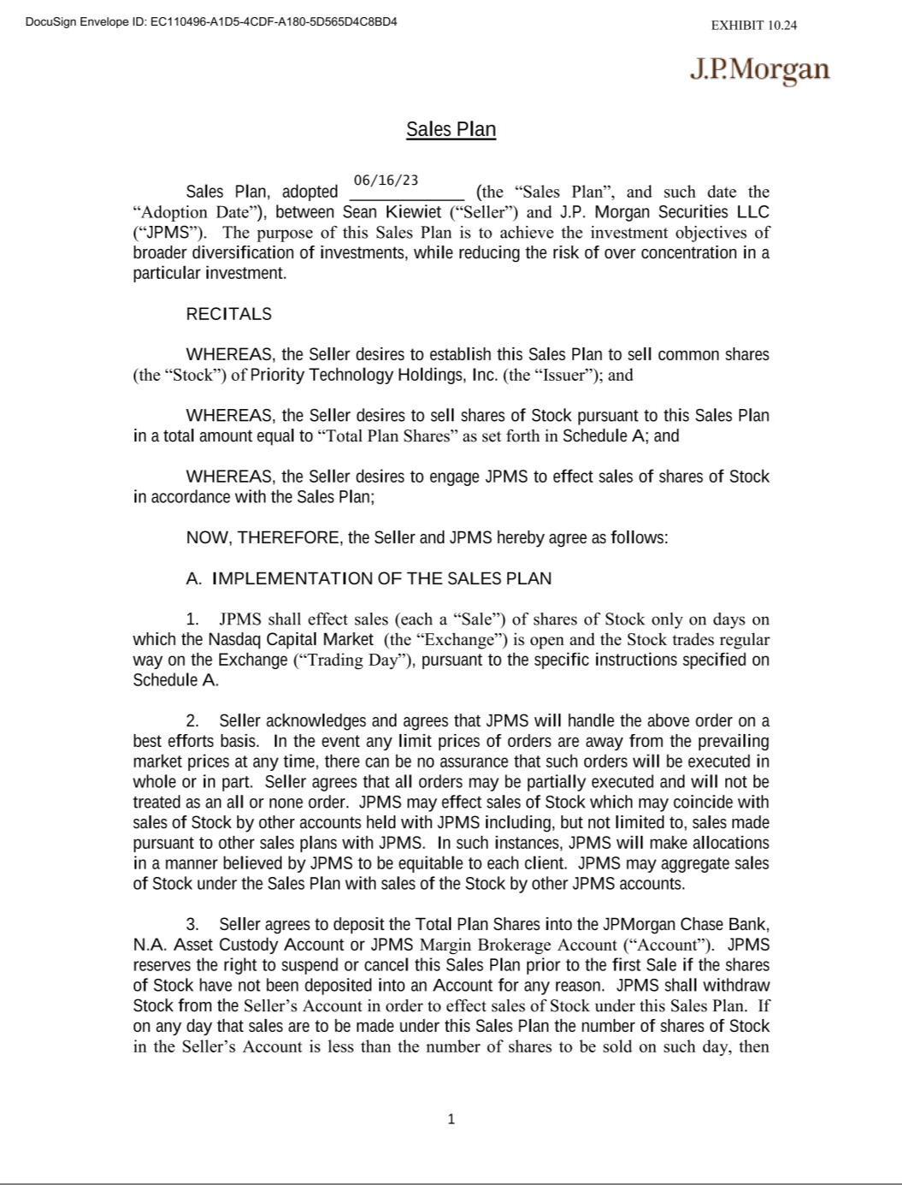

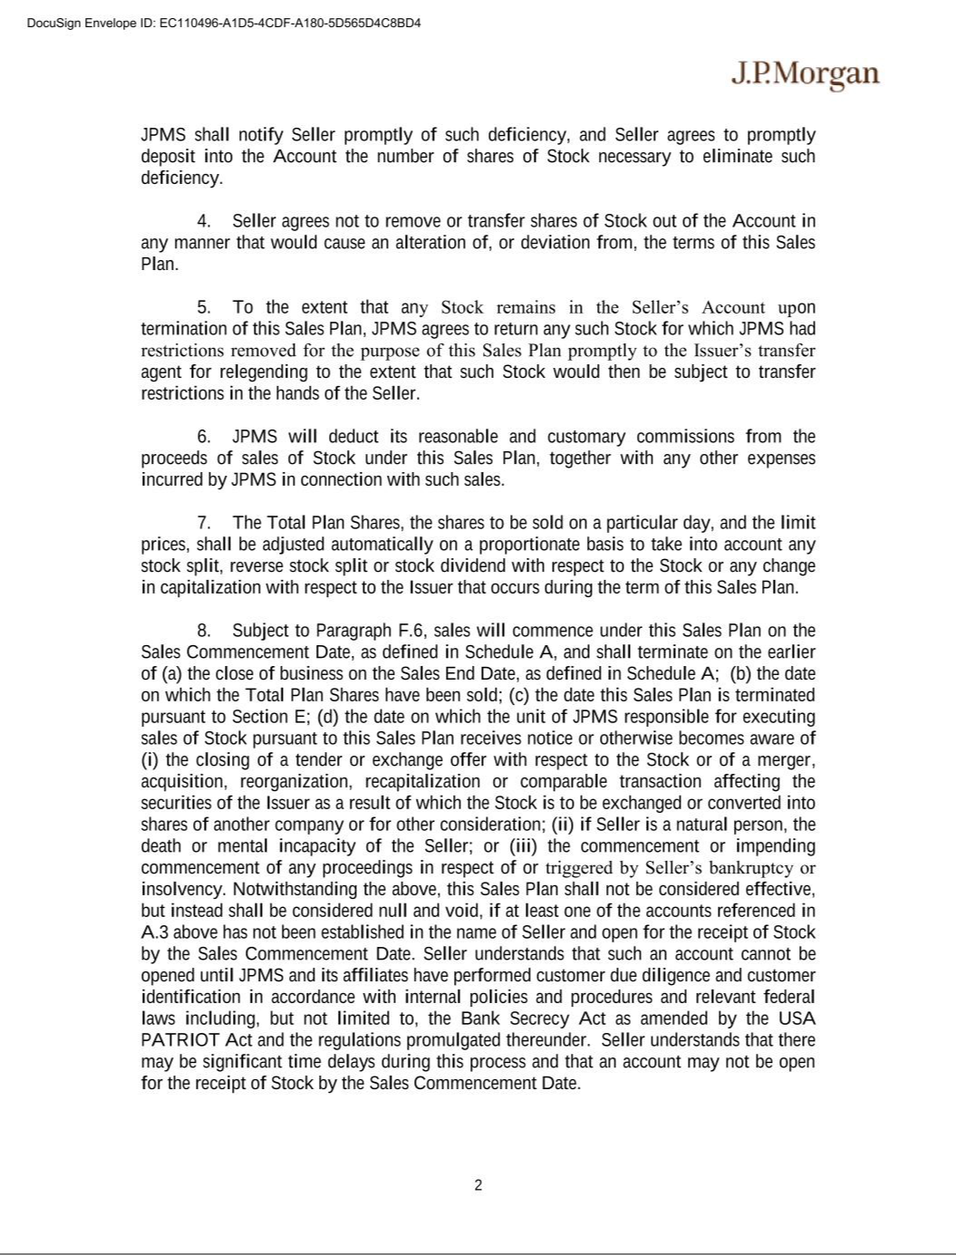

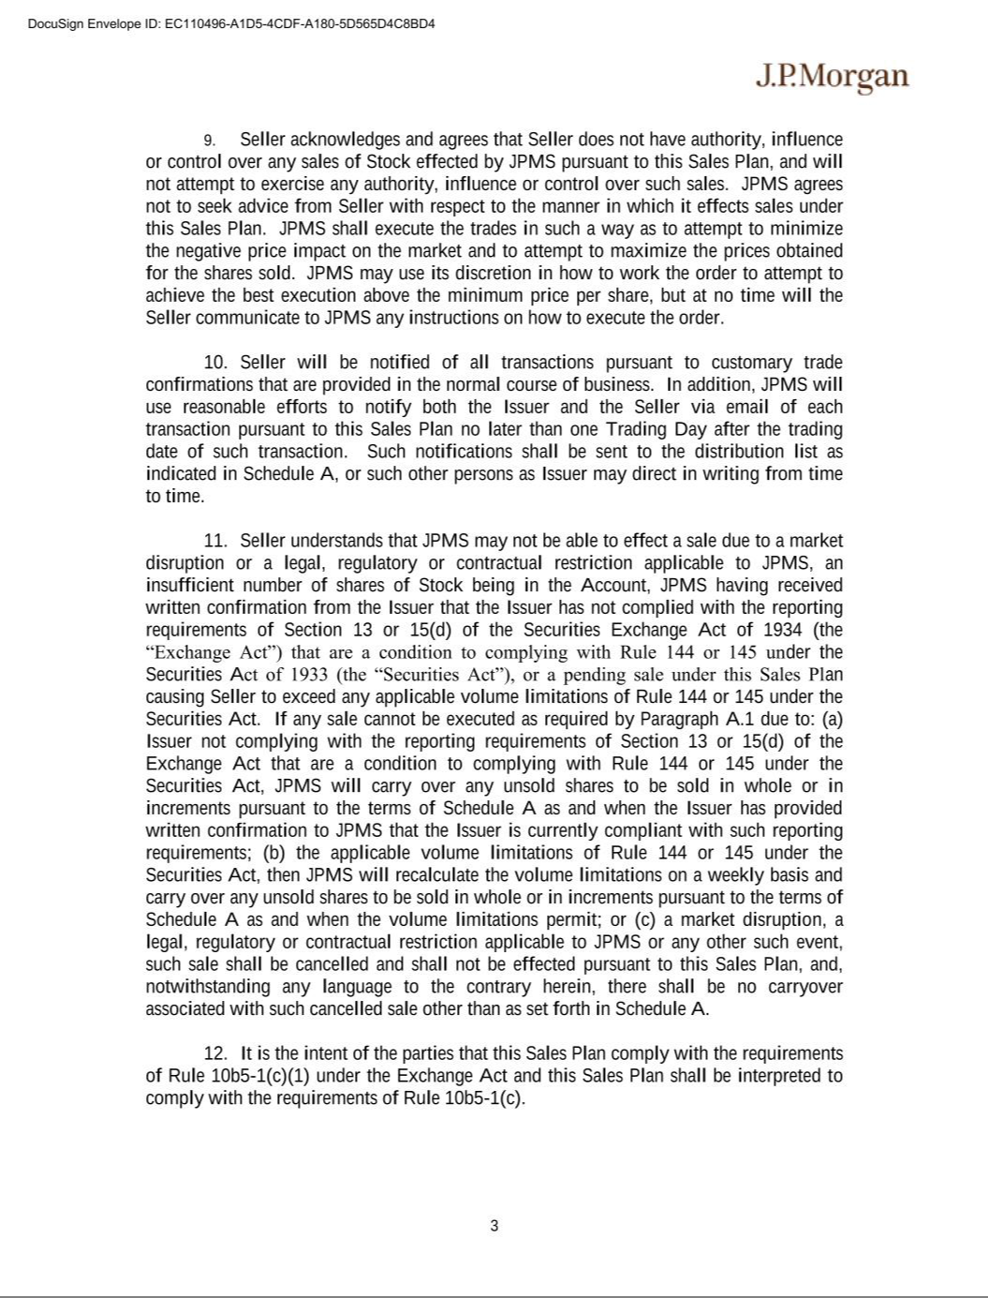

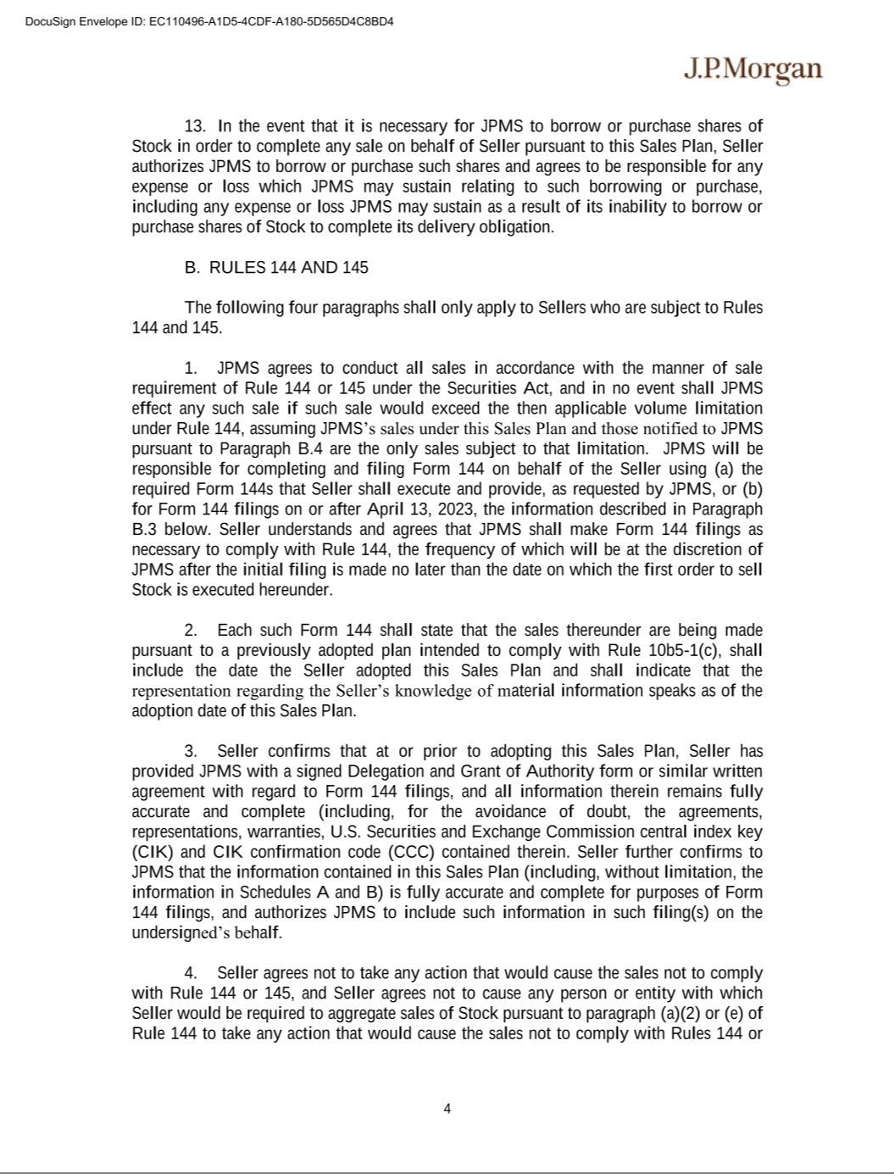

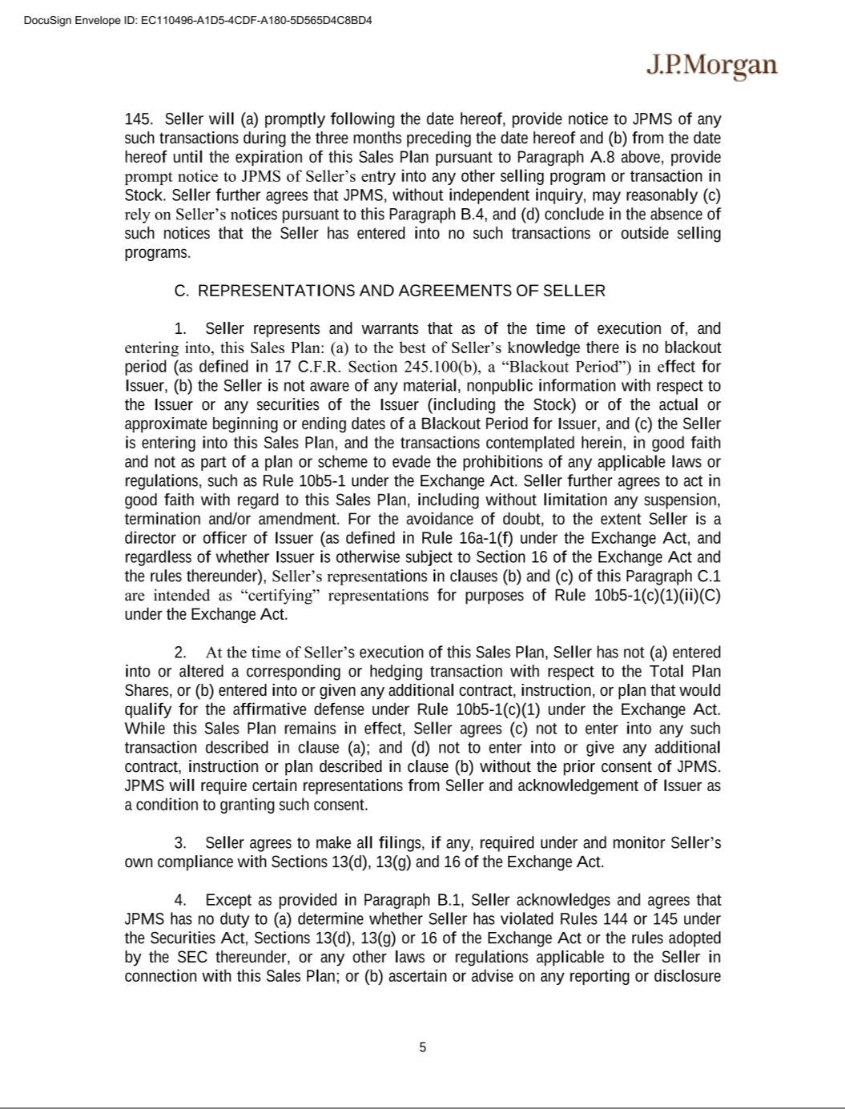

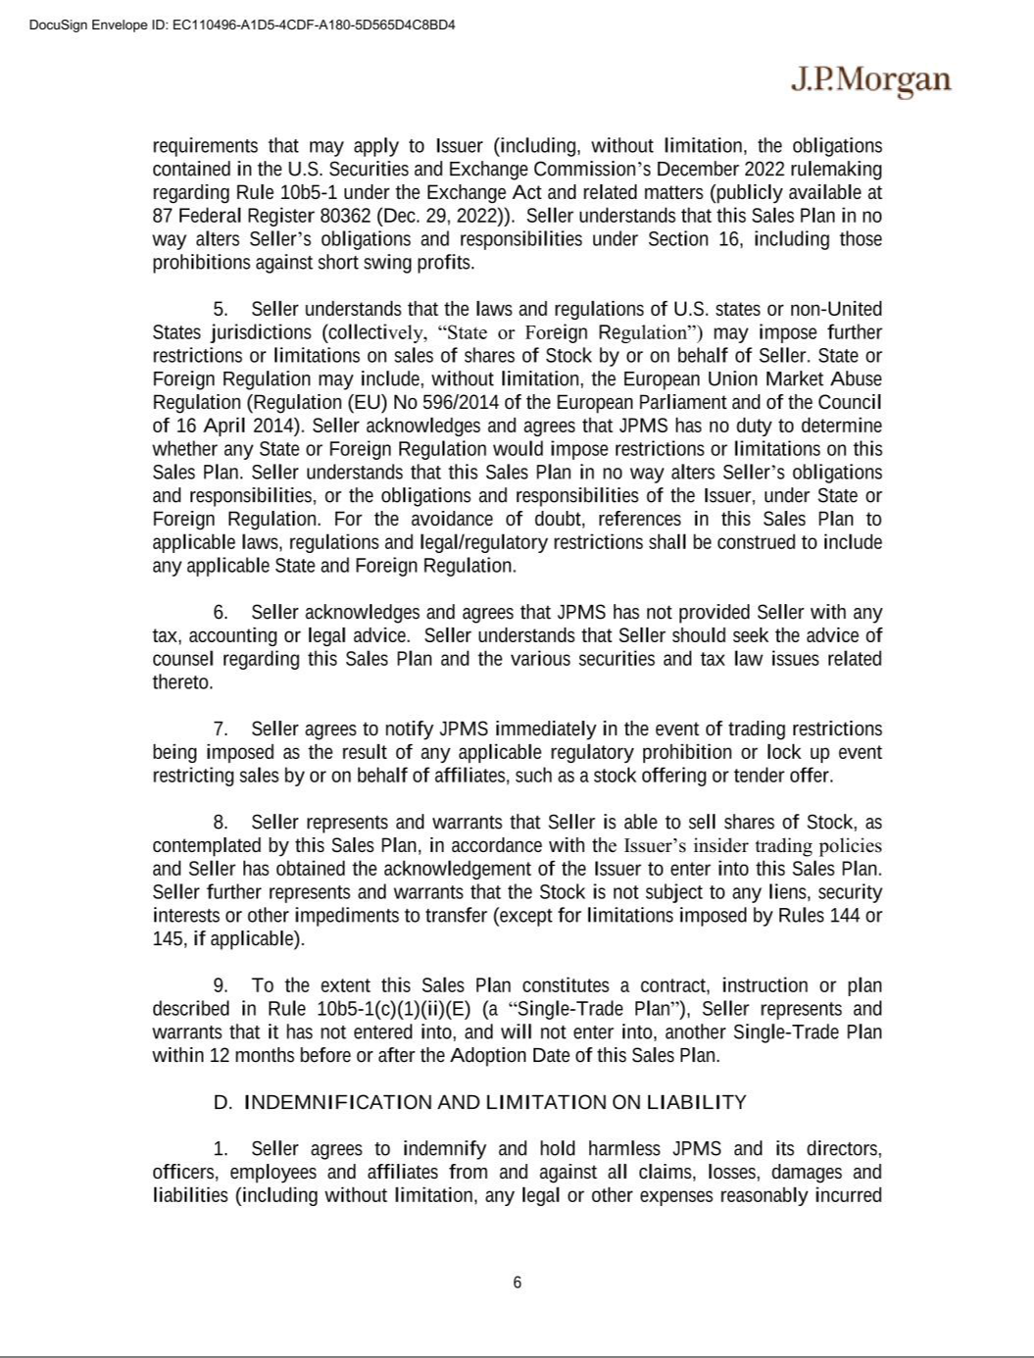

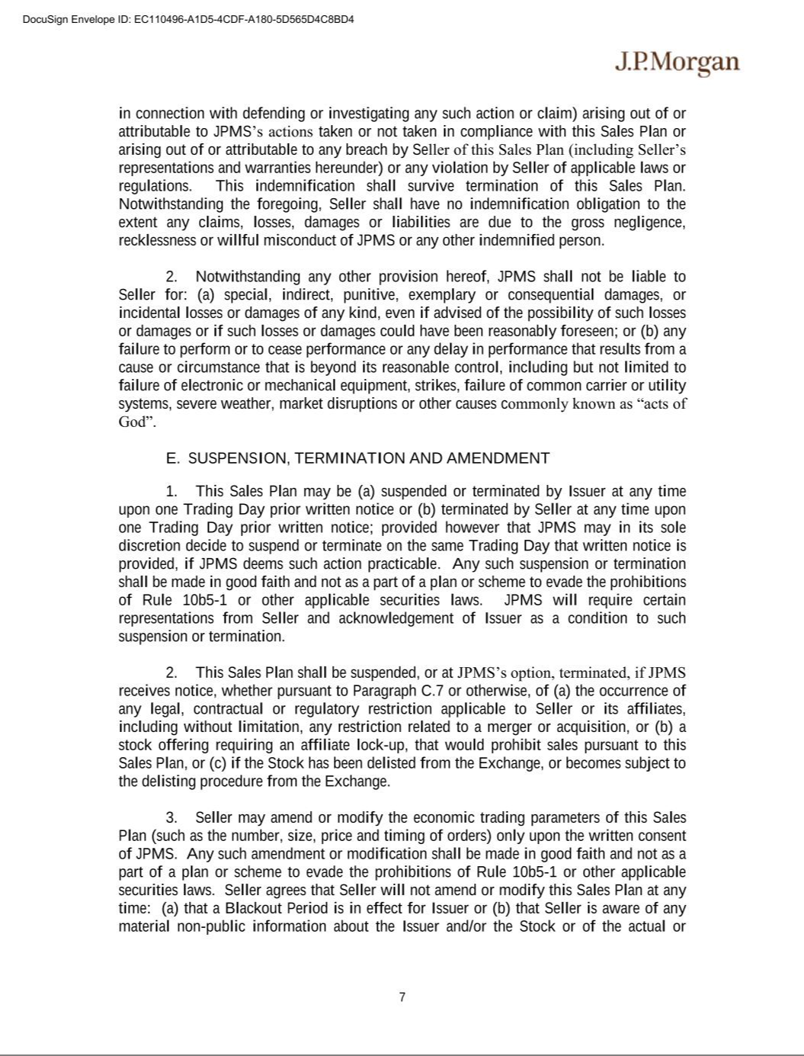

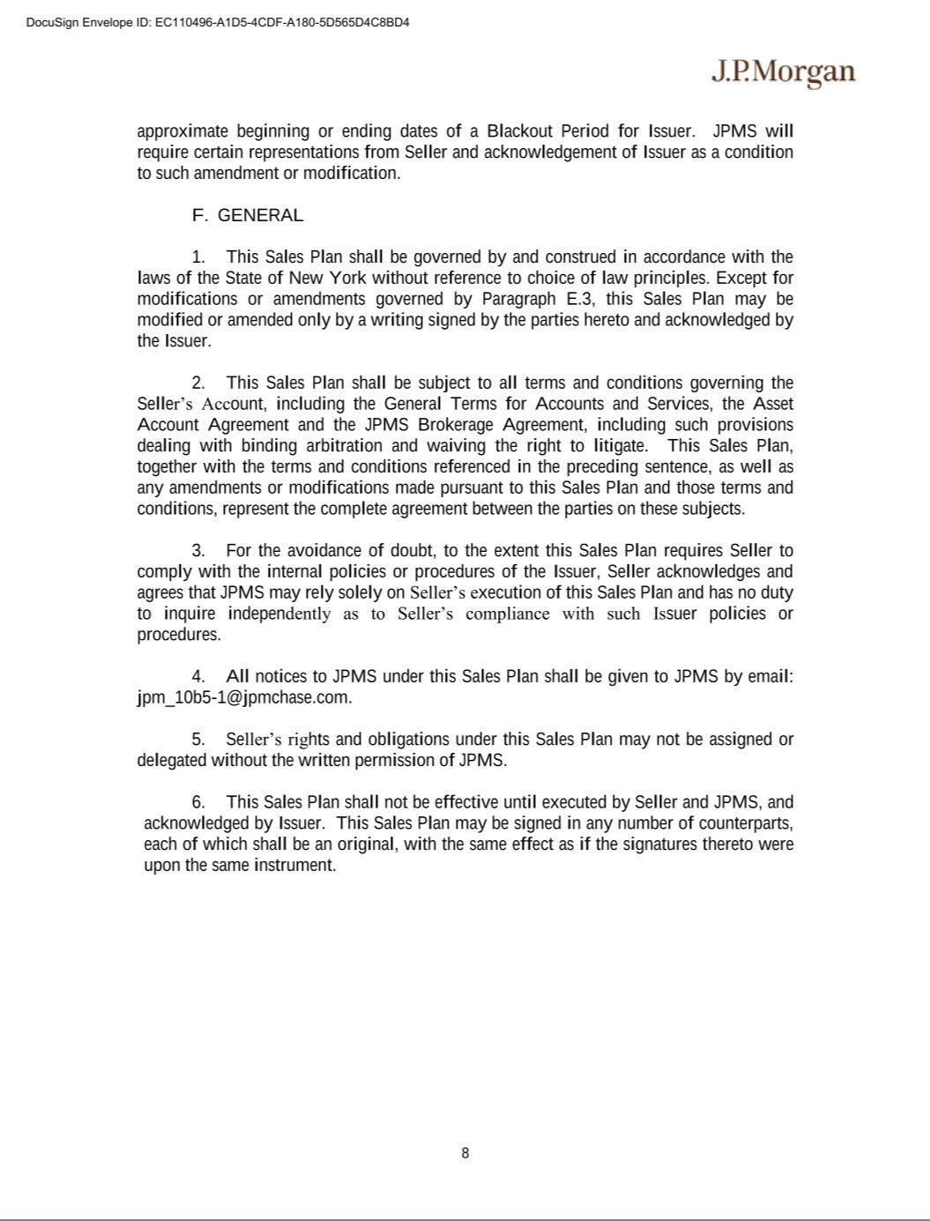

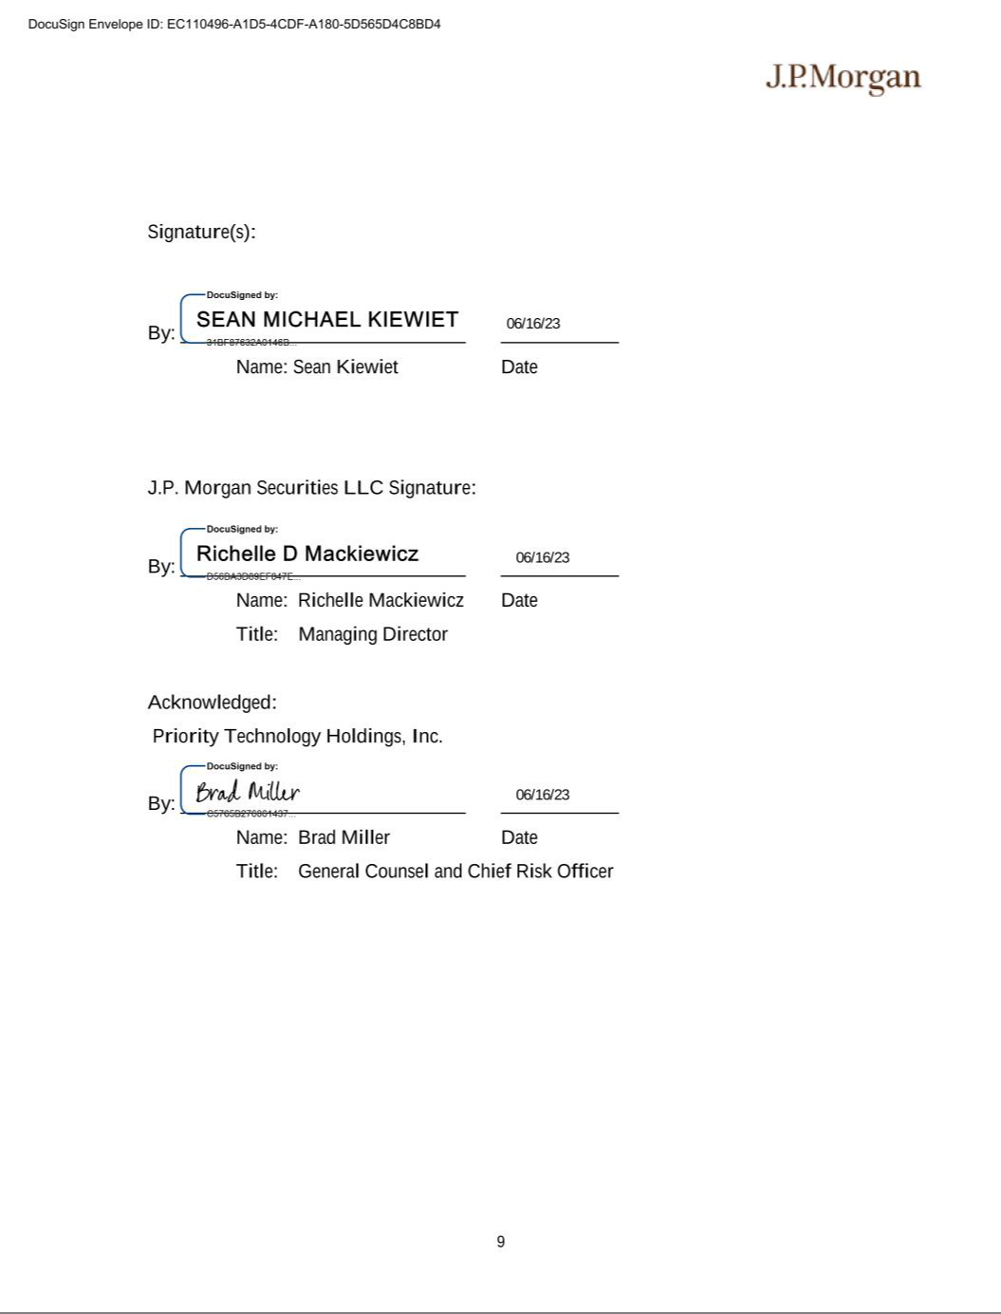

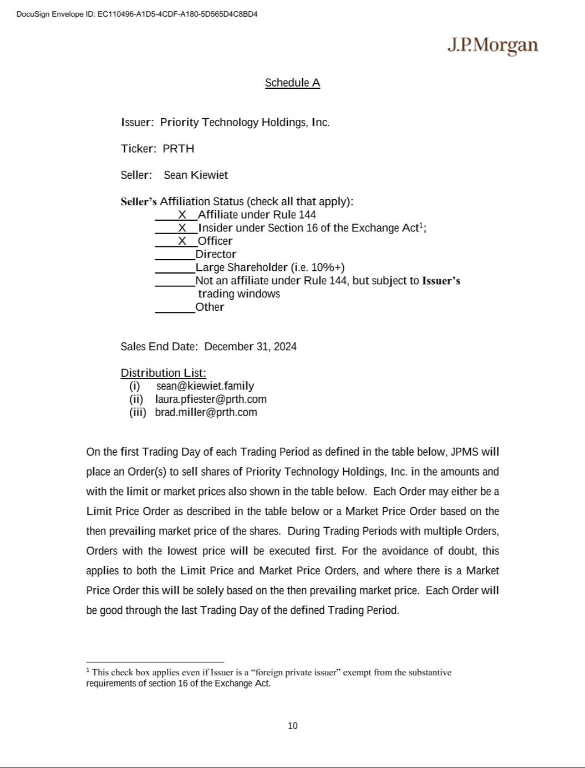

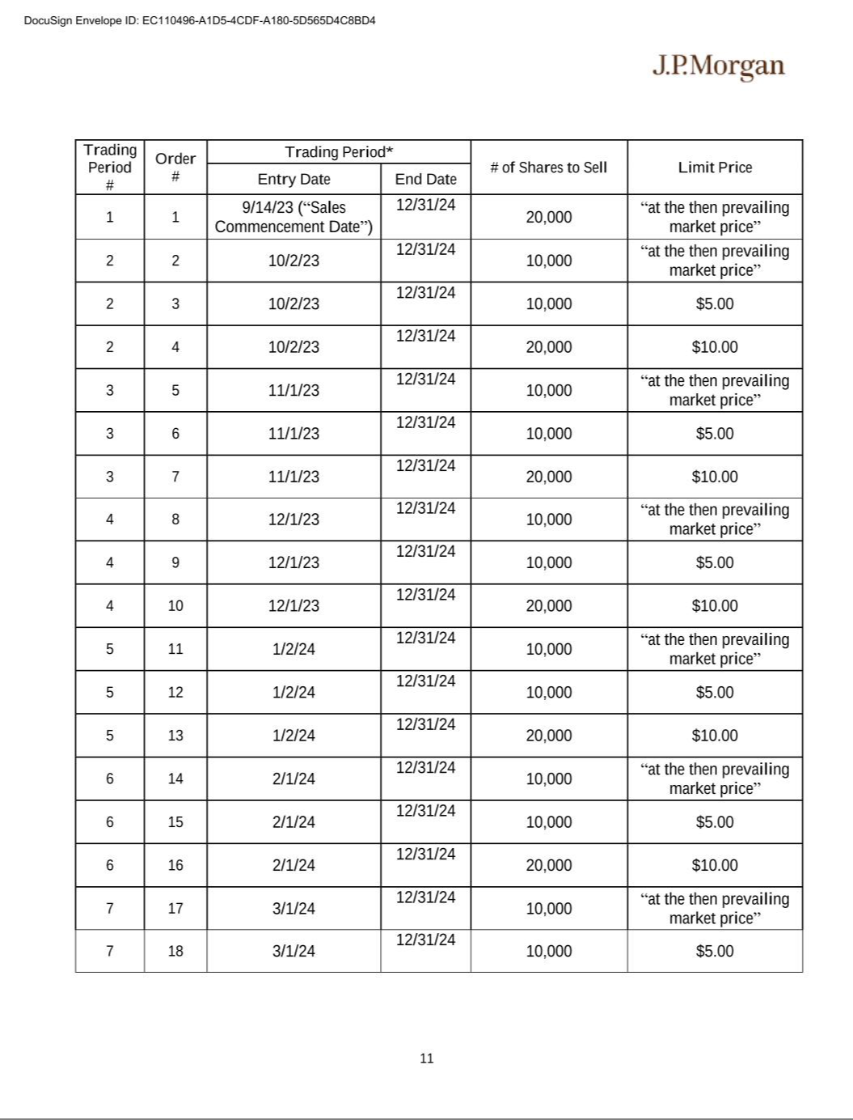

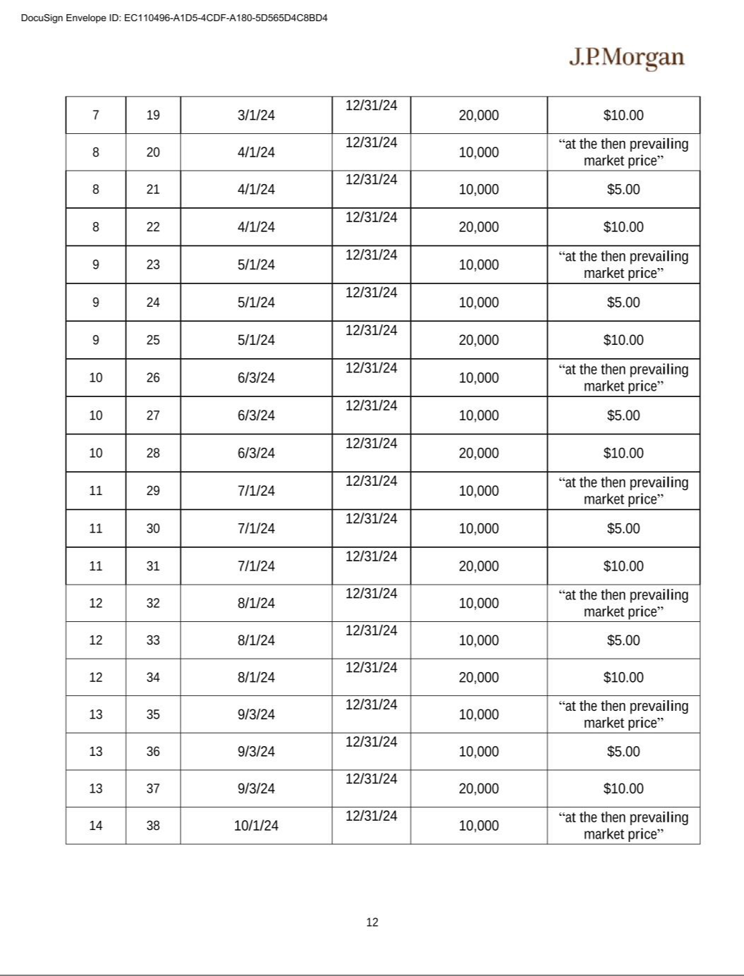

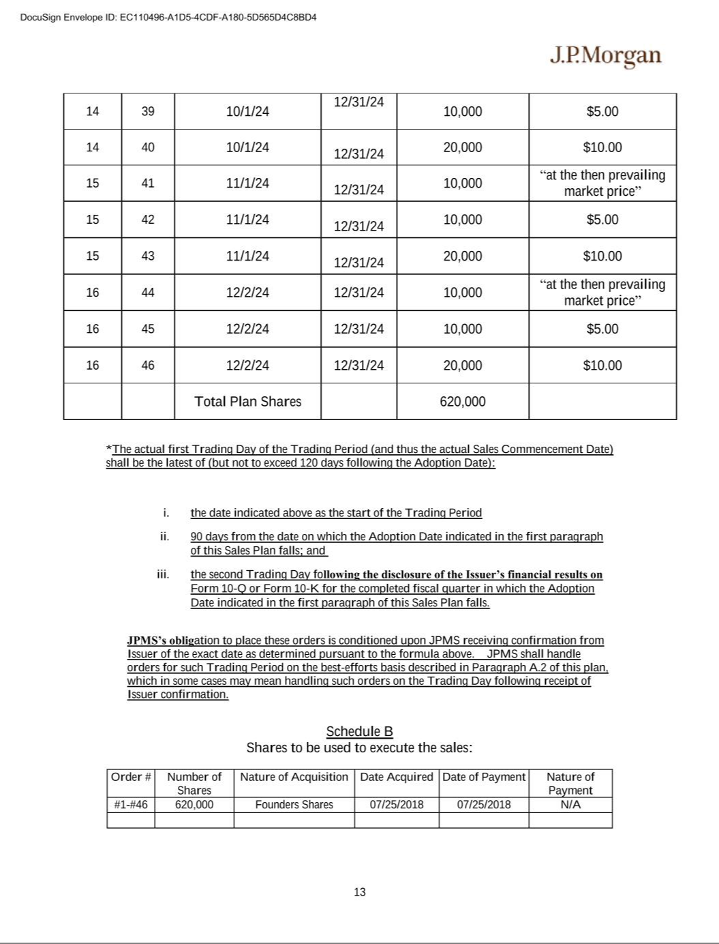

Exhibit 31.1

CERTIFICATION OF PRINCIPAL EXECUTIVE OFFICER PURSUANT TO

EXCHANGE ACT RULE 13a-14(a) AS ADOPTED PURSUANT TO

SECTION 303 OF THE SARBANES-OXLEY ACT OF 2002

I, Thomas C. Priore, certify that:

- I have reviewed this quarterly report on Form 10-Q of Priority Technology Holdings, Inc.;

- Based on my knowledge, this report does not contain any untrue statement of a material fact or omit to state a material fact necessary to make the statements made, in light of the circumstances under which such statements were made, not misleading with respect to the period covered by this report;

- Based on my knowledge, the financial statements, and other financial information included in this report, fairly present in all material respects the financial condition, results of operations and cash flows of the registrant as of, and for, the periods presented in this report;

- The registrant's other certifying officer(s) and I are responsible for establishing and maintaining disclosure controls and procedures (as defined in Exchange Act Rules 13a-15(e) and 15d-15(e)) and internal control over financial reporting (as defined in Exchange Act Rules 13a-15(f) and 15d-15(f)) for the registrant and have:

  - Designed such disclosure controls and procedures, or caused such disclosure controls and procedures to be designed under our supervision, to ensure that material information relating to the registrant, including its consolidated subsidiaries, is made known to us by others within those entities, particularly during the period in which this report is being prepared;
  - Designed such internal control over financial reporting, or caused such internal control over financial reporting to be designed under our supervision, to provide reasonable assurance regarding the reliability of financial reporting and the preparation of financial statements for external purposes in accordance with generally accepted accounting principles;
  - Evaluated the effectiveness of the registrant’s disclosure controls and procedures and presented in this report our conclusions about the effectiveness of the disclosure controls and procedures, as of the end of the period covered by this report based on such evaluation; and
  - Disclosed in this report any change in the registrant’s internal control over financial reporting that occurred during the registrant’s most recent fiscal quarter (the registrant’s fourth fiscal quarter in the case of an annual report) that has materially affected, or is reasonably likely to materially affect, the registrant’s internal control over financial reporting; and

- The registrant's other certifying officer(s) and I have disclosed, based on our most recent evaluation of internal control over financial reporting, to the registrant's auditors and the audit committee of the registrant's board of directors (or persons performing the equivalent functions):

  - All significant deficiencies and material weaknesses in the design or operation of internal control over financial reporting which are reasonably likely to adversely affect the registrant's ability to record, process, summarize and report financial information; and
  - Any fraud, whether or not material, that involves management or other employees who have a significant role in the registrant's internal control over financial reporting.

November 9, 2023 /s/ THOMAS C. PRIORE

Thomas C. Priore

Chief Executive Officer and Chairman

(Principal Executive Officer)

Exhibit 31.2

CERTIFICATION OF PRINCIPAL FINANCIAL OFFICER PURSUANT TO

EXCHANGE ACT RULE 13a-14(a) AS ADOPTED PURSUANT TO

SECTION 303 OF THE SARBANES-OXLEY ACT OF 2002

I, Timothy M. O’Leary, certify that:

- I have reviewed this quarterly report on Form 10-Q of Priority Technology Holdings, Inc.;

- Based on my knowledge, this report does not contain any untrue statement of a material fact or omit to state a material fact necessary to make the statements made, in light of the circumstances under which such statements were made, not misleading with respect to the period covered by this report;

- Based on my knowledge, the financial statements, and other financial information included in this report, fairly present in all material respects the financial condition, results of operations and cash flows of the registrant as of, and for, the periods presented in this report;

- The registrant's other certifying officer(s) and I are responsible for establishing and maintaining disclosure controls and procedures (as defined in Exchange Act Rules 13a-15(e) and 15d-15(e)) and internal control over financial reporting (as defined in Exchange Act Rules 13a-15(f) and 15d-15(f)) for the registrant and have:

  - Designed such disclosure controls and procedures, or caused such disclosure controls and procedures to be designed under our supervision, to ensure that material information relating to the registrant, including its consolidated subsidiaries, is made known to us by others within those entities, particularly during the period in which this report is being prepared;
  - Designed such internal control over financial reporting, or caused such internal control over financial reporting to be designed under our supervision, to provide reasonable assurance regarding the reliability of financial reporting and the preparation of financial statements for external purposes in accordance with generally accepted accounting principles;
  - Evaluated the effectiveness of the registrant’s disclosure controls and procedures and presented in this report our conclusions about the effectiveness of the disclosure controls and procedures, as of the end of the period covered by this report based on such evaluation; and
  - Disclosed in this report any change in the registrant’s internal control over financial reporting that occurred during the registrant’s most recent fiscal quarter (the registrant’s fourth fiscal quarter in the case of an annual report) that has materially affected, or is reasonably likely to materially affect, the registrant’s internal control over financial reporting; and

- The registrant's other certifying officer(s) and I have disclosed, based on our most recent evaluation of internal control over financial reporting, to the registrant's auditors and the audit committee of the registrant's board of directors (or persons performing the equivalent functions):

  - All significant deficiencies and material weaknesses in the design or operation of internal control over financial reporting which are reasonably likely to adversely affect the registrant's ability to record, process, summarize and report financial information; and
  - Any fraud, whether or not material, that involves management or other employees who have a significant role in the registrant's internal control over financial reporting.

November 9, 2023 /s/ TIMOTHY M. O’LEARY

Timothy M. O’Leary

Chief Financial Officer

(Principal Financial Officer)

Exhibit 32

CERTIFICATION OF PRINCIPAL EXECUTIVE OFFICER AND PRINCIPAL FINANCIAL OFFICER PURSUANT TO 18 U.S.C. SECTION 1350, AS ADOPTED PURSUANT TO SECTION 906 OF THE SARBANES-OXLEY ACT OF 2002

In connection with the Quarterly Report on Form 10-Q of Priority Technology Holdings, Inc. (the "Company") for the quarter ended September 30, 2023 as filed with the Securities and Exchange Commission (the "Report"), each of the undersigned, on the dates indicated below, hereby certifies pursuant to 18 U.S.C. Section 1350, as adopted pursuant to Section 906 of the Sarbanes-Oxley Act of 2002, that:

- The Report fully complies with the requirements of Section 13(a) or 15(d) of the Securities Act of 1934; and

- The information contained in the Report fairly presents, in all material respects, the financial condition and results of operation of the Company.

November 9, 2023 /s/ THOMAS C. PRIORE

Thomas C. Priore

Chief Executive Officer and Chairman

(Principal Executive Officer)

November 9, 2023 /s/ TIMOTHY M. O’LEARY

Timothy M. O’Leary

Chief Financial Officer

(Principal Financial Officer)

The foregoing certifications are being furnished solely pursuant to 18 U.S.C. § 1350 and are not being filed as part of the Report on Form 10-Q or as a separate disclosure document.

