UNITED STATES

SECURITIES AND EXCHANGE COMMISSION

Washington, D.C. 20549

FORM 10-Q

- QUARTERLY REPORT PURSUANT TO SECTION 13 OR 15(d) OF THE SECURITIES EXCHANGE ACT OF 1934 For the quarterly period ended September 30, 2022

OR

- TRANSITION REPORT PURSUANT TO SECTION 13 OR 15(d) OF THE SECURITIES EXCHANGE ACT OF 1934

For the transition period from to

Priority Technology Holdings, Inc.

Commission file number: 001-37872


 | Priority Technology Holdings, Inc.
 | (Exact name of registrant as specified in its charter)
Delaware |  |  |  | 47-4257046
(State or other jurisdiction of |  |  |  | (I.R.S. Employer
incorporation or organization) |  |  |  | Identification No.)
2001 Westside Parkway
Suite 155
Alpharetta, |  | Georgia |  | 30004
(Address of principal executive offices) |  |  |  | (Zip Code)
Registrant's telephone number, including area code: (800) 935-5961
 |  | Not applicable
(Former name, former address and former fiscal year, if changed since last report)
Securities registered pursuant to Section 12(b) of the Act:
Title of each class |  | Trading Symbol |  | Name of each exchange on which registered
Common Stock, par value $0.001 |  | PRTH |  | Nasdaq Global Market

Indicate by check mark whether the registrant (1) has filed all reports required to be filed by Section 13 or 15(d) of the Securities Exchange Act of 1934 during the preceding 12 months (or for such shorter period that the registrant was required to file such reports), and (2) has been subject to such filing requirements for the past 90 days. Yes ☒ No ☐

Indicate by check mark whether the registrant has submitted electronically every Interactive Data File required to be submitted

pursuant to Rule 405 of Regulation S-T (§232.405 of this chapter) during the preceding 12 months (or for such shorter period that the registrant was required to submit such files). Yes ☒ No ☐

Indicate by check mark whether the registrant is a large accelerated filer, an accelerated filer, a non-accelerated filer, a smaller

reporting company, or an emerging growth company. See the definitions of "large accelerated filer," "accelerated filer," "smaller reporting company," and "emerging growth company" in Rule 12b-2 of the Exchange Act.

Large accelerated filer | ☐ | Accelerated filer | ☐
Non-accelerated filer | ☒ | Smaller reporting company | ☒
 |  | Emerging growth company | ☐

If an emerging growth company, indicate by check mark if the registrant has elected not to use the extended transition period for complying with any new or revised financial accounting standards provided pursuant to Section 13(a) of the Exchange Act. ☐

Indicate by check mark whether the registrant is a shell company (as defined in Rule 12b-2 of the Exchange Act).

Yes ☐ No ☒

As of November 4, 2022, the number of the registrant's Common Stock outstanding was 76,002,368.

 |  |  |  |  |  |  |  |  |  |  |  |  |  |  |  |  |  |  |  |  |  | Table of Contents
 |  |  |  |  |  |  |  |  |  |  |  |  |  |  |  |  |  |  |  |  |  |  |  |  |  | Page
Commonly Used or Defined Terms |  |  |  |  |  |  |  |  |  |  |  |  |  |  |  |  |  |  |  |  |  |  |  |  |  |  | ii
PART I. FINANCIAL INFORMATION |  |  |  |  |  |  |  |  |  |  |  |  |  |  |  |  |  |  |  |  |  |  |  |  |  |  | 1
 | Item 1. Financial Statements |  |  |  |  |  |  |  |  |  |  |  |  |  |  |  |  |  |  |  |  |  |  |  |  | 1
 | Unaudited Consolidated Balance Sheets as of September 30, 2022 and December 31, 2021 |  |  |  |  |  |  |  |  |  |  |  |  |  |  |  |  |  |  |  |  |  |  |  |  | 1
 | Unaudited Consolidated Statements of Operations for the three and nine months ended September 30, 2022 and 2021 |  |  |  |  |  |  |  |  |  |  |  |  |  |  |  |  |  |  |  |  |  |  |  |  |  | 2
 | Unaudited Consolidated Statements of Changes in Stockholders' Deficit for the three and nine months ended September 30, 2022 and 2021 |  |  |  |  |  |  |  |  |  |  |  |  |  |  |  |  |  |  |  |  |  |  |  |  |  | 3
 | Unaudited Consolidated Statements of Cash Flows for the nine months ended September 30, 2022 and 2021 |  |  |  |  |  |  |  |  |  |  |  |  |  |  |  |  |  |  |  |  |  |  |  |  |  | 5
 | Notes to Unaudited Consolidated Financial Statements: |  |  |  |  |  |  |  |  |  |  |  |  |  |  |  |  |  |  |  |  |  |  |  |  | 7
 | 1. | Nature of Business and Significant Accounting Policies |  |  |  |  |  |  |  |  |  |  |  |  |  |  |  |  |  |  |  |  |  |  |  |  | 7
 | 2. | Revenues |  |  |  |  |  |  |  |  |  |  |  |  |  |  |  |  |  |  |  |  |  |  |  |  | 9
 | 3. | Acquisitions |  |  |  |  |  |  |  |  |  |  |  |  |  |  |  |  |  |  |  |  |  |  |  | 10
 | 4. | Settlement Assets and Customer Account Balances and Related Obligations |  |  |  |  |  |  |  |  |  |  |  |  |  |  |  |  |  |  |  |  |  |  |  | 12
 | 5. | Goodwill and Other Intangible Assets |  |  |  |  |  |  |  |  |  |  |  |  |  |  |  |  |  |  |  |  |  |  |  | 13
 | 6. | Property, Equipment and Software |  |  |  |  |  |  |  |  |  |  |  |  |  |  |  |  |  |  |  |  |  |  |  | 15
 | 7. | Notes Receivable |  |  |  |  |  |  |  |  |  |  |  |  |  |  |  |  |  |  |  |  |  |  |  | 16
 | 8. | Debt Obligations |  |  |  |  |  |  |  |  |  |  |  |  |  |  |  |  |  |  |  |  |  |  |  | 16
 | 9. | Fair Value |  |  |  |  |  |  |  |  |  |  |  |  |  |  |  |  |  |  |  |  |  |  |  | 17
 | 10. Redeemable Senior Preferred Stock and Warrants |  |  |  |  |  |  |  |  |  |  |  |  |  |  |  |  |  |  |  |  |  |  |  |  | 19
 | 11. Income Taxes |  |  |  |  |  |  |  |  |  |  |  |  |  |  |  |  |  |  |  |  |  |  |  |  | 20
 | 12. Commitments and Contingencies |  |  |  |  |  |  |  |  |  |  |  |  |  |  |  |  |  |  |  |  |  |  |  |  | 20
 | 13. Related Party Transactions |  |  |  |  |  |  |  |  |  |  |  |  |  |  |  |  |  |  |  |  |  |  |  |  | 21
 | 14. Stock-based Compensation |  |  |  |  |  |  |  |  |  |  |  |  |  |  |  |  |  |  |  |  |  |  |  |  | 22
 | 15. Stockholders' Equity |  |  |  |  |  |  |  |  |  |  |  |  |  |  |  |  |  |  |  |  |  |  |  |  | 23
 | 16. Segment Information |  |  |  |  |  |  |  |  |  |  |  |  |  |  |  |  |  |  |  |  |  |  |  |  | 23
 | 17. Loss per Common Share |  |  |  |  |  |  |  |  |  |  |  |  |  |  |  |  |  |  |  |  |  |  |  |  | 25
 | Item 2. Management's Discussion and Analysis of Financial Condition and Results of Operations |  |  |  |  |  |  |  |  |  |  |  |  |  |  |  |  |  |  |  |  |  |  |  |  | 26
 | Item 3. Qualitative and Quantitative Disclosures about Market Risk |  |  |  |  |  |  |  |  |  |  |  |  |  |  |  |  |  |  |  |  |  |  |  |  | 38
 | Item 4. Controls and Procedures |  |  |  |  |  |  |  |  |  |  |  |  |  |  |  |  |  |  |  |  |  |  |  |  | 38
PART II. OTHER INFORMATION |  |  |  |  |  |  |  |  |  |  |  |  |  |  |  |  |  |  |  |  |  |  |  |  |  | 39
 | Item 1. Legal Proceedings |  |  |  |  |  |  |  |  |  |  |  |  |  |  |  |  |  |  |  |  |  |  |  |  | 39
 | Item 1A. Risk Factors |  |  |  |  |  |  |  |  |  |  |  |  |  |  |  |  |  |  |  |  |  |  |  |  | 39
 | Item 2. Unregistered Sales of Equity Securities and Use of Proceeds |  |  |  |  |  |  |  |  |  |  |  |  |  |  |  |  |  |  |  |  |  |  |  |  | 39
 | Item 3. Defaults Upon Senior Securities |  |  |  |  |  |  |  |  |  |  |  |  |  |  |  |  |  |  |  |  |  |  |  |  | 39
 | Item 4. Mine Safety Disclosures |  |  |  |  |  |  |  |  |  |  |  |  |  |  |  |  |  |  |  |  |  |  |  |  | 39
 | Item 5. Other Information |  |  |  |  |  |  |  |  |  |  |  |  |  |  |  |  |  |  |  |  |  |  |  |  | 40
 | Item 6. Exhibits |  |  |  |  |  |  |  |  |  |  |  |  |  |  |  |  |  |  |  |  |  |  |  |  | 40
Signatures |  |  |  |  |  |  |  |  |  |  |  |  |  |  |  |  |  |  |  |  |  |  |  |  |  | 42

i

Table of Contents

 |  | Priority Technology Holdings, Inc.
 |  | Commonly Used or Defined Terms
Term |  | Definition
2018 Plan |  | 2018 Equity Incentive Plan
2021 Stock Purchase Plan |  | Priority Technology Holdings, Inc. 2021 Employee Stock Purchase Plan
2022 Share Repurchase Program |  | Priority Technology Holdings, Inc. 2022 Share Repurchase Program
2021 Share Repurchase Program |  | Priority Technology Holdings, Inc. 2021 Share Repurchase Program
AP |  | Accounts payable
ASC |  | Accounting Standards Codification
ASU |  | Accounting Standards Update
B2B |  | Business-to-business
B2C |  | Business-to-consumer
C&H |  | C&H Financial Services, Inc.
CEO |  | Chief Executive Officer
CFO |  | Chief Financial Officer
Common Stock |  | The Company's common stock, par value $0.001
Credit Agreement |  | Credit and Guaranty Agreement with Truist Bank dated as of April 27, 2021
EAETR |  | Estimated annual effective tax rate
EBITDA |  | Earnings before interest, taxes, depreciation and amortization
EGC |  | Emerging Growth Company
ESPP |  | Employee Stock Purchase Plan
Exchange Act |  | Securities Exchange Act of 1934
FASB |  | Financial Accounting Standards Board
FBO |  | For the Benefit Of
FI |  | Financial Institution
Finxera |  | Finxera Holdings, Inc.
GAAP |  | U.S. Generally Accepted Accounting Principles
IRA |  | Inflation Reduction Act, enacted by the U.S. Federal Government on August 16, 2022
ISO |  | Independent sales organization
ISV |  | Independent software vendor
JOBS Act |  | Jumpstart Our Business Startups Act of 2012
LIBOR |  | London Interbank Offered Rate
NCI |  | Non-controlling interests
PIK |  | Payment-in-kind
PHOT |  | Priority Hospitality Technology, LLC
SEC |  | Securities and Exchange Commission
SMB |  | Small to medium-sized businesses
Term facility |  | $620.0 million senior secured term loan facility issued under the Credit Agreement (including $320.0 million delayed draw facility)
Total Net Leverage Ratio |  | The ratio of consolidated total debt to the Consolidated Adjusted EBITDA (as defined in the Credit Agreement)

ii

Table of Contents
 |  | PART I. FINANCIAL INFORMATION
Item 1. Financial Statements
 |  | Priority Technology Holdings, Inc.
 |  | Unaudited Consolidated Balance Sheets
 |  | (in thousands, except share data)
 |  |  |  | September 30, 2022 |  |  | December 31, 2021
 | Assets
 | Current assets:
 | Cash and cash equivalents |  | $ | 12,707 |  | $ | 20,300
 | Restricted cash |  |  | 11,624 |  |  | 28,859
 | Accounts receivable, net of allowances of $1,026 and $555, respectively |  |  | 69,688 |  |  | 58,423
 | Prepaid expenses and other current assets |  |  | 16,725 |  |  | 15,807
 | Current portion of notes receivable |  |  | 986 |  |  | 272
 | Settlement assets and customer account balances |  |  | 516,687 |  |  | 479,471
 | Total current assets |  |  | 628,417 |  |  | 603,132
 | Notes receivable, less current portion |  |  | 2,072 |  |  | 105
 | Property, equipment and software, net |  |  | 29,773 |  |  | 25,233
 | Goodwill |  |  | 365,347 |  |  | 365,740
 | Intangible assets, net |  |  | 301,729 |  |  | 340,211
 | Deferred income taxes, net |  |  | 12,058 |  |  | 8,265
 | Other noncurrent assets |  |  | 10,353 |  |  | 9,256
 | Total assets |  | $ | 1,349,749 |  | $ | 1,351,942
 | Liabilities, Redeemable Senior Preferred Stock and Stockholders' Deficit
 | Current liabilities:
 | Accounts payable and accrued expenses |  | $ | 50,955 |  | $ | 42,523
 | Accrued residual commissions |  |  | 32,593 |  |  | 29,532
 | Customer deposits and advance payments |  |  | 3,111 |  |  | 5,021
 | Current portion of long-term debt |  |  | 6,200 |  |  | 6,200
 | Settlement and customer account obligations |  |  | 517,008 |  |  | 500,291
 | Total current liabilities |  |  | 609,867 |  |  | 583,567
 | Long-term debt, net of current portion, discounts and debt issuance costs |  |  | 593,068 |  |  | 604,105
 | Other noncurrent liabilities |  |  | 13,583 |  |  | 18,349
 | Total noncurrent liabilities |  |  | 606,651 |  |  | 622,454
 | Total liabilities |  |  | 1,216,518 |  |  | 1,206,021
 | Commitments and contingencies (Note 12)
 | Redeemable senior preferred stock, $0.001 par value; 250,000 shares authorized; 225,000 issued and outstanding at
 | September 30, 2022 and December 31, 2021 |  |  | 225,095 |  |  | 210,158
 | Stockholders' deficit:
 | Preferred stock, $0.001; 100,000,000 shares authorized; none issued or outstanding at September 30, 2022 and December 31,
2021 |  |  |  | — |  |  | —
 | Common stock, $0.001 par value; 1,000,000,000 shares authorized; 77,789,291 and 77,460,312 shares issued at September 30,
 | 2022 and December 31, 2021, respectively; and 75,981,186 and 76,739,896 shares outstanding at September 30, 2022 and
 | December 31, 2021, respectively |  |  | 78 |  |  | 77
 | Additional paid-in capital |  |  | 17,719 |  |  | 39,835
 | Treasury stock at cost, 1,808,105 and 720,416 shares at September 30, 2022 and December 31, 2021, respectively |  |  | (8,765) |  |  | (4,091)
 | Accumulated deficit |  |  | (100,896) |  |  | (100,058)
 | Total stockholders' deficit |  |  | (91,864) |  |  | (64,237)
 | Total liabilities, redeemable senior preferred stock and stockholders' deficit |  | $ | 1,349,749 |  | $ | 1,351,942

See Notes to Unaudited Consolidated Financial Statements

1

Table of Contents

Priority Technology Holdings, Inc.

Unaudited Consolidated Statements of Operations

(in thousands, except per share amounts)

 | Three Months Ended September 30, |  |  |  |  |  |  | Nine Months Ended September 30,
 | 2022 |  |  |  | 2021 |  |  | 2022 |  |  | 2021
Revenues | $ | 166,417 |  | $ | 132,542 |  | $ | 486,086 |  | $ | 370,853
Operating expenses
Cost of revenue (excludes depreciation and amortization) |  | 107,958 |  |  | 92,833 |  |  | 320,187 |  |  | 264,527
Salary and employee benefits |  | 16,384 |  |  | 11,909 |  |  | 48,231 |  |  | 31,808
Depreciation and amortization |  | 17,817 |  |  | 12,330 |  |  | 52,675 |  |  | 32,123
Selling, general and administrative |  | 10,178 |  |  | 7,220 |  |  | 27,027 |  |  | 22,213
Total operating expenses |  | 152,337 |  |  | 124,292 |  |  | 448,120 |  |  | 350,671
Operating income |  | 14,080 |  |  | 8,250 |  |  | 37,966 |  |  | 20,182
Other (expense) income
Interest expense |  | (13,412) |  |  | (8,155) |  |  | (37,282) |  |  | (24,608)
Debt extinguishment and modification costs |  | — |  |  | — |  |  | — |  |  | (8,322)
Other income, net |  | 231 |  |  | 146 |  |  | 311 |  |  | 92
Total other expense, net |  | (13,181) |  |  | (8,009) |  |  | (36,971) |  |  | (32,838)
Income (loss) before income taxes |  | 899 |  |  | 241 |  |  | 995 |  |  | (12,656)
Income tax expense |  | 1,691 |  |  | 790 |  |  | 1,833 |  |  | 49
Net loss |  | (792) |  |  | (549) |  |  | (838) |  |  | (12,705)
Less: Dividends and accretion attributable to redeemable senior preferred stockholders |  | (9,466) |  |  | (5,813) |  |  | (26,415) |  |  | (9,724)
Less: NCI preferred unit redemptions |  | — |  |  | — |  |  | — |  |  | (10,777)
Net loss attributable to common stockholders | $ | (10,258) |  | $ | (6,362) |  | $ | (27,253) |  | $ | (33,206)
Loss per common share:
Basic and diluted | $ | (0.13) |  | $ | (0.09) |  | $ | (0.35) |  | $ | (0.48)
Weighted-average common shares outstanding:
Basic and diluted |  | 77,984 |  |  | 71,979 |  |  | 78,392 |  |  | 69,689

See Notes to Unaudited Consolidated Financial Statements

2

Table of Contents

Priority Technology Holdings, Inc.

Unaudited Consolidated Statements of Changes in Stockholders' Deficit

(in thousands)

 | Common |  |  | Treasury
 | Stock |  |  | Stock |  |  | Additional Paid-In |  |  |  | Deficit Attributable to
 | Shares |  | $ | Shares |  | $ |  | Capital | Accumulated Deficit |  |  | Stockholders
December 31, 2021 | 76,740 | $ | 77 | 720 | $ | (4,091) | $ | 39,835 | $ | (100,058) | $ | (64,237)
Equity-classified stock-based compensation | — |  | — | — |  | — |  | 1,558 |  | — |  | 1,558
Vesting of stock-based compensation | 129 |  | — | — |  | — |  | — |  | — |  | —
Share repurchases and shares withheld for taxes | (27) |  | 1 | 27 |  | (157) |  | (1) |  | — |  | (157)
Dividends on redeemable senior preferred stock | — |  | — | — |  | — |  | (7,595) |  | — |  | (7,595)
Accretion of redeemable senior preferred stock | — |  | — | — |  | — |  | (805) |  | — |  | (805)
Net loss | — |  | — | — |  | — |  | — |  | (333) |  | (333)
March 31, 2022 | 76,842 | $ | 78 | 747 | $ | (4,248) | $ | 32,992 | $ | (100,391) | $ | (71,569)
Equity-classified stock-based compensation | — |  | — | — |  | — |  | 1,542 |  | — |  | 1,542
ESPP compensation and vesting of stock-based compensation | 157 |  | — | — |  | — |  | 57 |  | — |  | 57
Share repurchases and shares withheld for taxes | (431) |  | — | 431 |  | (1,922) |  | — |  | — |  | (1,922)
Dividends on redeemable senior preferred stock | — |  | — | — |  | — |  | (7,732) |  | — |  | (7,732)
Accretion of redeemable senior preferred stock | — |  | — | — |  | — |  | (817) |  | — |  | (817)
Net income | — |  | — | — |  | — |  | — |  | 287 |  | 287
June 30, 2022 | 76,568 | $ | 78 | 1,178 | $ | (6,170) | $ | 26,042 | $ | (100,104) | $ | (80,154)
Equity-classified stock-based compensation | — |  | — | — |  | — |  | 1,104 |  | — |  | 1,104
ESPP compensation and vesting of stock-based compensation | 43 |  | — | — |  | — |  | 39 |  | — |  | 39
Share repurchases and shares withheld for taxes | (630) |  | — | 630 |  | (2,595) |  | — |  | — |  | (2,595)
Dividends on redeemable senior preferred stock | — |  | — | — |  | — |  | (8,636) |  | — |  | (8,636)
Accretion of redeemable senior preferred stock | — |  | — | — |  | — |  | (830) |  | — |  | (830)
Net loss | — |  | — | — |  | — |  | — |  | (792) |  | (792)
September 30, 2022 | 75,981 | $ | 78 | 1,808 | $ | (8,765) | $ | 17,719 | $ | (100,896) | $ | (91,864)

3

Table of Contents

 | Common |  |  | Treasury
 | Stock |  |  | Stock |  |  | Additional Paid-In |  |  |  | Deficit Attributable to
 | Shares | $ |  | Shares |  | $ |  | Capital | Accumulated Deficit |  |  | Stockholders
December 31, 2020 | 67,391 | $ | 68 | 451 | $ | (2,388) | $ | 5,769 | $ | (102,013) | $ | (98,564)
Equity-classified stock-based compensation | — |  | — | — |  | — |  | 558 |  | — |  | 558
Vesting of stock-based compensation | 159 |  | — | — |  | — |  | — |  | — |  | —
Liability-classified stock-based compensation converted to equity- | — |  | — | — |  | — |  | 313 |  | — |  | 313
classified | — |  | — | — |  | — |  | 313 |  | — |  | 313
Exercise of stock options | 90 |  | — | — |  | — |  | 617 |  | — |  | 617
Net loss | — |  | — | — |  | — |  | — |  | (2,679) |  | (2,679)
March 31, 2021 | 67,640 | $ | 68 | 451 | $ | (2,388) | $ | 7,257 | $ | (104,692) | $ | (99,755)
Equity-classified stock-based compensation | — |  | — | — |  | — |  | 821 |  | — |  | 821
Vesting of stock-based compensation | 12 |  | — | — |  | — |  | — |  | — |  | —
Exercise of stock options | 30 |  | — | — |  | — |  | 204 |  | — |  | 204
Dividends on redeemable senior preferred stock | — |  | — | — |  | — |  | (3,413) |  | — |  | (3,413)
Accretion of redeemable senior preferred stock | — |  | — | — |  | — |  | (498) |  | — |  | (498)
Fair value of warrants issued | — |  | — | — |  | — |  | 11,357 |  | — |  | 11,357
Fair value of PHOT preferred units redemption | — |  | — | — |  | — |  | (10,777) |  | — |  | (10,777)
Fair value of common shares issued for PHOT redemption | 1,428 |  | 2 | — |  | — |  | 9,962 |  | — |  | 9,964
Net loss | — |  | — | — |  | — |  | — |  | (9,477) |  | (9,477)
June 30, 2021 | 69,110 | $ | 70 | 451 | $ | (2,388) | $ | 14,913 | $ | (114,169) | $ | (101,574)
Equity-classified stock-based compensation | — |  | — | — |  | — |  | 790 |  | — |  | 790
Vesting of stock-based compensation | 20 |  | — | — |  | — |  | — |  | — |  | —
Issuance of acquisition Common Stock | 7,551 |  | 7 | — |  | — |  | 34,381 |  | — |  | 34,388
Exercise of stock options | 53 |  | — | — |  | — |  | 369 |  | — |  | 369
Share repurchases | (163) |  | — | 163 |  | (1,023) |  | — |  | — |  | (1,023)
Dividends on redeemable senior preferred stock | — |  | — | — |  | — |  | (5,286) |  | — |  | (5,286)
Accretion of redeemable senior preferred stock | — |  | — | — |  | — |  | (527) |  | — |  | (527)
Net loss | — |  | — | — |  | — |  | — |  | (549) |  | (549)
September 30, 2021 | 76,571 | $ | 77 | 614 | $ | (3,411) | $ | 44,640 | $ | (114,718) | $ | (73,412)

See Notes to Unaudited Consolidated Financial Statements

4

Table of Contents

Priority Technology Holdings, Inc.

Unaudited Consolidated Statements of Cash Flows

(in thousands)

 | Nine Months Ended September 30,
 | 2022 |  |  | 2021
Cash flows from operating activities:
Net loss | $ | (838) |  | $ | (12,705)
Adjustments to reconcile net loss to net cash provided by (used in) operating activities:
Depreciation and amortization of assets |  | 52,675 |  |  | 32,123
Stock-based compensation |  | 4,204 |  |  | 2,349
Amortization of debt issuance costs and discounts |  | 2,613 |  |  | 1,607
Write-off of deferred loan costs and discount |  | — |  |  | 2,580
Deferred income tax benefit |  | (3,567) |  |  | (160)
PIK interest paid |  | — |  |  | (23,715)
Other non-cash items, net |  | (154) |  |  | (39)
Change in operating assets and liabilities:
Accounts receivable |  | (11,265) |  |  | (10,847)
Prepaid expenses and other current assets |  | (2,575) |  |  | (1,947)
Income taxes (receivable) payable |  | 1,003 |  |  | (1,541)
Notes receivable |  | 569 |  |  | (190)
Accounts payable and other accrued liabilities |  | 13,711 |  |  | 9,192
Customer deposits and advance payments |  | (1,910) |  |  | 713
Other assets and liabilities, net |  | (3,908) |  |  | 13
Net cash provided by (used in) operating activities |  | 50,558 |  |  | (2,567)
Cash flows from investing activities:
Acquisitions of businesses, net of cash acquired |  | — |  |  | (407,129)
Additions to property, equipment and software |  | (11,380) |  |  | (7,530)
Notes receivable loan funding |  | (3,250) |  |  | —
Acquisitions of intangible assets |  | (6,715) |  |  | (48,219)
Other investing activities |  | 250 |  |  | —
Net cash used in investing activities |  | (21,095) |  |  | (462,878)
Cash flows from financing activities:
Proceeds from issuance of long-term debt, net of issue discount |  | — |  |  | 607,318
Debt issuance and modification costs paid |  | — |  |  | (9,073)
Repayments of long-term debt |  | (4,650) |  |  | (359,875)
Borrowings under revolving credit facility |  | 23,000 |  |  | 30,000
Repayments of borrowings under revolving credit facility |  | (32,000) |  |  | —
Proceeds from the issuance of redeemable senior preferred stock, net of discount |  | — |  |  | 219,062
Redeemable senior preferred stock issuance fees and costs |  | — |  |  | (8,098)
Repurchases of Common Stock and shares withheld for taxes |  | (4,674) |  |  | (1,023)
Dividends paid to redeemable senior preferred stockholders |  | (11,478) |  |  | (4,015)
Proceeds from exercise of stock options |  | — |  |  | 1,190
Settlement and customer accounts obligations, net |  | 25,695 |  |  | 396,338
Contingent consideration for business combinations and asset acquisitions |  | (3,992) |  |  | —
Other financing activities |  | — |  |  | (814)

5

Table of Contents
 |  |  |  |  | Nine Months Ended September 30,
 |  |  |  |  | 2022 |  |  | 2021
 | Net cash (used in) provided by financing activities |  |  |  |  | (8,099) |  |  | 871,010
 | Net change in cash and cash equivalents, and restricted cash:
 | Net increase in cash and cash equivalents, and restricted cash |  |  |  |  | 21,364 |  |  | 405,565
 | Cash and cash equivalents, and restricted cash at beginning of period |  |  |  |  | 518,093 |  |  | 88,120
 | Cash and cash equivalents, and restricted cash equivalents at end of period |  |  |  | $ | 539,457 |  | $ | 493,685
 | Supplemental cash flow information:
 | Cash paid for interest |  |  |  | $ | 33,023 |  | $ | 17,043
 | Non-cash investing and financing activities:
 | Treasury stock purchases settled after the balance sheet date |  |  |  | $ | 651 |  | $ | —
 | Accruals for future contingent payments |  |  |  | $ | 4,825 |  | $ | 6,833
 | Notes receivable from sellers used as partial consideration for acquisitions |  |  |  | $ | — |  | $ | 3,499
 | Non-cash additions to other noncurrent assets for right-of-use operating leases |  |  |  | $ | 166 |  | $ | —
 | Reconciliation of cash and cash equivalents, and restricted cash:
 | Cash and cash equivalents |  |  |  | $ | 12,707 |  | $ | 16,974
 | Restricted cash |  |  |  |  | 11,624 |  |  | 17,258
 | Cash and cash equivalents included in settlement assets and customer account balances (see Note 4) |  |  |  |  | 515,126 |  |  | 459,453
 | Total cash and cash equivalents, and restricted cash |  |  |  | $ | 539,457 |  | $ | 493,685

See Notes to Unaudited Consolidated Financial Statements

6

Table of Contents

Priority Technology Holdings, Inc.

Notes to Unaudited Consolidated Financial Statements

1. Nature of Business and Significant Accounting Policies

Business, Consolidation and Presentation

Priority Technology Holdings, Inc. and its consolidated subsidiaries are referred to herein collectively as "Priority," "PRTH," the "Company," "we," "our" or "us," unless the context requires otherwise. Priority is a provider of merchant acquiring, integrated payment software, licensed money transmission services and commercial payments solutions.

The Company operates on a calendar year ending each December 31 and on four calendar quarters ending on March 31, June 30, September 30 and December 31 of each year. Results of operations reported for interim periods are not necessarily indicative of results for the entire year.

The accompanying Unaudited Consolidated Financial Statements include the accounts of the Company and its majority-owned subsidiaries. All material intercompany balances and transactions have been eliminated in consolidation. These Unaudited Consolidated Financial Statements have been prepared in accordance with GAAP for interim financial information pursuant to the rules and regulations of the SEC. The Consolidated Balance Sheet as of December 31, 2021 was derived from the audited financial statements included in the Company's Annual Report on Form 10-K for the year ended December 31, 2021 but does not include all disclosures required by GAAP for annual financial statements.

In the opinion of the Company's management, all known adjustments necessary for a fair presentation of the Unaudited Consolidated Financial Statements for interim periods have been made. These adjustments consist of normal recurring accruals and estimates that affect the carrying amounts of assets and liabilities. These Unaudited Consolidated Financial Statements should be read in conjunction with the Consolidated Financial Statements and notes thereto included in the Company's Annual Report on Form 10-K for the year ended December 31, 2021.

Use of Estimates

The preparation of Unaudited Consolidated Financial Statements in conformity with GAAP requires management to make estimates and assumptions that affect the reported amounts of assets and liabilities and the disclosure of contingent assets and liabilities at the date of the Unaudited Consolidated Financial Statements and the reported amounts of revenues and expenses during the reported period. Actual results could materially differ from those estimates. In particular, the continued magnitude, duration and effects of the COVID-19 pandemic are difficult to predict, and the ultimate effect could result in future charges related to the recoverability of assets, including financial assets, long-lived assets, goodwill and other losses.

Foreign Currency

The Company's reporting currency is the U.S. dollar. Assets and liabilities denominated in a foreign currency are translated into U.S. dollars at the current exchange rate on the last day of the reporting period. Revenues and expenses are translated using the average exchange rate in effect during the reporting period. Foreign exchange translation and transaction gains and losses were not material for the periods presented and are included in the Unaudited Consolidated Statements of Operations.

Emerging Growth Company Status

Prior to December 31, 2021, the Company was an EGC, as defined in JOBS Act, and elected to take advantage of certain exemptions from various reporting requirements that are applicable to other public companies until the Company is no longer an EGC, including using the extended transition period for complying with new or revised accounting standards. On December 31, 2021, we ceased to qualify as an EGC and have adopted any new standards that we are now required to adopt.

7

Table of Contents

Recently Issued Accounting Standards Pending Adoption

Reference Rate Reform

In March 2020, the FASB issued ASU 2020-04, Facilitation of the Effects of Reference Rate Reform on Financial Reporting, which provides temporary optional expedients and exceptions to the GAAP guidance on contract modifications and hedge accounting to ease the financial reporting burdens of the expected market transition from the LIBOR and other interbank offered rates to alternative reference rates, such as the Secured Overnight Financial Rate. If certain criteria are met, entities can elect not to apply certain modification accounting requirements to contracts affected by what the guidance calls reference rate reform. An entity that makes this election would not have to remeasure the contract at the modification date or reassess a previous accounting determination. In January 2021, the FASB issued ASU 2021-01, Reference Rate Reform (Topic 848), which clarifies that certain optional expedients and exceptions in Topic 848 for contract modifications and hedge accounting apply to derivatives that are affected by the discounting transition. These updates can be adopted at any time before December 31, 2022. The Company's term facility and revolving credit facility bear interest at rates based on LIBOR, and the dividend rate on the Company's redeemable senior preferred stock is also based on LIBOR. The Company is evaluating the potential impact these updates may have on its Unaudited Consolidated Financial Statements.

Credit Losses

In June 2016, the FASB issued ASU 2016-13, Measurement of Credit Losses on Financial Instruments. This new guidance will change how entities account for credit impairment for trade and other receivables, as well as for certain financial assets and other instruments. ASU 2016-13 will replace the current "incurred loss" model with an "expected loss" model. Under the "incurred loss" model, a loss (or allowance) is recognized only when an event has occurred (such as a payment delinquency) that causes the entity to believe that a loss is probable (i.e., that it has been "incurred"). Under the "expected loss" model, a loss (or allowance) is recognized upon initial recognition of the asset that reflects all future events that leads to a loss being realized, regardless of whether it is probable that the future event will occur. The "incurred loss" model considers past events and current conditions, while the "expected loss" model includes expectations for the future which have yet to occur. The standard will require entities to record a cumulative-effect adjustment to the balance sheet as of the beginning of the first reporting period in which the guidance is effective. The Company is currently evaluating the potential impact that this update may have on the timing of recognizing future provisions for expected losses on the Company's accounts receivable and notes receivable. Since the Company is a smaller reporting company, the Company must adopt this new standard no later than the beginning of 2023 for annual and interim reporting periods.

Recently Adopted Accounting Standards

Business Combinations

In October 2021, the FASB issued ASU 2021-08, Business Combinations (Topic 805): Accounting for Contract Assets and Contract Liabilities from Contracts with Customers, which requires entities to recognize and measure contract assets and liabilities acquired in a business combination in accordance with ASC 606, as if the acquirer had originated the contracts. Generally this will result in the acquirer recognizing and measuring the acquired contract assets and liabilities consistent with the manner by which they were recognized and measured by the acquiree. This update is effective for public companies for fiscal years beginning after December 15, 2022, including interim periods within those fiscal years, and early adoption is permitted, including in an interim period. If this update is adopted early in an interim period, it must be applied retrospectively to all business combinations that occurred since the beginning of the fiscal year. The Company elected to early adopt ASU 2021-08 in the second quarter of 2022. The Company has not acquired any businesses during 2022, therefore there was no impact on the Company's Unaudited Consolidated Financial Statements.

8

Table of Contents

2. Revenues

Disaggregation of Revenues

The following table presents a disaggregation of our consolidated revenues by type for the three and nine months ended September 30, 2022 and 2021:

 |  | Three Months Ended September 30, |  |  |  |  |  | Nine Months Ended September 30,
(in thousands) |  | 2022 |  |  | 2021 |  |  | 2022 |  |  | 2021
Revenue Type:
Merchant card fees | $ | 137,659 |  | $ | 122,175 |  | $ | 405,404 |  | $ | 348,244
Money transmission services revenue |  | 18,291 |  |  | 2,873 |  |  | 51,757 |  |  | 2,873
Outsourced services and other services |  | 7,933 |  |  | 5,778 |  |  | 21,917 |  |  | 14,981
Equipment |  | 2,534 |  |  | 1,716 |  |  | 7,008 |  |  | 4,755
Total revenues^{(1),(2)} | $ | 166,417 |  | $ | 132,542 |  | $ | 486,086 |  | $ | 370,853

- Includes contracts with an original duration of one year or less and variable consideration under a stand-ready series of distinct days of service. The aggregate fixed consideration portion of customer contracts with an initial contract duration greater than one year is not material.

- Approximately $2.0 million and $3.4 million of interest income for the three and nine months ended September 30, 2022, respectively, and $0.1 million and $0.1 million three and nine months ended September 30, 2021, respectively, is included in outsourced services and other services revenue in the table above. Approximately $0.2 million and $0.4 million of interest income for the three and nine months ended September 30, 2022, respectively, and $0.1 million and $0.6 million of interest income three and nine months ended September 30, 2021, respectively, is included in other income, net on the Company's Unaudited Consolidated Statements of Operations and not reflected in the table above.

Deferred revenues were not material for the three and nine months ended September 30, 2022 and 2021.

Contract Assets and Contract Liabilities

Material contract assets and liabilities are presented net at the individual contract level in the Unaudited Consolidated Balance Sheets and are classified as current or noncurrent based on the nature of the underlying contractual rights and obligations.

Supplemental balance sheet information related to contracts from customers as of September 30, 2022 and December 31, 2021 was as follows:

(in thousands) | Consolidated Balance Sheet Line Item |  |  | September 30, 2022 |  |  | December 31, 2021
Liabilities:
Contract liabilities, net (current) | Customer deposits and advance payments |  | $ | — $ |  |  | 1,280

Substantially all of these balances are recognized as revenue within 12 months. As of September 30, 2022, all of the contract liabilities, have been recognized as revenue. Net contract assets were not material for any period presented.

Impairment losses recognized on receivables or contract assets arising from the Company's contracts with customers were not material for the three and nine months ended September 30, 2022 and September 30, 2021.

9

Table of Contents

- Acquisitions Finxera Acquisition

On September 17, 2021, the Company completed its acquisition of 100% of the equity interests of Finxera. Finxera is a provider of deposit account management and licensed money transmission services in the U.S. The acquisition will allow the Company to offer clients turn-key merchant services, payment facilitation, card issuing, automated payables, virtual banking, e-wallet tools, risk management, underwriting and compliance on a single platform.

The transaction was funded with the Company's cash on hand, proceeds from the issuance of the redeemable senior preferred stock and debt, and the issuance of common equity shares to the sellers.

The acquisition was accounted for as a business combination using the acquisition method of accounting, under which the assets acquired and liabilities assumed were recognized at their fair values as of September 17, 2021, with the excess of the fair value of consideration transferred over the fair value of the net assets acquired recognized as goodwill. The fair values of the assets acquired and liabilities assumed as of September 17, 2021 were estimated by management based on the valuation of the Finxera business using the discounted cash flow method and other factors specific to certain assets and liabilities. The final purchase price allocation is set forth in the table below.

(in thousands)

Consideration:
Cash

Equity instruments⁽¹⁾
Less: cash and restricted cash acquired

Total purchase consideration, net of cash and restricted cash acquired

Recognized amounts of assets acquired and liabilities assumed:

Accounts receivable

Prepaid expenses and other current assets⁽²⁾
Current portion of notes receivable

Settlement assets and customer account balances
Property, equipment and software, net
Goodwill⁽²⁾
Intangible assets, net⁽³⁾
Other noncurrent assets

Accounts payable and accrued expenses

Settlement and customer account obligations
Deferred income taxes, net⁽²⁾
Other noncurrent liabilities

Total purchase consideration

$ | 379,220
 | 34,388
 | (6,598)
$ | 407,010
$ | 385
 | 5,298
 | 784
 | 498,811
 | 712
 | 244,711
 | 211,400
 | 955
 | (7,837)
 | (498,811)
 | (44,018)
 | (5,380)
$ | 407,010

- The fair value of the 7,551,354 shares of Common stock that were issued was determined based on their market price at the time of closing adjusted for an appropriate liquidity discount due to trading restrictions under Securities Act Rule 144.

- During the nine months ended September 30, 2022, the Company recorded measurement period adjustments due to additional information received related to income taxes and deferred income taxes, net. These measurement period adjustments resulted in an increase of $0.1 million in prepaid expenses and an increase of $0.3 million in other current assets and deferred income taxes, offset by a decrease in goodwill of $0.4 million.
- The intangible assets acquired consist of $154.9 million for referral partner relationships, $34.3 million for technology, $20.1 million for customer relationships and $2.1 million for money transmission licenses.

10

Table of Contents

Goodwill of $244.7 million arising from the acquisition of Finxera primarily consists of the expected synergies and other benefits from combining operations. Goodwill attributable to the acquisition of $8.7 million was deductible for income tax purposes. The goodwill was allocated 100% to the Company's Enterprise Payments reportable segment.

In 2020, Finxera acquired two businesses for which the purchase price included contingent consideration valued at $6.1 million. The contingent consideration payable is comprised of earnout opportunities equal to 25% to 50% of certain revenues earned from the customers assumed in these acquisitions. The associated earnout opportunities are to be measured and paid every six months and expire at various dates through December 31, 2023. As of September 30, 2022, an adjustment of $1.1 million was recorded due to changes in the fair value of the contingent consideration (as selling, general and administrative expenses in the Company's Consolidated Statements of Operations) resulting in total contingent consideration of $7.2 million. The accretion of contingent consideration was $0.1 million and $0.4 million for the three and nine months ended September 30, 2022, respectively, which is included in interest expense on the Company's Unaudited Consolidated Statements of Operations, increasing the total liability to $7.6 million of which $1.8 million has been paid. The remaining $5.8 million was accrued, of which $3.9 million and

$1.9 million were included in accounts payable and accrued expenses and other noncurrent liabilities, respectively, on the Company's Unaudited Consolidated Balance Sheet as of September 30, 2022.

Other Acquisitions

Wholesale Payments, Inc.

On April 28, 2021, a subsidiary of the Company completed its acquisition of certain residual portfolio rights for a purchase price of $42.4 million in addition to $24.8 million of post-closing payments and earnout payments based on meeting certain attrition thresholds over a three-year period from the date of acquisition. The transaction did not meet the definition of a business, therefore it was accounted for as an asset acquisition under which the cost of the acquisition was allocated to the acquired assets based on relative fair values. As this is an asset acquisition, additional purchase price is accounted for when payment to the seller becomes probable and is added to the carrying value of the asset. The seller's note payable to the Company of $3.0 million and an advance of $2.0 million outstanding at the time of the purchase was netted against the initial purchase price, resulting in cash of $41.2 million being paid by the Company to the seller, which was funded from cash proceeds from the issuance of the redeemable senior preferred stock and cash on hand.

As of the second quarter 2022, the sellers earned $9.4 million of the $24.8 million earnout, increasing the total purchase price recorded to $51.8 million, which was recorded to residual buyout intangible assets with a seven-year useful life amortized on a straight-line basis. In September 2022, an adjustment of $0.5 million was recorded, decreasing the total amount earned as of September 30, 2022 to $8.9 million. As of September 30, 2022, $5.1 million had been paid.

C&H

On June 25, 2021, a subsidiary of the Company acquired certain assets and assumed certain related liabilities of C&H under an asset purchase agreement. C&H was an ISO partner of the Company where it developed expertise in software-integrated payment services, as well as marketing programs for specific verticals such as automotive and youth sports. This business is reported within the Company's SMB Payments reportable segment. The initial purchase price for the net assets was $35.0 million in cash and a total purchase price of not more than $60.0 million including post-closing payments and earnout payments based on certain gross profit and revenue achievements over a three-year period from the date of acquisition. The acquisition date fair value of the contingent consideration was $4.7 million, which increased the total purchase price to $39.7 million. The seller's note payable to the Company of $0.5 million at the time of purchase was netted against the initial purchase price, resulting in cash of $34.5 million being paid by the Company to the seller, which was funded from a $30.0 million draw down of the revolving credit facility under the Credit Agreement held by the Company and $4.5 million cash on hand. Transaction costs were not material and were expensed. The purchase price allocation is set forth in the table below.

11

Table of Contents
(in thousands)
Accounts receivable |  | $ | 214
Prepaid expenses and other current assets |  |  | 209
Property, equipment and software, net and other current assets |  |  | 287
Goodwill |  |  | 13,804
Intangible assets, net⁽¹⁾ |  |  | 25,400
Other noncurrent liabilities |  |  | (214)
Total purchase price |  | $ | 39,700

- The intangible assets acquired consist of $20.2 million for merchant portfolio intangible assets with a ten-year useful life and $5.2 million for ISO partner relationships with a twelve-year useful life.

As of September 30, 2022, the fair value of the C&H contingent consideration was $5.0 million, of which $3.0 million and $2.0 million were included in accounts payable and accrued expenses and other noncurrent liabilities, respectively, on the Company's Unaudited Consolidated Balance Sheet as of September 30, 2022. The accretion of contingent consideration was $0.3 million for the three and nine months ended September 30, 2022, which is included in interest expense on the Company's Unaudited Consolidated Statements of Operations.

The goodwill for the C&H business combination is deductible by the Company for income tax purposes.

4. Settlement Assets and Customer Account Balances and Related Obligations

SMB Payments Segment

In the Company's SMB Payments reportable segment, funds settlement refers to the process of transferring funds for sales and credits between card issuers and merchants. The standards of the card networks require possession of funds during the settlement process by a member bank which controls the clearing transactions. Since settlement funds are required to be in the possession of a member bank until the merchant is funded, these funds are not assets of the Company and the associated obligations related to these funds are not liabilities of the Company. Therefore, neither is recognized in the Company's Unaudited Consolidated Balance Sheets. Member banks held merchant funds of $113.3 million and $102.1 million at September 30, 2022 and December 31, 2021, respectively.

Exception items that become the liability of the Company are recorded as merchant losses, a component of cost of revenue in the Company's Unaudited Consolidated Statements of Operations. Exception items that the Company is still attempting to collect from the merchants through the funds settlement process or merchant reserves are recognized as settlement assets and customer account balances in the Company's Unaudited Consolidated Balance Sheets, with an offsetting reserve for those amounts the Company estimates it will not be able to recover. Expenses for merchant losses for the three and nine months ended September 30, 2022 were $0.7 million and $2.8 million, respectively. Expenses for merchant losses for the three and nine months ended September 30, 2021 were $0.6 million and $1.6 million, respectively.

B2B Payments Segment

In the Company's B2B Payments segment, the Company earns revenues from certain of its services by processing transactions for FIs and other business customers. Customers transfer funds to the Company, which are held in either company-owned bank accounts controlled by the Company or bank-owned FBO accounts controlled by the banks, until such time that the transactions are settled with the customer payees. Amounts due to customer payees that are held by the Company in company-owned bank accounts are included in restricted cash. Amounts due to customer payees that are held in bank-owned FBO accounts are not assets of the Company, and the associated obligations related to these funds are not liabilities of the Company. Therefore, neither is recognized in the Company's Unaudited Consolidated Balance Sheets. Bank-owned FBO accounts held funds of $71.8 million and $45.5 million at September 30, 2022 and December 31, 2021, respectively. Company-owned bank accounts held $4.4 million and $21.4 million at September 30, 2022 and December 31, 2021, respectively, which are included in restricted cash and settlement and customer account obligations in the Company's Unaudited Consolidated Balance Sheets.

12

Table of Contents

Enterprise Payments Segment

In the Company's Enterprise Payments segment revenue is derived primarily from enrollment fees, monthly subscription fees and transaction-based fees from licensed money transmission services. As part of its licensed money transmission services, the Company accepts deposits from consumers and subscribers which are held in bank accounts maintained by the Company on behalf of consumers and subscribers. After accepting deposits, the Company is allowed to invest available balances in these accounts in certain permitted investments, and the return on such investments contributes to the Company's net cash inflows. These balances are payable on demand. As such, the Company recorded these balances and related obligations as current assets and current liabilities. The nature of these balances are cash and cash equivalents, but they are not available for day-to-day operations of the Company. Therefore, the Company has classified these balances as settlement assets and customer account balances and the related obligations as settlement and customer account obligations in the Company's Unaudited Consolidated Balance Sheets.

The Company's settlement assets and customer account balances and settlement and customer account obligations were as follows:

(in thousands) |  | September 30, 2022 |  |  | December 31, 2021
Settlement Assets:
Card settlements due from merchants, net of estimated losses | $ | 1,561 |  | $ | 537
Customer Account Balances:
Cash and cash equivalents |  | 515,126 |  |  | 468,934
Time deposits |  | — |  |  | 10,000
Total settlement assets and customer account balances | $ | 516,687 |  | $ | 479,471
Settlement and Customer Account Obligations:
Customer account obligations | $ | 515,126 |  | $ | 478,935
Due to customer payees⁽¹⁾ |  | 1,882 |  |  | 21,356
Total settlement and customer account obligations | $ | 517,008 |  | $ | 500,291
⁽¹⁾ The related assets are included in restricted cash on our Unaudited Consolidated Balance Sheets.
5. Goodwill and Other Intangible Assets
Goodwill
The Company's goodwill relates to the following reporting units as of September 30, 2022 and December 31, 2021:
(in thousands) |  | September 30, 2022 |  |  | December 31, 2021
SMB Payments | $ | 120,636 |  | $ | 120,636
Enterprise Payments |  | 244,711 |  |  | 245,104
Total | $ | 365,347 |  | $ | 365,740

13

Table of Contents
The following table summarizes the changes in the carrying value of goodwill for the periods ended September 30, 2022 and December 31, 2021
(in thousands) |  |  |  |  |  |  |  |  |  |  |  |  | Amount
Balance at December 31, 2021 |  |  |  |  |  |  |  |  |  |  | $ |  | 365,740
Changes in the value of goodwill |  |  |  |  |  |  |  |  |  |  |  |  | —
Balance at March 31, 2022 |  |  |  |  |  |  |  |  |  |  |  |  | 365,740
Changes in the value of goodwill |  |  |  |  |  |  |  |  |  |  |  |  | —
Balance at June 30, 2022 |  |  |  |  |  |  |  |  |  |  |  |  | 365,740
Final purchase price adjustment for Finxera |  |  |  |  |  |  |  |  |  |  |  |  | (393)
Balance at September 30, 2022 |  |  |  |  |  |  |  |  |  |  | $ |  | 365,347
As of September 30, 2022, the Company is not aware of any triggering events for impairment that have occurred since the last annual impairment test.
Other Intangible Assets
At September 30, 2022 and December 31, 2021, other intangible assets consisted of the following:
(in thousands, except weighted-average data) |  |  |  |  |  | September 30, 2022 |  |  |  |  |  |  | Weighted-average
 |  |  | Gross Carrying Value |  | Accumulated Amortization |  |  |  | Net Carrying Value |  |  |  | Weighted-average
 |  |  |  |  |  |  |  |  |  |  |  |  | Useful Life
Other intangible assets:
ISO and referral partner relationships |  | $ | 175,300 |  | $ | (20,941) |  | $ | 154,359 |  |  |  | 14.8
Residual buyouts |  |  | 132,997 |  |  | (71,182) |  |  | 61,815 |  |  |  | 6.2
Customer relationships |  |  | 95,566 |  |  | (80,254) |  |  | 15,312 |  |  |  | 8.0
Merchant portfolios |  |  | 76,423 |  |  | (40,087) |  |  | 36,336 |  |  |  | 6.7
Technology |  |  | 48,690 |  |  | (17,684) |  |  | 31,006 |  |  |  | 9.9
Non-compete agreements |  |  | 3,390 |  |  | (3,390) |  |  | — |  |  |  | 0.0
Trade names |  |  | 2,870 |  |  | (2,069) |  |  | 801 |  |  |  | 11.7
Money transmission licenses⁽¹⁾ |  |  | 2,100 |  |  | — |  |  | 2,100
Total |  | $ | 537,336 |  | $ | (235,607) |  | $ | 301,729 |  |  |  | 9.9

- Money transmission licenses have an indefinite useful life.

14

Table of Contents

(in thousands, except weighted-average data) |  |  |  |  | December 31, 2021 |  |  |  |  | Weighted-average
 |  | Gross Carrying Value |  | Accumulated Amortization |  |  |  | Net Carrying Value |  | Weighted-average
 |  |  |  |  |  |  |  | Net Carrying Value |  | Useful Life
Other intangible assets:
ISO and referral partner relationships | $ | 175,300 |  | $ | (11,679) |  | $ | 163,621 | 14.8
Residual buyouts⁽¹⁾ |  | 126,225 |  |  | (56,186) |  |  | 70,039 | 6.4
Customer relationships |  | 95,566 |  |  | (70,883) |  |  | 24,683 | 8.1
Merchant portfolios |  | 76,016 |  |  | (30,879) |  |  | 45,137 | 6.7
Technology⁽²⁾ |  | 48,690 |  |  | (15,039) |  |  | 33,651 | 9.9
Non-compete agreements⁽²⁾ |  | 3,390 |  |  | (3,390) |  |  | — | 0.0
Trade names |  | 2,870 |  |  | (1,890) |  |  | 980 | 11.6
Money transmission licenses⁽³⁾ |  | 2,100 |  |  | — |  |  | 2,100
Total | $ | 530,157 |  | $ | (189,946) |  | $ | 340,211 | 9.7

- Additions to residual buyouts were offset by certain assets that became fully amortized in 2021 but are still in service.

- Certain assets in the group became fully amortized in 2021 but are still in service.

- These assets have an indefinite useful life.

 | Three Months Ended September 30, |  |  |  |  |  |  | Nine Months Ended September 30,
(in thousands) | 2022 |  |  | 2021 |  |  |  | 2022 |  |  | 2021
Amortization expense | $ | 15,452 |  | $ | 10,191 |  | $ | 45,773 |  | $ | 25,858

As of September 30, 2022, there were no impairment indicators present.

6. Property, Equipment and Software

A summary of property, equipment and software, net as of September 30, 2022 and December 31, 2021 was as follows:

(in thousands) |  |  |  |  |  | September 30, 2022 |  |  |  |  |  |  | December 31, 2021
Computer software |  |  |  |  | $ |  |  | 63,087 |  | $ |  |  | 52,715
Equipment |  |  |  |  |  |  |  | 12,916 |  |  |  |  | 12,255
Leasehold improvements |  |  |  |  |  |  |  | 6,720 |  |  |  |  | 6,467
Furniture and fixtures |  |  |  |  |  |  |  | 2,869 |  |  |  |  | 2,819
Property, equipment and software |  |  |  |  |  |  |  | 85,592 |  |  |  |  | 74,256
Less: accumulated depreciation |  |  |  |  |  |  |  | (55,819) |  |  |  |  | (49,023)
Property, equipment and software, net |  |  |  |  | $ |  |  | 29,773 |  | $ |  |  | 25,233
 | Three Months Ended September 30, |  |  |  |  |  |  | Nine Months Ended September 30,
(in thousands) | 2022 |  |  | 2021 |  |  |  | 2022 |  |  |  |  | 2021
Depreciation expense | $ | 2,365 |  | $ | 2,139 |  | $ | 6,902 |  |  |  | $ | 6,265

Computer software represents purchased software and internally developed back office and merchant interfacing systems used to assist in the reporting of merchant processing transactions and other related information.

15

Table of Contents

- Notes Receivable

The Company had notes receivable of $3.1 million and $0.4 million as of September 30, 2022 and December 31, 2021, respectively, which are reported as current portion of notes receivable and notes receivable less current portion on the Company's Unaudited Consolidated Balance Sheets. The notes receivable carried weighted-average interest rates of 14.8% and 13.8% as of September 30, 2022 and December 31, 2021, respectively. The notes receivable are comprised of notes receivable from ISOs, and under the terms of the agreements the Company preserves the right to hold back residual payments due to the ISOs and to apply such residuals against future payments due to the Company. As of September 30, 2022 and December 31, 2021, the Company had no allowance for doubtful notes receivable.

As of September 30, 2022, the principal payments for the Company's notes receivable are due as follows:

(in thousands)

Twelve months ending September 30,

2023 |  | $ |  |  |  | 986
2024 |  |  |  |  |  | 792
2025 |  |  |  |  |  | 522
2026 |  |  |  |  |  | 515
2027 |  |  |  |  |  | 243
After 2027 |  |  |  |  |  | —
Total |  |  | $ |  |  | 3,058
8. Debt Obligations
Outstanding debt obligations as of September 30, 2022 and December 31, 2021 consisted of the following:
(in thousands) |  | September 30, 2022 |  |  |  | December 31, 2021
Term facility - matures April 27, 2027, interest rates of 8.27% and 6.75% at September 30, 2022 and December 31, 2021,
respectively | $ | 612,250 |  |  | $ | 616,900
Revolving credit facility - $40.0 million line, matures April 27, 2026, interest rates of 7.24% and 5.75% at September 30, 2022
and December 31, 2021, respectively |  | 6,000 |  |  |  | 15,000
Total debt obligations |  | 618,250 |  |  |  | 631,900
Less: current portion of long-term debt |  | (6,200) |  |  |  | (6,200)
Less: unamortized debt discounts and deferred financing costs |  | (18,982) |  |  |  | (21,595)
Long-term debt, net | $ | 593,068 |  |  | $ | 604,105

Interest Expense and Amortization of Deferred Loan Costs and Discounts

Deferred financing costs and debt discounts are amortized using the effective interest method over the remaining term of the respective debt and are recorded as a component of interest expense.

Unamortized deferred financing costs and debt discounts are included in long-term debt on the Company's Unaudited Consolidated Balance Sheets.

Outstanding borrowings under the Credit Agreement accrue interest using either a base rate or a LIBOR rate plus an applicable margin per year, subject to a LIBOR rate floor of 1.00% per year. The revolving credit facility incurs an unused commitment fee on any undrawn amount in an amount equal to 0.50% per year of the unused portion. The future applicable interest rate margins may vary based on the Company's Total Net Leverage Ratio in addition to future changes in the underlying market rates for LIBOR and the rate used for base-rate borrowings.

16

Table of Contents

Interest expense for outstanding debt, including fees for undrawn amounts and amortization of deferred financing costs and debt discounts was as follows:

 | Three Months Ended September 30, |  |  |  |  |  | Nine Months Ended September 30,
(in thousands) | 2022 |  |  | 2021 |  |  | 2022 |  |  | 2021
Interest expense | $ | 13,303 |  | $ | 8,155 |  | $ | 36,571 |  | $ | 24,608

Interest expense included amortization of deferred financing costs and debt discounts of $0.9 million and $2.6 million for the three and nine months ended September 30, 2022, respectively, and $2.1 million and $3.3 million three and nine months ended September 30, 2021, respectively.

Deferred Loan Costs and Discounts, and Debt Extinguishment and Modification Expenses

In connection with the April 2021 refinancing, the Company recorded $8.3 million of debt extinguishment and modification costs for the nine months ended September 30, 2021 on the Company's Unaudited Consolidated Statements of Operations.

Debt Covenants

The Credit Agreement contains representations and warranties, financial and collateral requirements, mandatory payment events, events of default and affirmative and negative covenants, including without limitation, covenants that restrict among other things, the ability to create liens, pay dividends or distribute assets from the loan parties to the Company, merge or consolidate, dispose of assets, incur additional indebtedness, make certain investments or acquisitions, enter into certain transactions (including with affiliates) and to enter into certain leases.

If the aggregate principal amount of outstanding revolving loans and letters of credit under the Credit Agreement exceeds 35% of the total revolving facility thereunder, the loan parties are required to comply with certain restrictions on its Total Net Leverage Ratio. If applicable, the maximum permitted Total Net Leverage Ratio is: 1) 6.50:1.00 at each fiscal quarter ended September 30, 2021 through June 30, 2022; 2) 6.00:1.00 at each fiscal quarter ended September 30, 2022 through June 30, 2023; and 3) 5.50:1.00 at each fiscal quarter ended September 30, 2023 each fiscal quarter thereafter. As of September 30, 2022, the Total Net Leverage Ratio was not applicable and the Company was in compliance with our financial covenants.

9. Fair Value

Fair Value Measurements

Contingent consideration related to the Company's business combinations is estimated based on the present value of a weighted payout probability at the measurement date, which falls within Level 3 on the fair value hierarchy. The current portion of contingent consideration is included in accounts payable and accrued expenses on the Company's Unaudited Consolidated Balance Sheets and the noncurrent portion of contingent consideration is included in other noncurrent liabilities on the Company's Unaudited Consolidated Balance Sheets.

Liabilities measured at fair value on a recurring basis consisted of the following:
(in thousands) | Fair Value Hierarchy |  |  | September 30, 2022 |  |  | December 31, 2021
Contingent consideration, current portion | Level 3 |  | $ | 6,883 |  | $ | 4,006
Contingent consideration, noncurrent portion | Level 3 |  |  | 3,870 |  |  | 6,680
Total contingent consideration |  |  | $ | 10,753 |  | $ | 10,686

During the three and nine months ended September 30, 2022, there were no transfers into, out of, or between levels of the fair value hierarchy.

17

Table of Contents

The following table provides a reconciliation of the beginning and ending balance of the Company's contingent consideration liability for the three and nine months ended September 30, 2022:

(in thousands) |  | Contingent Consideration Liability
December 31, 2021 | $ | 10,686
Payment of contingent consideration |  | (415)
March 31, 2022 |  | 10,271
Accretion of discount on contingent consideration |  | 602
Fair value adjustments due to resolution of contingencies related to future payments |  | (48)
June 30, 2022 |  | 10,825
Addition of contingent consideration due to acquisition |  | —
Accretion of discount on contingent consideration |  | 108
Fair value adjustments due to resolution of contingencies related to future payments |  | 1,070
Payment of contingent consideration |  | (1,250)
September 30, 2022 | $ | 10,753

The following table provides a reconciliation of the beginning and ending balance of the Company's contingent consideration liability for the three and nine months ended September 30, 2021:

(in thousands) |  | Contingent Consideration Liability
December 31, 2020 | $ | —
Payment of contingent consideration |  | —
March 31, 2021 |  | —
Addition of contingent consideration due to acquisition |  | 4,700
Payment of contingent consideration |  | —
June 30, 2021 |  | 4,700
Addition of contingent consideration due to acquisition |  | 5,986
Accretion of discount on contingent consideration |  | —
Fair value adjustments due to resolution of contingencies related to future payments |  | —
Payment of contingent consideration |  | —
September 30, 2021 | $ | 10,686
Fair Value Disclosures
Notes Receivable

Notes receivable are carried at amortized cost. Substantially all of the Company's notes receivable are secured, and the Company provides for allowances when it believes that certain notes receivable may not be collectible. The carrying value of the Company's notes receivable, net approximates fair value and was approximately $3.1 million and $0.4 million at September 30, 2022 and December 31, 2021, respectively. On the fair value hierarchy, Level 3 inputs are used to estimate the fair value of these notes receivable.

Debt Obligations

Outstanding debt obligations are reflected in the Company's Unaudited Consolidated Balance Sheets at carrying value since the Company did not elect to remeasure debt obligations to fair value at the end of each reporting period.

18

Table of Contents

The fair value of the of the term facility was estimated to be $590.8 million and $613.8 million at September 30, 2022 and December 31, 2021, respectively, and was estimated using binding and non-binding quoted prices in an active secondary market, which considers the credit risk and market related conditions, and is within Level 3 of the fair value hierarchy.

The carrying values of the other long-term debt obligations approximate fair value due to mechanisms in the credit agreements that adjust the applicable interest rates and the lack of a market for these debt obligations.

10. Redeemable Senior Preferred Stock and Warrants

The following table provides a reconciliation of the beginning and ending carrying amounts of the redeemable senior preferred stock for the three and nine months ended September 30, 2022:

(in thousands) | Shares |  |  | Amount
December 31, 2021 | 225 |  | $ | 210,158
Unpaid dividend on redeemable senior preferred stock | — |  |  | 4,090
Accretion of discounts and issuance cost | — |  |  | 805
March 31, 2022 | 225 |  |  | 215,053
Unpaid dividend on redeemable senior preferred stock | — |  |  | 4,161
Accretion of discounts and issuance cost | — |  |  | 817
June 30, 2022 | 225 |  | $ | 220,031
Unpaid dividend on redeemable senior preferred stock | — |  |  | 4,234
Accretion of discounts and issuance cost | — |  |  | 830
September 30, 2022 | 225 |  | $ | 225,095

The following table provides a reconciliation of the beginning and ending carrying amounts of the redeemable senior preferred stock for the three and nine months ended September 30, 2021

(in thousands) |  |  |  |  |  |  |  |  | Shares |  |  |  |  |  | Amount
December 31, 2020 |  |  |  |  |  |  |  |  |  |  | — |  |  | $ | —
Proceeds from issuance of redeemable senior preferred stock, net of discount and issuance costs |  |  |  |  |  |  |  |  |  | 150 |  |  |  | $ | 131,426
Unpaid dividend on redeemable senior preferred stock |  |  |  |  |  |  |  |  |  |  | — |  |  |  | 1,838
Accretion of discounts and issuance cost |  |  |  |  |  |  |  |  |  |  | — |  |  |  | 498
June 30, 2021 |  |  |  |  |  |  |  |  |  | 150 |  |  |  |  | 133,762
Proceeds from issuance of redeemable senior preferred stock, net of discount and issuance costs |  |  |  |  |  |  |  |  |  | 75 |  |  |  |  | 68,183
Unpaid dividend on redeemable senior preferred stock |  |  |  |  |  |  |  |  |  |  | — |  |  |  | 2,846
Accretion of discounts and issuance cost |  |  |  |  |  |  |  |  |  |  | — |  |  |  | 527
September 30, 2021 |  |  |  |  |  |  |  |  |  | 225 |  |  |  | $ | 205,318
The following table provides a summary of the dividends for the period presented:
(in thousands) |  | Three Months Ended September 30, |  |  |  |  |  | Nine Months Ended September 30,
(in thousands) |  | 2022 |  |  | 2021 |  |  | 2022 |  |  |  |  |  |  | 2021
Dividends paid in cash | $ | 4,402 |  | $ | 2,440 |  | $ | 11,478 |  |  |  | $ |  |  | 4,015
Accumulated dividends accrued as part of the carrying value of redeemable senior |  | 4,234 |  |  | 2,846 |  |  | 12,485 |  |  |  |  |  |  | 4,684
preferred stock |  | 4,234 |  |  | 2,846 |  |  |  |  |  |  |  |  |  | 4,684
Dividends declared at the rate of 13.0% per year | $ | 8,636 |  | $ | 5,286 |  | $ | 23,963 |  |  |  | $ |  |  | 8,699

19

Table of Contents

On April 27, 2021, the Company issued warrants to purchase up to 1,803,841 shares of the Common Stock, at an exercise price of $0.001. As of September 30, 2022, none of the warrants have been exercised. The warrants are considered to be equity contracts indexed in the Company's own shares and therefore were recorded at their inception date relative fair value and are included in additional paid-in capital on the Company's Unaudited Consolidated Balance Sheets.

11. Income Taxes

The Company's consolidated effective income tax rate for the three and nine months ended September 30, 2022, was 188.1% and 184.2%, respectively. The effective rate for the three and nine months ended September 30, 2022 differed from the statutory rate of 21.0% primarily due to an increase in the valuation allowance against certain business interest carryover deferred tax assets.

The Company's consolidated effective income tax (benefit) rate for the three and nine months ended September 30, 2021, was 327.8% and (0.4)%, respectively. The effective rate for the three and nine months ended September 30, 2021 differed from the statutory federal rate of 21.0% primarily due to an increase in the valuation allowance against certain business interest carryover deferred tax assets.

Valuation Allowance for Deferred Income Tax Assets

The Company considers all available positive and negative evidence to determine whether sufficient taxable income will be generated in the future to permit realization of the existing deferred tax assets. In accordance with the provisions of ASC 740, Income Taxes, the Company is required to provide a valuation allowance against deferred income tax assets when it is "more likely than not" that some portion or all of the deferred tax assets will not be realized.

Based on management's assessment, as of September 30, 2022, the Company continues to record a full valuation allowance against non-deductible interest expense. The Company will continue to evaluate the realizability of the net deferred tax asset on a quarterly basis and, as a result, the valuation allowance may change in future periods.

On August 16, 2022, the U.S. government enacted the Inflation Reduction Act into law. The IRA, among other provisions, implements a 15% corporate alternative minimum tax based on global adjusted financial statement income and a 1% excise tax on share repurchases, which shall take effect in tax years beginning after December 31, 2022. We are in the process of evaluating the provisions of the IRA, but we do not currently believe the IRA will have a material effect on our reported results, cash flows, or financial position when it becomes effective. If applicable, we expect to reflect the excise tax within equity as part of the repurchase price of common stock.

12. Commitments and Contingencies

Minimum Annual Commitments with Third-party Processors

The Company has multi-year agreements with third parties to provide certain payment processing services to the Company. The Company pays processing fees under these agreements that are based on the volume and dollar amounts of processed payment transactions. Some of these agreements have minimum annual requirements for processing volumes. Based on existing contracts in place at September 30, 2022, the Company is committed to pay minimum processing fees under these agreements of approximately $15.7 million in 2022 and $17.0 million in 2023.

Contingent Consideration

For asset acquisitions that do not meet the definition of a business, the portion of the unpaid purchase price that is contingent on future activities is not initially recorded by the acquirer on the date of acquisition. Rather, the acquirer generally recognizes contingent consideration when it becomes probable and estimable.

On April 14, 2022, the Company amended the purchase agreement related to its acquisition of certain residual portfolio rights in 2019 to provide for an additional earnout opportunity to be earned during the 12 months ending March 31, 2023. The initial

20

Table of Contents

purchase price was subject to an increase of up to $6.4 million in accordance with the terms of the agreement between the Company and the sellers. In connection with this amendment, the Company paid $2.1 million to the sellers during the second quarter of 2022.

As of September 30, 2022 and December 31, 2021, the Company had accrued $0.1 million and $2.4 million, respectively, of estimated remaining cash consideration and additional accumulated costs

related to its October 2019 acquisition of certain merchant portfolio rights. The Company had recorded aggregate costs, including both actual costs and estimated remaining consideration, totaling

$11.5 million and $11.1 million as of September 30, 2022 and December 31, 2021, respectively. Amortization expense was adjusted to reflect the new carrying value at the original purchase date. As

of September 30, 2022 and December 31, 2021, accumulated amortization was $6.7 million and $5.0 million, respectively. The merchant portfolio has an estimated remaining life of two years at

September 30, 2022.

See Note 3, Acquisitions, for information about contingent consideration related to other acquisitions.

Legal Proceedings

The Company is involved in certain legal proceedings and claims which arise in the ordinary course of business. In the opinion of the Company and based on consultations with internal and external counsel, the results of any of these matters, individually and in the aggregate, are not expected to have a material effect on the Company's results of operations, financial condition or cash flows. As more information becomes available, and the Company determines that an unfavorable outcome is probable on a claim and that the amount of probable loss that the Company will incur on that claim is reasonably estimable, the Company will record an accrued expense for the claim in question. If and when the Company records such an accrual, it could be material and could adversely impact the Company's results of operations, financial condition and cash flows.

Concentration of Risks

The Company's revenue is substantially derived from processing Visa and Mastercard bankcard transactions. Because the Company is not a member bank, in order to process these bankcard transactions, the Company maintains sponsorship agreements with member banks which require, among other things, that the Company abide by the by-laws and regulations of the card associations.

A majority of the Company's cash and restricted cash is held in certain FIs, substantially all of which is in excess of federal deposit insurance corporation limits. The Company does not believe it is exposed to any significant credit risk from these transactions.

13. Related Party Transactions

Employee Loan

In February 2021, the Company loaned $0.9 million to an employee who is considered to be an affiliate of the Company. Under the terms the loan agreement, the loan accrues interest at the rate of 4.0% per year and is secured by shares of the Company's Common Stock that are owned by the employee. The loan was originally repayable in August 2021, but the agreement was amended in August 2021 to automatically renew for one year terms until the Company requires repayment. The loan may be prepaid at any time. As of September 30, 2022 and December 31, 2021, the amount due to the Company for this loan was $0.9 million.

PHOT Preferred Unit Redemption - Distribution to NCIs

In November 2020, the Company agreed to an exchange of shares of Common Stock of the Company, or cash, for the $4.8 million of remaining undistributed preferred equity interests related to the February 2019 contribution of the eTab and Cumulus assets to PHOT. An exchange valuation for the Company's Common Stock was established as of November 12, 2020 at the prior 20-day volume weighted average price of $2.78 per share. The exchange was contingent upon receiving approval of the Company's lenders; therefore, the binding exchange agreements were not entered into until after lender approval was received in April 2021. In May 2021, the Company entered into exchange agreements and completed the exchange of 1,428,358

21

Table of Contents

shares of Common Stock and $0.8 million of cash for the undistributed preferred equity interests. The CEO received 605,623 shares of Common Stock of the Company in exchange for his 35.3% interest, and the Company's Chief Operating Officer received 413,081 shares of Common Stock of the Company in exchange for her 24.1% interest. Subsequent to establishing the Common Stock valuation in November 2020 and the date of exchange in May 2021, the Company's Common Stock price appreciated to $7.75 per share. The Company's Unaudited Consolidated Financial Statements for the nine months ended September 30, 2021 reflect this exchange as a distribution to NCIs at an appreciated Common Stock value of $6.975 per share, which incorporates a 10% liquidity discount of $0.775 per share due to trading restrictions under Securities Act Rule 144. Therefore, the total distribution amounted to $10.8 million, comprised of $10.0 million of Common Stock and $0.8 million of cash. In addition, the Company recorded a $2.8 million tax benefit related to an increase in the tax basis associated with the share exchange, for a net impact to equity of $8.0 million.

14. Stock-based Compensation

For the three and nine months ended September 30, 2022 and 2021, stock-based compensation expense was as follows:

 |  | Three Months Ended September 30, |  |  |  |  | Nine Months Ended September 30,
(in thousands) |  | 2022 |  |  | 2021 |  | 2022 |  |  | 2021
Stock-based compensation expense | $ | 1,104 |  | $ | 935 |  | 4,204 |  | $ | 2,349

In March 2021, the Company converted a $0.3 million liability-classified stock-based compensation award for restricted stock units under the 2018 Plan, whereby the service inception date preceded the future grant-date, to an equity-classified award when the restricted stock units were granted.

Income tax benefit for stock-based compensation was immaterial for the three and nine months ended September 30, 2022 and 2021. No stock-based compensation has been capitalized.

2018 Plan

The Company's 2018 Plan initially provided for the issuance of up to 6,685,696 shares of the Company's Common Stock. On March 17, 2022, the Company's Board of Directors unanimously approved an amendment to the 2018 Plan, which was subsequently approved by our shareholders, to increase the number of shares authorized for issuance under the plan by 2,500,000 shares, resulting in 9,185,696 shares of the Company's Common Stock authorized for issuance under the plan.

2021 Stock Purchase Plan

The 2021 Stock Purchase Plan provides for up to 200,000 shares to be purchased under the plan. Shares issued under the plan may be authorized but unissued or reacquired shares of Common Stock.

All employees of the Company who work more than 20 hours per week and have been employed by the Company for at least 30 days may participate in the 2021 Stock Purchase Plan.

Under the 2021 Stock Purchase Plan, participants are offered, on the first day of the offering period, the option to purchase shares of Common Stock at a discount on the last day of the offering period. The offering period shall be for a period of three months, and the first offering period began on January 10, 2022. The 2021 Stock Purchase Plan provides eligible employees the opportunity to purchase shares of the Company's Common Stock on a quarterly basis through payroll deductions at a price equal to 95% of the lesser of the fair value on the first and last trading day of each offering period. The compensation expense for the three and nine months ended September 30, 2022, was immaterial and is included in stock-based compensation in the table above.

22

Table of Contents

- Stockholders' Equity

The Company is authorized to issue 100,000,000 shares of preferred stock with such designations, voting and other rights and preferences as may be determined from time to time by the Company's Board of Directors. As of September 30, 2022 and December 31, 2021, the Company has not issued any shares of preferred stock.

2022 Share Repurchase Program

During the second quarter of 2022, PRTH's Board of Directors authorized the Company to implement a general share repurchase program under which the Company may purchase up to 2.0 million shares of its outstanding Common Stock for a total of up to $10.0 million. Under the terms of this plan, the Company may purchase shares through open market purchases, unsolicited or solicited privately negotiated transactions, or in another manner so long as it complies with applicable rules and regulations.

In August 2021, Priority's Board of Directors authorized a $10.0 million share repurchase program. Under this program the Company was authorized to purchase up to 1.0 million shares of its

Common Stock through open market transactions, unsolicited or solicited privately negotiated transactions, or otherwise in accordance with all applicable securities laws and regulations. The 2021

Share Repurchase Program was terminated effective on the close of business on September 23, 2021.

For the three and nine months ended September 30, 2022 and 2021, share repurchase activity was as follows:

 |  | Three Months Ended September 30, |  |  |  |  |  | Nine Months Ended September 30,
in thousands, except share data, which is in whole units |  | 2022 |  |  | 2021 |  |  | 2022 |  |  | 2021
Number of shares purchased⁽¹⁾ |  | 626,673 |  |  | 162,715 |  |  | 1,005,918 |  |  | 162,715
Average price paid per share | $ | 4.11 |  | $ | 6.29 |  | $ | 4.20 |  | $ | 6.29
Total Investment | $ | 2,578 |  | $ | 1,023 |  | $ | 4,227 |  | $ | 1,023

^{(1.)} These amounts may differ from the repurchases of common stock amounts in the Consolidated Statements of Cash Flows due to unsettled share repurchases at the end of quarter.

16. Segment Information

Prior to the fourth quarter of 2021, the Company's three reportable segments included the Consumer Payments segment, the Commercial Payments segment and the Integrated Partners segment. As a result of the Company's organic growth and recent acquisitions, a new internal reporting structure was implemented which resulted in changes to the Company's reportable segments. The three new reportable operating segments are SMB Payments, B2B Payments and Enterprise Payments. All comparative periods have been adjusted to reflect the new reportable segments.

More information about our three reportable segments:

- SMB Payments – provides full-service acquiring and payment-enabled solutions for B2C transactions, leveraging the Company's proprietary software platform, distributed through ISOs, direct sales and vertically focused ISV channels.

- B2B Payments – provides AP automation solutions to corporations, software partners and FIs, including Citi, Mastercard and American Express.

- Enterprise Payments – provides embedded payment and banking solutions to enterprise customers that modernize legacy platforms and accelerate modern software partners looking to monetize payments.

Corporate includes costs of corporate functions and shared services not allocated to our reportable segments.

23

Table of Contents

Information on reportable segments and reconciliations to consolidated revenues, consolidated depreciation and amortization, and consolidated operating income are as follows:

(in thousands) |  | Three Months Ended September 30, |  |  |  |  |  | Nine Months Ended September 30,
 |  | 2022 |  |  | 2021 |  |  | 2022 |  |  | 2021
Revenues:
SMB Payments | $ | 139,892 |  | $ | 124,737 |  | $ | 412,357 |  | $ | 354,149
B2B Payments |  | 4,868 |  |  | 4,181 |  |  | 16,088 |  |  | 11,722
Enterprise Payments |  | 21,657 |  |  | 3,624 |  |  | 57,641 |  |  | 4,982
Consolidated revenues | $ | 166,417 |  | $ | 132,542 |  | $ | 486,086 |  | $ | 370,853
Depreciation and amortization:
SMB Payments | $ | 11,040 |  | $ | 11,049 |  | $ | 32,844 |  | $ | 30,130
B2B Payments |  | 295 |  |  | 73 |  |  | 441 |  |  | 220
Enterprise Payments |  | 6,203 |  |  | 939 |  |  | 18,599 |  |  | 939
Corporate |  | 279 |  |  | 269 |  |  | 791 |  |  | 834
Consolidated depreciation and amortization | $ | 17,817 |  | $ | 12,330 |  | $ | 52,675 |  | $ | 32,123
Operating (loss) income:
SMB Payments | $ | 13,447 |  | $ | 14,647 |  | $ | 39,928 |  | $ | 42,380
B2B Payments |  | 217 |  |  | (29) |  |  | 1,289 |  |  | (417)
Enterprise Payments |  | 9,312 |  |  | 1,229 |  |  | 19,504 |  |  | 1,564
Corporate |  | (8,896) |  |  | (7,597) |  |  | (22,755) |  |  | (23,345)
Consolidated operating income | $ | 14,080 |  | $ | 8,250 |  | $ | 37,966 |  | $ | 20,182

A reconciliation of total operating (loss) income of reportable segments to the Company's net (loss) is provided in the following table:

(in thousands) |  | Three Months Ended September 30, |  |  |  |  |  | Nine Months Ended September 30,
 |  | 2022 |  |  | 2021 |  |  | 2022 |  |  | 2021
Total operating income of reportable segments | $ | 22,976 |  | $ | 15,847 |  | $ | 60,721 |  | $ | 43,527
Corporate |  | (8,896) |  |  | (7,597) |  |  | (22,755) |  |  | (23,345)
Interest expense |  | (13,412) |  |  | (8,155) |  |  | (37,282) |  |  | (24,608)
Debt modification and extinguishment costs |  | — |  |  | — |  |  | — |  |  | (8,322)
Other income, net |  | 231 |  |  | 146 |  |  | 311 |  |  | 92
Income tax expense |  | (1,691) |  |  | (790) |  |  | (1,833) |  |  | (49)
Net loss | $ | (792) |  | $ | (549) |  | $ | (838) |  | $ | (12,705)

24

Table of Contents
17. Loss per Common Share
The following tables set forth the computation of the Company's basic and diluted loss per common share:`
(in thousands except per share amounts) |  |  | Three Months Ended September 30, |  |  |  |  |  | Nine Months Ended September 30,
 |  |  | 2022 |  |  | 2021 |  |  | 2022 |  |  | 2021
Numerator:
Net loss |  | $ | (792) |  | $ | (549) |  | $ | (838) |  | $ | (12,705)
Less: Dividends and accretion attributable to redeemable senior preferred stockholders |  |  | (9,466) |  |  | (5,813) |  |  | (26,415) |  |  | (9,724)
Less: Non-controlling interest preferred unit redemptions |  |  | — |  |  | — |  |  | — |  |  | (10,777)
Net loss attributable to common stockholders |  | $ | (10,258) |  | $ | (6,362) |  | $ | (27,253) |  | $ | (33,206)
Denominator:
Basic and diluted:
Weighted-average common shares outstanding⁽¹⁾ |  |  | 77,984 |  |  | 71,979 |  |  | 78,392 |  |  | 69,689
Loss per common share |  | $ | (0.13) |  | $ | (0.09) |  | $ | (0.35) |  | $ | (0.48)

- The weighted-average common shares outstanding includes 1,803,841 warrants issued in the second quarter of 2021.

Potentially anti-dilutive securities that were excluded from the Company's loss per common share that could potentially be dilutive in future periods are as follows:

 | Nine Months Ended September 30,
(in thousands) | 2022 |  | 2021
Outstanding warrants on Common Stock⁽¹⁾ | 3,557 |  | 3,557
Outstanding options and warrants issued to adviser⁽²⁾ | 600 |  | 600
Restricted stock awards⁽³⁾ | 1,126 |  | 1,202
Liability-classified restricted stock units | — |  | 135
Outstanding stock option awards⁽³⁾ | 2,292 |  | 1,232
Total | 7,575 |  | 6,726

- The warrants are exercisable at $11.50 per share and expire on August 24, 2023.

- The warrants and options are exercisable at $12.00 per share and expire on August 24, 2023.

- Granted under the 2018 Plan.

25

Table of Contents

Item 2. Management's Discussion and Analysis of Financial Condition and Results of Operations

The following discussion and analysis of our financial condition and results of operations should be read in conjunction with our Audited Consolidated Financial Statements and related Notes and the section entitled "Management's Discussion and Analysis of Financial Condition and Results of Operations," included in the Company's Annual Report on Form 10-K for the year ended December 31, 2021.

Cautionary Note Regarding Forward-looking Statements

Some of the statements made in this Quarterly Report on Form 10-Q constitute forward-looking statements within the meaning of the federal securities laws. Such forward-looking statements include, but are not limited to, statements regarding our management's expectations, hopes, beliefs, intentions or strategies regarding the future. In addition, any statements that refer to projections, forecasts or other characterizations of future events or circumstances, such as statements about our future financial performance, including any underlying assumptions, are forward-looking statements. The words "anticipate," "believe," "continue," "could," "estimate," "expect," "future," "goal," "intend," "likely," "may," "might," "plan," "possible," "potential," "predict," "project," "seek," "should," "would," "will," "approximately," "shall" and similar expressions may identify forward-looking statements, but the absence of these words does not mean that a statement is not forward-looking. Forward-looking statements contained in this Quarterly Report on Form 10-Q include, but are not limited to, statements about:

- the impact of the COVID-19 pandemic and its continuing effects on the economic and business environment in which we operate;

- negative economic and political conditions that adversely affect the general economy, consumer confidence and consumer and commercial spending habits, which may, among other things, negatively impact our business, financial condition and results of operations;
- competition in the payment processing industry;

- the use of distribution partners;

- any unauthorized disclosures of merchant or cardholder data, whether through breach of our computer systems, computer viruses or otherwise;

- any breakdowns in our processing systems;

- government regulation, including regulation of consumer information;

- the use of third-party vendors;

- any changes in card association and debit network fees or products;

- any failure to comply with the rules established by payment networks or standards established by third-party processors;

- any proposed acquisitions or dispositions or any risks associated with completed acquisitions or dispositions; and

- other risks and uncertainties set forth in the "Item 1A - Risk Factors" section of this Quarterly Report on Form 10-Q or our Annual Report on Form 10-K.

We caution you that the foregoing list may not contain all of the forward-looking statements made in this Quarterly Report on Form 10-Q.

The forward-looking statements contained in this Quarterly Report on Form 10-Q are based on our current expectations and beliefs concerning future developments and their potential effects on us. You should not place undue reliance on these forward-looking statements in deciding whether to invest in our securities. We cannot assure you that future developments affecting us will be those that we have anticipated. These forward-looking statements involve a number of risks, uncertainties (some of which are beyond our control) or other assumptions, including the risk factors set forth in the "Item 1A - Risk Factors" section of this Quarterly Report on Form 10-Q or our Annual Report on Form 10-K, that may cause our actual results or performance to be materially different from those expressed or implied by these forward-looking statements. Should one or more of these risks or uncertainties materialize, or should any of our assumptions prove incorrect, actual results may vary in material respects from those projected in these forward-looking statements.

In addition, statements that "we believe" and similar statements reflect our beliefs and opinions on the relevant subject. These statements are based upon information available to us as of the date of this Quarterly Report on Form 10-Q, and while we

26

Table of Contents

believe such information forms a reasonable basis for such statements, such information may be limited or incomplete, and our statements should not be read to indicate that we have conducted an exhaustive inquiry into, or review of, all potentially available relevant information. These statements are inherently uncertain, and investors are cautioned not to unduly rely upon these statements.

You should read this Quarterly Report on Form 10-Q with the understanding that our actual future results, levels of activity, performance and achievements may be materially different from what we expect. We qualify all of our forward-looking statements by these cautionary statements.

Forward-looking statements speak only as of the date they were made. We undertake no obligation to update or revise any forward-looking statements, whether as a result of new information, future events or otherwise, except as may be required under applicable securities laws.

Terms Used in this Quarterly Report on Form 10-Q

As used in this Quarterly Report on Form 10-Q, unless the context otherwise requires, references to the terms "Company," "Priority," "we," "us" and "our" refer to Priority Technology Holdings, Inc.

and its consolidated subsidiaries.

27

Table of Contents

Results of Operations

This section includes certain components of our results of operations for the three and nine months ended September 30, 2022, compared to the three and nine months ended September 30, 2021. We have derived this data, except key indicators for merchant bankcard processing dollar values, transaction volumes and average billed accounts from our Unaudited Consolidated Financial Statements included elsewhere in this Quarterly Report on Form 10-Q and our Audited Consolidated Financial Statements included in our Annual Report on Form 10-K for the year ended December 31, 2021.

Revenue

For the three months ended September 30, 2022, our consolidated revenue of $166.4 million increased by $33.9 million, or 25.6%, from $132.5 million for the three months ended September 30, 2021. This overall increase was mainly driven by an increase in bankcard volumes resulting from increased consumer spending and acquisitions completed by the Company in 2021.

For the nine months ended September 30, 2022, our consolidated revenue of $486.1 million increased by $115.2 million, or 31.1%, from $370.9 million for the nine months ended September 30, 2021. This overall increase was primarily driven by an increase in bankcard volumes resulting from increased consumer spending, an increase in certain fee-based revenue and acquisitions completed by the Company in 2021.

The following table presents our revenues by type for the three and nine months ended September 30, 2022 and 2021:

(in thousands) |  | Three Months Ended September 30, |  |  |  |  |  |  |  |  | Nine Months Ended September 30,
 |  | 2022 |  |  | 2021 |  | $ | Change |  |  | 2022 |  |  | 2021 |  | $ | Change
Revenue Type:
Merchant card fees | $ | 137,659 |  | $ | 122,175 |  | $ | 15,484 |  | $ | 405,404 |  | $ | 348,244 |  | $ | 57,160
Money transmission services revenue |  | 18,291 |  |  | 2,873 |  |  | 15,418 |  |  | 51,757 |  |  | 2,873 |  |  | 48,884
Outsourced services and other services |  | 7,933 |  |  | 5,778 |  |  | 2,155 |  |  | 21,917 |  |  | 14,981 |  |  | 6,936
Equipment |  | 2,534 |  |  | 1,716 |  |  | 818 |  |  | 7,008 |  |  | 4,755 |  |  | 2,253
Total revenues | $ | 166,417 |  | $ | 132,542 |  | $ | 33,875 |  | $ | 486,086 |  | $ | 370,853 |  | $ | 115,233

For the three months ended September 30, 2022, our merchant card fees revenue of $137.7 million increased by $15.5 million, or 12.7%, from $122.2 million for the three months ended September 30, 2021. This increase was primarily driven by an increase in the merchant bankcard volume processed by the Company slightly offset by rate decreases.

For the nine months ended September 30, 2022, our merchant card fees revenue of $405.4 million increased by $57.2 million, or 16.4%, from $348.2 million for the nine months ended September 30, 2021. This increase was primarily driven by an increase in the merchant bankcard volume processed by the Company and an increase in certain fee-based revenue slightly offset by rate decreases.

Money transmission services revenue of $18.3 million and $51.8 million for the three and nine months ended September 30, 2022, respectively, is related to the business acquired from Finxera in September 2021.

Outsourced services and other services revenue of $7.9 million for the three months ended September 30, 2022 increased by $2.1 million, or 36.2%, from $5.8 million for the three months ended September 30, 2021, primarily due to growth in revenue from AP automation solutions and increased volumes in the card issuing business offset by decreases due to the wind down of certain customer programs in the managed services business.

Outsourced services and other services revenue of $21.9 million for the nine months ended September 30, 2022 increased by $6.9 million, or 46.0%, from $15.0 million for the nine months ended September 30, 2021. This increase was primarily driven by growth in revenue from AP automation solutions and increased volumes in the card issuing business.

28

Table of Contents

Equipment revenue of $2.5 million for the three months ended September 30, 2022 increased by $0.8 million, or 47.1%, from $1.7 million for the three months ended September 30, 2021. The increase was primarily due to increased sales of mobile card reader equipment and other equipment from our MX product line.

Equipment revenue of $7.0 million for the nine months ended September 30, 2022 increased by $2.2 million, or 45.8%, from $4.8 million for the nine months ended September 30, 2021. This increase was primarily due to increased sales of mobile card reader equipment and other equipment from our MX product line.

Operating expenses for three and nine months ended September 30, 2022 and 2021 were as follows:

(in thousands) |  | Three Months Ended September 30, |  |  |  |  |  |  |  |  | Nine Months Ended September 30,
 |  | 2022 |  |  | 2021 |  | $ | Change |  |  | 2022 |  |  | 2021 |  | $ | Change
Operating expenses
Cost of revenue (excludes depreciation and amortization) $ |  | 107,958 |  | $ | 92,833 |  | $ | 15,125 |  | $ | 320,187 |  | $ | 264,527 |  | $ | 55,660
Salary and employee benefits |  | 16,384 |  |  | 11,909 |  |  | 4,475 |  |  | 48,231 |  |  | 31,808 |  |  | 16,423
Depreciation and amortization |  | 17,817 |  |  | 12,330 |  |  | 5,487 |  |  | 52,675 |  |  | 32,123 |  |  | 20,552
Selling, general and administrative |  | 10,178 |  |  | 7,220 |  |  | 2,958 |  |  | 27,027 |  |  | 22,213 |  |  | 4,814
Total operating expenses | $ | 152,337 |  | $ | 124,292 |  | $ | 28,045 |  | $ | 448,120 |  | $ | 350,671 |  | $ | 97,449

Cost of Revenue (excludes depreciation and amortization)

Cost of revenue (excludes depreciation and amortization) of $108.0 million for the three months ended September 30, 2022 increased by $15.2 million, or 16.4%, from $92.8 million for the three months ended September 30, 2021, primarily due to the corresponding increase in revenues. For the three months ended September 30, 2022, cost of revenue (excludes depreciation and amortization) as a percentage of total revenues decreased to 64.9% as compared to 70.0% for the three months ended September 30, 2021. This decrease was primarily due to the impact of the Finxera acquisition, partially offset by mix of bankcard volume growth from larger partners with higher commissions.

Cost of revenue (excludes depreciation and amortization) of $320.2 million for the nine months ended September 30, 2022 increased by $55.7 million, or 21.1% from $264.5 million for the nine months ended September 30, 2021. For the nine months ended September 30, 2022 cost of revenue (excludes depreciation and amortization) as a percentage of total revenues decreased to 65.9% as compared to 71.3% for the nine months ended September 30, 2021. This decrease was primarily due to the impact of the Finxera acquisition, partially offset by mix of bankcard volume growth from larger partners with higher commissions and risk management initiatives taken by the Company in the specialized merchant acquiring portfolio during the prior year period.

Salary and Employee Benefits

Salary and employee benefits expense of $16.4 million for the three months ended September 30, 2022 increased by $4.5 million, or 37.8%, from $11.9 million for the three months ended September 30, 2021, primarily due to pay raises, increases in headcount related to our acquisition of Finxera in September 2021, an increase in stock-based compensation and overall growth of the Company.

Salary and employee benefits expense of $48.2 million for the nine months ended September 30, 2022 increased by $16.4 million, or 51.6%, from $31.8 million for the nine months ended September 30, 2021, primarily due to increases in headcount related to our acquisition of Finxera in September 2021, an increase in stock-based compensation and overall growth of the Company.

Depreciation and Amortization Expense

Depreciation and amortization expense of $17.8 million for the three months ended September 30, 2022 increased by $5.5 million, or 44.7%, from $12.3 million for the three months ended September 30, 2021, primarily due to the amortization of finite-lived intangible assets acquired from the business combinations completed during 2021.

29

Table of Contents

Depreciation and amortization expense of $52.7 million for the nine months ended September 30, 2022 increased by $20.6 million, or 64.2%, from $32.1 million for the nine months ended September 30, 2021, primarily due to the amortization of finite-lived intangible assets acquired from the business combinations completed during 2021.

Selling, General and Administrative

Selling, general and administrative expenses of $10.2 million for the three months ended September 30, 2022 increased by $3.0 million, or 41.7%, from $7.2 million for the three months ended September 30, 2021, primarily due to an increase in expenses from acquired businesses and certain non-recurring expenses.

Selling, general and administrative expenses of $27.0 million for the nine months ended September 30, 2022 increased by $4.8 million, or 21.6%, from $22.2 million for the nine months ended September 30, 2021, primarily due to an increase in expenses from acquired businesses, offset by a decrease in certain non-recurring transaction related expenses.

Other Expense, net

Other expenses, net for three and nine months ended September 30, 2022 and 2021 were as follows:

(in thousands) |  | Three Months Ended September 30, |  |  |  |  |  |  |  |  | Nine Months Ended September 30,
 |  | 2022 |  |  | 2021 |  | $ | Change |  |  | 2022 |  |  | 2021 |  | $ | Change
Other (expense) income
Interest expense | $ | (13,412) |  | $ | (8,155) |  | $ | (5,257) |  | $ | (37,282) |  | $ | (24,608) |  | $ | (12,674)
Debt extinguishment and modification costs |  | — |  |  | — |  |  | — |  |  | — |  |  | (8,322) |  |  | 8,322
Other income, net |  | 231 |  |  | 146 |  |  | 85 |  |  | 311 |  |  | 92 |  |  | 219
Total other expense, net | $ | (13,181) |  | $ | (8,009) |  | $ | (5,172) |  | $ | (36,971) |  | $ | (32,838) |  | $ | (4,133)

Interest Expense

Interest expense of $13.4 million for the three months ended September 30, 2022 increased by $5.2 million, or 63.4%, from $8.2 million for the three months ended September 30, 2021, due to additional borrowings to fund the acquisition of Finxera in September 2021 and increased interest rates in the three months ended September 30, 2022.

Interest expense of $37.3 million for the nine months ended September 30, 2022 increased by $12.7 million, or 51.6%, from $24.6 million for the nine months ended September 30, 2021, primarily due to additional borrowings to fund the acquisition of Finxera in September 2021 and increased interest rates in the nine months ended September 30, 2022.

Debt Extinguishment and Modification Costs

In April 2021, the Company expensed unamortized deferred costs and discounts of $3.0 million associated with the retirement of our subordinated debt facility and refinancing of our senior debt facility, and expensed $5.3 million of third-party costs incurred in connection with the refinancing.

30

Table of Contents
Income Tax Expense (Benefit)
Income tax expense (benefit) for three and nine months ended September 30, 2022 and 2021 was as follows:
(in thousands) |  |  |  | Three Months Ended September 30, |  |  |  |  |  |  |  |  | Nine Months Ended September 30,
 |  |  | 2022 |  |  | 2021 |  |  | $ | Change |  |  | 2022 |  |  | 2021 |  |  | $ Change
Income (loss) before income taxes |  |  | $ | 899 |  | $ | 241 |  | $ | 658 |  | $ | 995 |  | $ | (12,656) |  | $ | 13,651
Income tax expense |  |  | $ | 1,691 |  | $ | 790 |  | $ | 901 |  | $ | 1,833 |  | $ | 49 |  | $ | 1,784
Effective tax rate |  |  |  | 188.1 % |  |  | 327.8 % |  |  |  |  |  | 184.2 % |  |  | (0.4)%

We compute our interim period income tax expense or benefit by using a forecasted EAETR and adjust for any discrete items arising during the interim period and any changes in our projected full-year business interest expense and taxable income. The EAETR for 2022 is 162.7% and includes the income tax provision on pre-tax income and a tax provision related to establishment of a valuation allowance for deferred income tax on the future portion of the Section 163(j) limitation created by additional 2022 interest expense. The effective tax rate for 2022 changed primarily due to an increase in the valuation allowance against certain business interest carryover deferred tax assets.

Our consolidated effective income tax rates differ from the statutory rate due to timing and permanent differences between amounts calculated under accounting principles GAAP and the U.S. tax code. The consolidated effective income tax rate for 2022 may not be indicative of our effective tax rate for future periods.

On August 16, 2022, the U.S. government enacted the Inflation Reduction Act into law. The IRA, among other provisions, implements a 15% corporate alternative minimum tax based on global adjusted financial statement income and a 1% excise tax on share repurchases, which shall take effect in tax years beginning after December 31, 2022. We are in the process of evaluating the provisions of the IRA, but we do not currently believe the IRA will have a material effect on our reported results, cash flows, or financial position when it becomes effective. If applicable, we expect to reflect the excise tax within equity as part of the repurchase price of common stock.

Segment Results

The Company reorganized its business segments as of December 31, 2021, resulting in three segments: SMB Payments, B2B Payments and Enterprise Payments. Segment results included in the discussion below were restated in accordance with the new segment structure for comparison purposes.

31

Table of Contents
The impact of the restatement of the prior period results is as follows:
(in thousands) |  |  |  | Three Months Ended September 30, 2021
 |  | SMB Payments⁽¹⁾ |  |  |  |  | B2B Payments⁽²⁾ |  |  | Enterprise Payments⁽³⁾
Revenue:
Restated |  | $ | 124,737 | $ |  |  | 4,181 |  | $ | 3,624
Historically reported |  |  | 124,027 |  |  |  | 4,181 |  |  | 4,334
Difference |  | $ | 710 |  |  | $ | — |  | $ | (710)
Operating Income (Loss):
Restated |  | $ | 14,647 | $ |  |  | (29) |  | $ | 1,229
Historically reported |  |  | 14,656 |  |  |  | (29) |  |  | 1,220
Difference⁽⁴⁾ |  | $ | (9) |  |  | $ | — |  | $ | 9
Depreciation and Amortization:
Restated |  | $ | 11,049 | $ |  |  | 73 |  | $ | 939
Historically reported |  |  | 10,971 |  |  |  | 73 |  |  | 1,017
Difference |  | $ | 78 |  |  | $ | — |  | $ | (78)
(in thousands) |  |  |  |  | Nine Months Ended September 30, 2021
 |  | SMB Payments⁽¹⁾ |  |  |  |  | B2B Payments⁽²⁾ |  |  | Enterprise Payments⁽³⁾
Revenue:
Restated |  | $ | 354,149 | $ |  |  | 11,722 |  | $ | 4,982
Historically reported |  |  | 352,045 |  |  |  | 11,722 |  |  | 7,086
Difference |  | $ | 2,104 |  |  | $ | — |  | $ | (2,104)
Operating Income (Loss):
Restated |  | $ | 42,380 | $ |  |  | (417) |  | $ | 1,564
Historically reported |  |  | 42,467 |  |  |  | (417) |  |  | 1,477
Difference |  | $ | (87) |  |  | $ | — |  | $ | 87
Depreciation and Amortization:
Restated |  | $ | 30,130 | $ |  |  | 220 |  | $ | 939
Historically reported |  |  | 29,847 |  |  |  | 220 |  |  | 1,222
Difference |  | $ | 283 |  |  | $ | — |  | $ | (283)

- Compared to the Company's legacy Consumer Payments segment.

- Compared to the Company's legacy Commercial Payments segment.

- Compared to the Company's legacy Integrated Partners segment.

- Amounts may not net to zero due to rounding differences.

32

Table of Contents
SMB Payments
(in thousands) |  |  | Three Months Ended September 30, |  |  |  |  |  |  |  |  | Nine Months Ended September 30,
 |  |  | 2022 |  |  | 2021 |  |  | $ Change |  |  | 2022 |  |  | 2021 |  |  | $ Change
Revenue |  | $ | 139,892 |  | $ | 124,737 |  | $ | 15,155 |  | $ | 412,357 |  | $ | 354,149 |  | $ | 58,208
Operating expenses |  |  | 126,445 |  |  | 110,090 |  |  | 16,355 |  |  | 372,429 |  |  | 311,769 |  |  | 60,660
Operating income |  | $ | 13,447 |  | $ | 14,647 |  | $ | (1,200) |  | $ | 39,928 |  | $ | 42,380 |  | $ | (2,452)
Operating margin
 |  |  | 9.6 % |  |  | 11.7 % |  |  |  |  |  | 9.7 % |  |  | 12.0 %
Depreciation and amortization |  | $ | 11,040 |  | $ | 11,049 |  | $ | (9) |  | $ | 32,844 |  | $ | 30,130 |  | $ | 2,714
Key Indicators:
Merchant bankcard processing dollar value |  | $ | 15,098,450 |  | $ | 13,830,550 |  | $ | 1,267,900 |  | $ | 44,577,857 |  | $ | 39,602,577 |  | $ | 4,975,280
Merchant bankcard transaction volume |  |  | 165,796 |  |  | 153,053 |  |  | 12,743 |  |  | 476,084 |  |  | 431,369 |  |  | 44,715

Revenue

Revenue from our SMB Payments segment was $139.9 million for the three months ended September 30, 2022, compared to $124.7 million for the three months ended September 30, 2021. The increase of $15.2 million, or 12.2%, was primarily driven by increased merchant bankcard volume. The Company's revenue from the SMB Payments segment as a percentage of merchant bankcard processing dollar value during 2022 increased to 0.92% from 0.90% during 2021. The increase was primarily driven by increased volume (transaction count) related fees revenues and changes in the merchant mix.

Revenue from our SMB Payments segment was $412.4 million for the nine months ended September 30, 2022, compared to $354.1 million for the nine months ended September 30, 2021. The increase of $58.3 million, or 16.5%, was primarily driven by increased merchant bankcard volume and an increase in certain fee-based revenue. The Company's revenue from the SMB Payments segment as a percentage of merchant bankcard processing dollar value during 2022 increased to 0.92% from 0.89% during 2021. The increase was primarily driven by an increase in other fees revenues and changes in the merchant mix.

Operating Income

Operating income from our SMB Payments segment was $13.4 million for the three months ended September 30, 2022, compared to $14.6 million for the three months ended September 30, 2021. The decrease of $1.2 million, or 8.2%, was primarily driven by mix-related margin compression, a $1.7 million increase in salary and employee benefits due to higher headcount, higher stock-based compensation and pay raises, a $0.7 million increase in selling, general and administrative expenses driven by higher travel and other operating costs and a $0.1 million increase in depreciation and amortization, offset by an increase in operating income from higher revenue. The increase in headcount and selling, general and administrative expenses are mainly attributable to growth initiatives.

Operating income from our SMB Payments segment was $39.9 million for the nine months ended September 30, 2022, compared to $42.4 million for the nine months ended September 30, 2021. The decrease of $2.5 million, or 5.9%, was primarily driven by mix related margin compression, a $5.3 million increase in salary and employee benefits due to higher headcount, higher stock-based compensation and annual pay raises, a $2.3 million increase in selling, general and administrative expenses driven by higher software and travel and other operating costs and a $2.7 million increase in depreciation and amortization offset by an increase in operating income from higher revenue. The increase in headcount and selling, general and administrative expenses are mainly attributable to growth initiatives.

Depreciation and Amortization

Depreciation and amortization expense from our SMB Payments segment was $11.0 million for the three months ended September 30, 2022, compared to $11.0 million for the three months ended September 30, 2021.

Depreciation and amortization expense from our SMB Payments segment was $32.8 million for the nine months ended September 30, 2022, compared to $30.1 million for the nine months ended September 30, 2021. The increase of $2.7 million

33

Table of Contents

was primarily driven by the amortization of acquired intangibles resulting from the C&H and Wholesale Payments, Inc. acquisitions.

B2B Payments
(in thousands) |  | Three Months Ended September 30, |  |  |  |  |  |  |  |  | Nine Months Ended September 30,
 |  | 2022 |  |  | 2021 |  |  | $ Change |  |  | 2022 |  |  | 2021 |  |  | $ Change
Revenue | $ | 4,868 |  | $ | 4,181 |  | $ | 687 |  | $ | 16,088 |  | $ | 11,722 |  | $ | 4,366
Operating expenses |  | 4,651 |  |  | 4,210 |  |  | 441 |  |  | 14,799 |  |  | 12,139 |  |  | 2,660
Operating income (loss) | $ | 217 |  | $ | (29) |  | $ | 246 |  | $ | 1,289 |  | $ | (417) |  | $ | 1,706
Operating margin
Operating margin |  | 4.5 % |  |  | (0.7)% |  |  |  |  |  | 8.0 % |  |  | (3.6)%
Depreciation and amortization | $ | 295 |  | $ | 73 |  | $ | 222 |  | $ | 441 |  | $ | 220 |  | $ | 221
Key Indicators:
Merchant bankcard processing dollar value | $ | 116,348 |  | $ | 87,116 |  | $ | 29,232 |  | $ | 380,217 |  | $ | 226,056 |  | $ | 154,161
Merchant bankcard transaction volume |  | 63 |  |  | 55 |  |  | 8 |  |  | 239 |  |  | 143 |  |  | 96

Revenue

Revenue from our B2B Payments segment was $4.9 million for the three months ended September 30, 2022, compared to $4.2 million for the three months ended September 30, 2021. The increase of $0.7 million, or 16.7%, was primarily driven by an increase of $1.1 million in the CPX business, of which $0.5 million is related to volume growth, and the remaining increase of $0.6 million is from the recognition of certain revenues for which recovery became probable during the current quarter. This increase was offset by a decrease of $0.4 million driven by wind down of certain customer programs in managed services business.

Revenue from our B2B Payments segment was $16.1 million for the nine months ended September 30, 2022, compared to $11.7 million for the nine months ended September 30, 2021. The increase of $4.4 million, or 37.6%, was primarily driven by an increase of $0.8 million, during the first six months of 2022, as a result of the acceleration of certain programs in the managed services business operations that were scaled back in 2021 as a result of the COVID-19 pandemic, an increase of $3.6 million in the CPX business, of which $2.0 million is related to volume growth, and the remaining increase of $1.6 million is from the recognition of certain revenues for which recovery became probable.

Operating Income (Loss)

Operating income from our B2B Payments segment was $0.2 million for the three months ended September 30, 2022, compared to a loss of $29 thousand for the three months ended September 30, 2021. The increase was primarily attributable to increases in revenue.

Operating income from our B2B Payments segment was $1.3 million for the nine months ended September 30, 2022. compared to an operating loss of $0.4 million for the nine months ended September 30, 2021. The increase of $1.7 million was primarily attributable to increases in revenue.

34

Table of Contents
Enterprise Payments
(in thousands) |  |  | Three Months Ended September 30, |  |  |  |  |  |  |  |  | Nine Months Ended September 30,
 |  |  | 2022 |  |  | 2021 |  |  | $ Change |  |  | 2022 |  |  | 2021 |  |  | $ Change
Revenue |  | $ | 21,657 |  | $ | 3,624 |  | $ | 18,033 |  | $ | 57,641 |  | $ | 4,982 |  | $ | 52,659
Operating expenses |  |  | 12,345 |  |  | 2,395 |  |  | 9,950 |  |  | 38,137 |  |  | 3,418 |  |  | 34,719
Operating income |  | $ | 9,312 |  | $ | 1,229 |  | $ | 8,083 |  | $ | 19,504 |  | $ | 1,564 |  | $ | 17,940
Operating margin
 |  |  | 43.0 % |  |  | 33.9 % |  |  |  |  |  | 33.8 % |  |  | 31.4 %
Depreciation and amortization |  | $ | 6,203 |  | $ | 939 |  | $ | 5,264 |  | $ | 18,599 |  | $ | 939 |  | $ | 17,660
Key Indicators:
Merchant bankcard processing dollar value |  | $ | 585,382 |  | $ | 23 |  | $ | 585,359 |  | $ | 1,189,034 |  | $ | 23 |  | $ | 1,189,011
Merchant bankcard transaction volume |  |  | 808 |  |  | — |  |  | 808 |  |  | 2,023 |  |  | — |  |  | 2,023
Average billed clients |  |  | 387,384 |  |  | 342,789 |  |  | 44,595 |  |  | 363,993 |  |  | 349,595 |  |  | 14,398

Revenue

Revenue from our Enterprise Payments segment was $21.7 million for the three months ended September 30, 2022, compared to $3.6 million for the three months ended September 30, 2021. The increase of $18.1 million was primarily driven by revenues contributed by the Finxera business acquired in September 2021.

Revenue from our Enterprise Payments segment was $57.6 million for the nine months ended September 30, 2022, compared to $5.0 million for the nine months ended September 30, 2021. The increase of $52.6 million was primarily driven by revenues contributed by the Finxera business acquired in September 2021.

Operating Income

Operating income from our Enterprise Payments segment was $9.3 million for the three months ended September 30, 2022, compared to $1.2 million for the three months ended September 30, 2021.

The increase of $8.1 million was primarily driven by operating income contributed by the Finxera business acquired in September 2021.

Operating income from our Enterprise Payments segment was $19.5 million for the nine months ended September 30, 2022, compared to $1.6 million for the nine months ended September 30, 2021.

The increase of $17.9 million was primarily driven by operating income contributed by the Finxera business acquired in September 2021.

Depreciation and Amortization

Depreciation and amortization expense from our Enterprise Payments segment was $6.2 million for the three months ended September 30, 2022, compared to $0.9 million depreciation and expense for the three months ended September 30, 2021. The increase of $5.3 million was primarily driven by the amortization of acquired intangibles resulting from the Finxera acquisition in September 2021.

Depreciation and amortization from our Enterprise Payments segment was $18.6 million for the nine months ended September 30, 2022, compared to $0.9 million depreciation and amortization expense for the nine months ended September 30, 2021. The increase of $17.7 million was primarily driven by the amortization of acquired intangibles resulting from the Finxera acquisition in September 2021.

Critical Accounting Policies and Estimates

Our Unaudited Consolidated Financial Statements have been prepared in accordance with GAAP for interim periods, which often require the judgment of management in the selection and application of certain accounting principles and methods. Our

35

Table of Contents

critical accounting policies and estimates are discussed in "Management's Discussion and Analysis of Financial Condition and Results of Operations" in our Annual Report on Form 10-K for the year ended December 31, 2021. There have been no material changes to these critical accounting policies and estimates as of September 30, 2022.

Liquidity and Capital Resources

Liquidity and capital resource management is a process focused on providing the funding we need to meet our short-term and long-term cash and working capital needs. We have used our funding sources to build our merchant portfolio, for technology solutions and to make acquisitions with the expectation that such investments will generate cash flows sufficient to cover our working capital and other anticipated needs, including our acquisition strategy. We anticipate that cash on hand, funds generated from operations and available borrowings under our revolving credit facility are sufficient to meet our working capital requirements for at least the next 12 months.

During the second quarter of 2022, PRTH's Board of Directors authorized the Company to implement a general share repurchase program under which the Company may purchase up to 2.0 million shares of its outstanding Common Stock for a total of up to $10.0 million. Under the terms of this plan, the Company may purchase shares through open market purchases, unsolicited or solicited privately negotiated transactions, or in another manner so long as it complies with applicable rules and regulations. As of September 30, 2022, 1,005,918 shares were repurchased under the plan, with a total purchase price of $4.2 million. Average price per share was $4.20 and there were approximately 1.0 million shares available for repurchase under the plan.

Our principal uses of cash are to fund business operations and administrative costs, and to service our debt.

Our working capital, defined as current assets less current liabilities, was $18.6 million at September 30, 2022 and $19.6 million at December 31, 2021. As of September 30, 2022, we had cash totaling $12.7 million compared to $20.3 million at December 31, 2021. These cash balances do not include restricted cash of $11.6 million and $28.9 million at September 30, 2022 and December 31, 2021, respectively, which reflects cash accounts holding customer settlement funds and cash reserves for potential losses. The current portion of long-term debt included in current

liabilities was $6.2 million at September 30, 2022 and December 31, 2021. At September 30, 2022, we had availability of approximately $34.0 million under our revolving credit facility.

The following table and discussion reflect our changes in cash flows for the comparative nine month periods.
 |  | Nine Months Ended September 30,
(in thousands) |  | 2022 |  |  | 2021
Net cash provided by (used in):
Operating activities | $ | 50,558 |  | $ | (2,567)
Investing activities |  | (21,095) |  |  | (462,878)
Financing activities |  | (8,099) |  |  | 871,010
Net increase in cash and cash equivalents and restricted cash | $ | 21,364 |  | $ | 405,565

Cash Provided by (Used in) Operating Activities

Net cash provided by operating activities was $50.6 million for the nine months ended September 30, 2022 compared to $2.6 million of net cash used in operating activities for the nine months ended September 30, 2021. The $53.2 million increase in 2022 was primarily driven by the PIK interest upon the refinancing of our credit facilities in April 2021 and cash generated from the operations of the Company, offset by changes in operating assets and liabilities.

Cash Used in Investing Activities

Net cash used in investing activities was $21.1 million and $462.9 million for the nine months ended September 30, 2022 and 2021, respectively. For the nine months ended September 30, 2022, net cash used in investing activities included $3.3 million

36

Table of Contents

related to the funding of new loans to ISOs, additions to property, equipment and software of $11.4 million, and acquisitions of intangible assets of $6.7 million. For the nine months ended September 30, 2021, net cash used in investing activities included $48.2 million of cash used to fund acquisitions of intangible assets, $407.1 million of net cash used for the acquisition of businesses and $7.5 million of cash used to acquire property, equipment and software.

Cash (Used in) Provided by Financing Activities

Net cash used in financing activities was $8.1 million for the nine months ended September 30, 2022, compared to $871.0 million of cash provided by financing activities for the nine months ended September 30, 2021. The net cash provided by financing activities for the nine months ended September 30, 2022 included changes in the net obligations for funds held on the behalf of customers of $25.7 million and $23.0 million related to additional borrowings under the revolving credit facility, offset by $36.7 million of cash used for the repayment of debt, $11.5 million of cash dividends paid to redeemable senior preferred stockholders, $4.7 million of cash used for stock repurchases, including a portion related to shares withheld for taxes, and $4.0 million of payments of contingent consideration for business combinations and asset acquisitions. The net cash provided by financing activities for the nine months ended September 30, 2021 included $598.2 million of cash proceeds from the issuance of long-term debt, net of debt issuance and modification costs, $211.0 million of proceeds from the issuance of the redeemable senior preferred stock, net of issuance fees and costs, and $30.0 million related to borrowings under the revolving credit facility, offset by $359.9 million of cash used for the repayment of debt, $396.3 million of cash provided by related to changes in the net obligations for funds held on behalf of customers, and $4.0 million of cash dividends paid to the redeemable senior preferred stockholders.

Long-term Debt

As of September 30, 2022, we had outstanding debt obligations, including the current portion and net of unamortized debt discount of $599.3 million, compared to $610.3 million at December 31, 2021, resulting in a decrease of $11.0 million. The debt balance at September 30, 2022 consisted of $612.3 million outstanding under the term facility and $6.0 million outstanding under the revolving credit facility, offset by $19.0 million of unamortized debt discounts and issuance costs. Minimum amortization of the term facility are equal quarterly installments in aggregate annual amounts equal to 1.0% of the original principal, with the balance paid upon maturity. The term facility matures in April 2027 and the revolving credit facility expires in April 2026.

The Credit Agreement contains representations and warranties, financial and collateral requirements, mandatory payment events, events of default and affirmative and negative covenants, including without limitation, covenants that restrict among other things, the ability to create liens, pay dividends or distribute assets from the loan parties to the Company, merge or consolidate, dispose of assets, incur additional indebtedness, make certain investments or acquisitions, enter into certain transactions (including with affiliates) and to enter into certain leases.

If the aggregate principal amount of outstanding revolving loans and letters of credit under the Credit Agreement exceeds 35% of the total revolving credit facility thereunder, the loan parties are required to comply with certain restrictions on its Total Net Leverage Ratio. If applicable, the maximum permitted Total Net Leverage Ratio is: 1) 6.50:1.00 at each fiscal quarter ended September 30, 2021 through June 30, 2022; 2) 6.00:1.00 at each fiscal quarter ended September 30, 2022 through June 30, 2023; and 3) 5.50:1.00 at each fiscal quarter ended September 30, 2023 each fiscal quarter thereafter. As of September 30, 2022, the Total Net Leverage Ratio was not applicable and the Company was in compliance with our financial covenants.

Effect of New Accounting Pronouncements and Recently Issued Accounting Pronouncements Not Yet Adopted

From time to time, new accounting pronouncements are issued by the FASB or other standards setting bodies that may affect our current and/or future financial statements. See Note 1, Basis of Presentation and Significant Accounting Policies, to our Unaudited Consolidated Financial Statements included in Part I, Item 1 of this Quarterly Report on Form 10-Q, for a discussion of recently issued accounting pronouncements not yet adopted.

37

Table of Contents

Item 3. Quantitative and Qualitative Disclosures About Market Risk

For quantitative and qualitative disclosures about market risk, see Item 7A, "Quantitative and Qualitative Disclosures About Market Risk," of our Annual Report on Form 10-K for the year ended December 31, 2021. Our exposures to market risk have not changed materially since December 31, 2021.

Item 4. Controls and Procedures

Evaluation of Disclosure Controls and Procedures

We maintain disclosure controls and procedures, as defined in Rules 13a-15(e) and 15d-15(e) of the Exchange Act, designed to provide reasonable assurance that information required to be disclosed by the Company in reports that it files or submits under the Exchange Act is recorded, processed, summarized or reported within the time periods specified in SEC rules and regulations and that such information is accumulated and communicated to our management, including our principal executive officer (CEO), our principal financial officer (CFO) and, as appropriate, to allow timely decisions regarding required disclosures.

Management, with the participation of the CEO and CFO, has evaluated the effectiveness of the Company's disclosure controls and procedures as of September 30, 2022. Based on that evaluation, the Company's CEO and CFO concluded that the Company's disclosure controls and procedures were effective as of September 30, 2022.

Changes in Internal Control over Financial Reporting

During the three months ended September 30, 2022, the Company implemented new general ledger, accounts payable, consolidation and financial reporting systems. The implementation involved changes to certain processes and related internal controls over financial reporting. The Company has reviewed the system and controls affected and has made the appropriate changes as necessary.

There have been no other changes in the Company's internal control over financial reporting during the three and nine months ended September 30, 2022 that have materially affected, or are reasonably likely to materially affect, the Company's internal control over financial reporting.

38

Table of Contents

PART II. OTHER INFORMATION

Item 1. Legal Proceedings

We are involved in certain legal proceedings and claims, which arise in the ordinary course of business. In the opinion of the Company, based on consultations with internal and external counsel, the results of any of these ordinary course matters, individually and in the aggregate, are not expected to have a material effect on our results of operations, financial condition, or cash flows. As more information becomes available and we determine that an unfavorable outcome is probable on a claim and that the amount of probable loss that we will incur on that claim is reasonably estimable, we will record an accrued expense for the claim in question. If and when we record such an accrual, it could be material and could adversely impact our results of operations, financial condition and cash flows.

Item 1A. Risk Factors

In addition to the other information set forth in this report, you should carefully consider the factors discussed in our Annual Report under Part I, Item 1A "Risk Factors" because these risk factors may affect our operations and financial results. The risks described in the Annual Report are not the only risks we face. Additional risks and uncertainties not currently known to us or that we currently deem to be immaterial also may materially adversely affect our business, financial condition and operating results.

Item 2. Unregistered Sales of Equity Securities and Use of Proceeds

Unregistered Sales of Equity Securities and Use of Proceeds

None.

Issuer Purchases of Equity Securities

The Company's purchases of its Common Stock during the three months ended September 30, 2022 were as follows:

Period

July 1-31, 2022 August 1-31, 2022 September 1-30, 2022

Total

Total Number of |  | Average Price Paid |  |  | Total Number of Shares Purchased as Part of |  | Maximum Number of Shares that May Yet Be
Shares Purchased⁽¹⁾ |  |  | per Share |  | Publicly Announced Plans or Programs⁽²⁾ |  | Purchased Under the Plans or Programs
395,743 |  | $ | 4.02 |  | 391,921 |  | 1,228,834
103,305 | $ |  | 4.53 |  | 103,305 | 1,125,529
131,447 | $ |  | 4.07 |  | 131,447 | 994,082
630,495 | $ |  | 4.09 |  | 626,673

- Includes shares (in whole units) withheld to satisfy employees' tax withholding obligations related to the vesting of restricted stock awards, which was determined based on the fair market value on the vesting date.

- In May 2022, the Company's Board of Directors approved a stock repurchase program for the purchase of up to 2.0 million of the Company's Common Stock outstanding for up to $10.0 million.

Item 3. Defaults Upon Senior Securities

N/A

Item 4. Mine Safety Disclosures

N/A

39

Table of Contents

Item 5. Other Information

N/A

Item 6. Exhibits
 | Exhibit |  |  |  |  | Description
 | 2.1 |  |  |  |  | Second Amended and Restated Contribution Agreement, dated as of April 17, 2018, by and among Priority Investment Holdings, Priority Incentive Equity Holdings, LLC and M
 |  |  |  |  |  | I Acquisitions, Inc. (incorporated by reference to Annex A to the Company's Proxy Statement on Schedule 14(a), filed July 5, 2018).
 | 2.2 † |  |  |  |  | Agreement and Plan of Merger, dated as of March 5, 2021, by and among the Company, Finxera, Merger Sub, and the Equityholder Representative.
 | 2.3 |  |  |  |  | Certificate of Amendment to the Certificate of Incorporation of Priority Technology Holdings dated April 16, 2021, filed April 29, 2021
 | 2.4 |  |  |  |  | Agreement and Plan of Merger by and among the Company, Finxera Holdings, Inc., Prime Warrior Acquisition Corp., and Stone Point Capital LLC.
 | 3.1 |  |  |  |  | Second Amended and Restated Certificate of Incorporation of Priority Technology Holdings, Inc. (incorporated by reference to Exhibit 3.1 to the Company's Current Report on
 |  |  |  |  |  | Form 8-K, filed July 31, 2018).
 | 3.2 |  |  |  |  | Amended and Restated Bylaws of Priority Technology Holdings, Inc. (incorporated by reference to Exhibit 3.2 to the Company's Current Report on Form 8-K, filed July 31,
 |  |  |  |  |  | 2018).
 | 3.3 |  |  |  |  | Certificate of Designations of Senior Preferred Stock
 | 4.4 |  |  |  |  | Warrant Agreement, dated September 13, 2016, by and between American Stock Transfer & Trust Company, LLC and the Registrant (incorporated by reference to Exhibit 4.1 to
 |  |  |  |  |  | the Current Report on Form 8-K, filed September 16, 2016).
 | 10.1 |  |  |  |  | Registration Rights Agreement dated as of July 25, 2018 by and among M I Acquisitions, Inc. and the other parties thereto (incorporated by reference to Exhibit 10.1 to the
 |  |  |  |  |  | Company's Current Report on Form 8-K, filed July 31, 2018).
 | 10.2 † |  |  |  |  | Priority Technology Holdings, Inc. 2018 Equity Incentive Plan (incorporated by reference to Exhibit 10.2 to the Company's Current Report on Form 8-K, filed July 31, 2018).
 | 10.3 |  |  |  |  | Priority Technology Holdings, Inc. 2021 Employee Stock Purchase Plan
 | 10.3.1 |  |  |  |  | Amendment No. 1 to Priority Technology Holdings, Inc. 2021 Employee Stock Purchase Plan
 | 10.4 † |  |  |  |  | Credit Agreement, dated as of April 27, 2021, among the Loan Parties name therein and Truist Bank.
 | 10.5 † |  |  |  |  | Director Agreement by and among Priority Holdings LLC, Pipeline Cynergy Holdings, LLC, Priority Payment Systems Holdings, LLC and Thomas C. Priore, dated May 21,
 |  |  |  |  |  | 2014 (incorporated by reference to Exhibit 10.6 to the Company's Registration Statement on Form S-4/A, filed December 26, 2018).
 | 10.6 † |  |  |  |  | Amendment No. 1 to Director Agreement by and among Priority Holdings LLC, Pipeline Cynergy Holdings, LLC, Priority Payment Systems Holdings, LLC and Thomas C.
 |  |  |  |  |  | Priore, dated April 19, 2018 (incorporated by reference to Exhibit 10.7 to the Company's Registration Statement on Form S-4/A, filed December 26, 2018).
 | 10.11 † |  |  |  |  | Executive Employment Agreement between Priority Technology Holdings, Inc. and Michael Vollkommer, dated December 20, 2018 (incorporated by reference to Exhibit 10.1 to
 |  |  |  |  |  | the Company's Current Report on Form 8-K, filed December 26, 2018).
 | 10.12 † |  |  |  |  | Restricted Stock Unit Award Agreement between Priority Technology Holdings, Inc. and Michael Vollkommer, dated December 20, 2018 (incorporated by reference to Exhibit
 |  |  |  |  |  | 10.13 to the Company's Annual Report on Form 10-K, filed March 29, 2019).
 | 10.13 † |  |  |  |  | Form of Independent Director Agreement (incorporated by reference to Exhibit 10.19 to the Company's Annual Report on Form 10-K, filed March 29, 2019).
 | 10.14 |  |  |  |  | Asset Purchase Agreement by and between MRI Payments LLC, MRI Software LLC, and Priority Real Estate Technology LLC, dated August 31, 2020 (incorporated by
 |  |  |  |  |  | reference to Exhibit 10.1 to the Company's Current Report on Form 8-K filed September 1, 2020).
 | 10.15 |  |  |  |  | Support Agreement, dated as of March 5, 2021, by and among the Stockholders and Finxera
 | 10.16 |  |  |  |  | Debt Commitment Letter, dated as of March 5, 2021, between Priority Holdings, LLC and Truist Securities, Inc.

40

Table of Contents
10.17 |  |  |  |  |  |  | Preferred Stock Commitment Letter, dated as of March 5, 2021, among the Company and certain affiliates of Ares Capital Management LLC
10.18 |  |  |  | † |  |  | Securities Purchase Agreement, dated as of April 27, 2021, among the Company and the Investors named therein
10.19 |  |  |  | † |  |  | Registration Rights Agreement, dated as of April 27, 2021, among the Company and the Investors name therein
10.21 |  |  |  | † |  |  | Credit Agreement, dated as of April 27, 2021, among the Loan Parties name therein and Truist Bank
10.22 |  |  |  |  |  |  | Amendment No. 2, dated September 17, 2021, to the Credit Agreement, dated as of April 27, 2021, by and among the Loan Parties named therein and Truist Bank.
10.23 |  |  |  |  |  |  | Form Restricted Stock Unit Award Agreement
10.24 |  |  |  | * |  |  | Executive Employment Agreement between Priority Technology Holdings, Inc. and Tim O'Leary, dated September 19, 2022
21.1 |  |  |  |  |  |  | Subsidiaries
31.1 * |  |  |  |  |  |  | Certification of Chief Executive Officer pursuant to Rule 13a-14 and Rule 15d-14(a), promulgated under the Securities and Exchange Act of 1934, as amended.
31.2 * |  |  |  |  |  |  | Certification of Chief Financial Officer pursuant to Rule 13a-14 and Rule 15d-14(a), promulgated under the Securities and Exchange Act of 1934, as amended.
32 ** |  |  |  |  |  |  | Certification of Chief Executive Officer and Chief Financial Officer pursuant to 18 U.S.C. Section 1350, as adopted pursuant to Section 906 of the Sarbanes-Oxley Act of 2002.
 | 101.INS * |  |  |  |  |  | XBRL Instance Document - the instance document does not appear in the Interactive Data File because its XBRL tags are embedded within the Inline XBRL document.
 | 101.SCH * |  |  |  |  |  | XBRL Taxonomy Extension Schema Document
 | 101.CAL * |  |  |  |  |  | XBRL Taxonomy Extension Calculation Linkbase Document
 | 101.LAB * |  |  |  |  |  | XBRL Taxonomy Extension Label Linkbase Document
 | 101.PRE * |  |  |  |  |  | XBRL Taxonomy Extension Presentation Linkbase Document
 | 101.DEF * |  |  |  |  |  | XBRL Taxonomy Extension Definition Linkbase Document

* Filed herewith.

** Furnished herewith.

- Indicates exhibits that constitute management contracts or compensation plans or arrangements.

41

Table of Contents

SIGNATURES

Pursuant to the requirements of the Securities Exchange Act of 1934, the registrant has duly caused this report to be signed on its behalf by the undersigned thereunto duly authorized.

 | PRIORITY TECHNOLOGY HOLDINGS, INC.
November 10, 2022 |  | /s/ Thomas C. Priore
 |  | Thomas C. Priore
 |  | President, Chief Executive Officer and Chairman
 |  | (Principal Executive Officer)
November 10, 2022 |  | /s/ Timothy M. O'Leary
 |  | Tim O'Leary
 |  | Chief Financial Officer
 |  | (Principal Financial Officer)

42

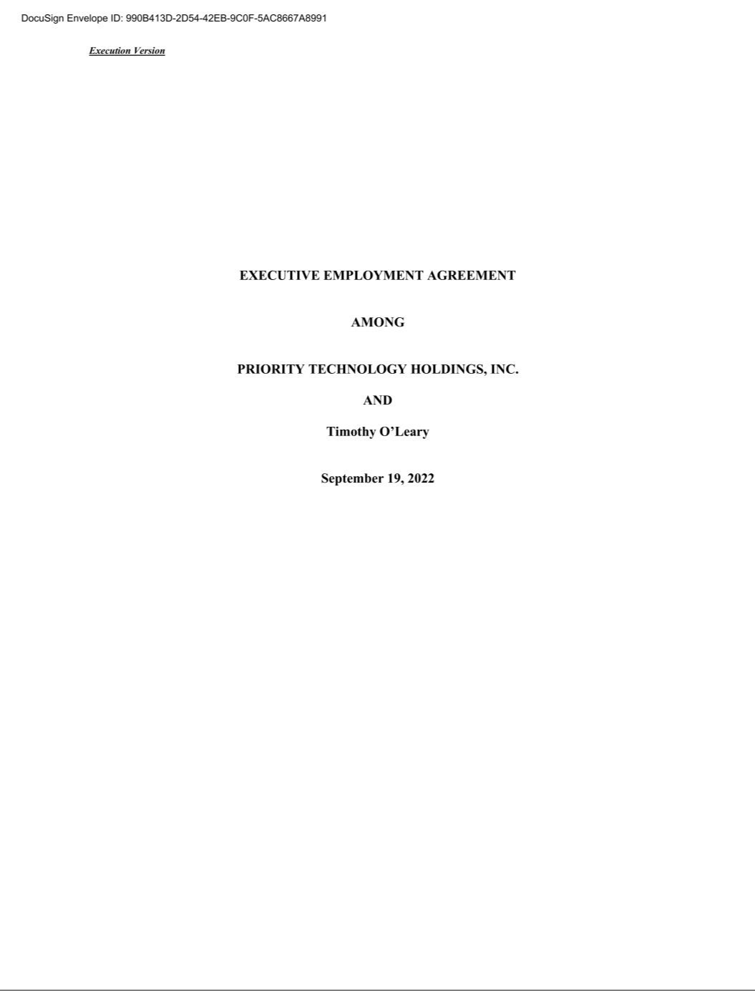

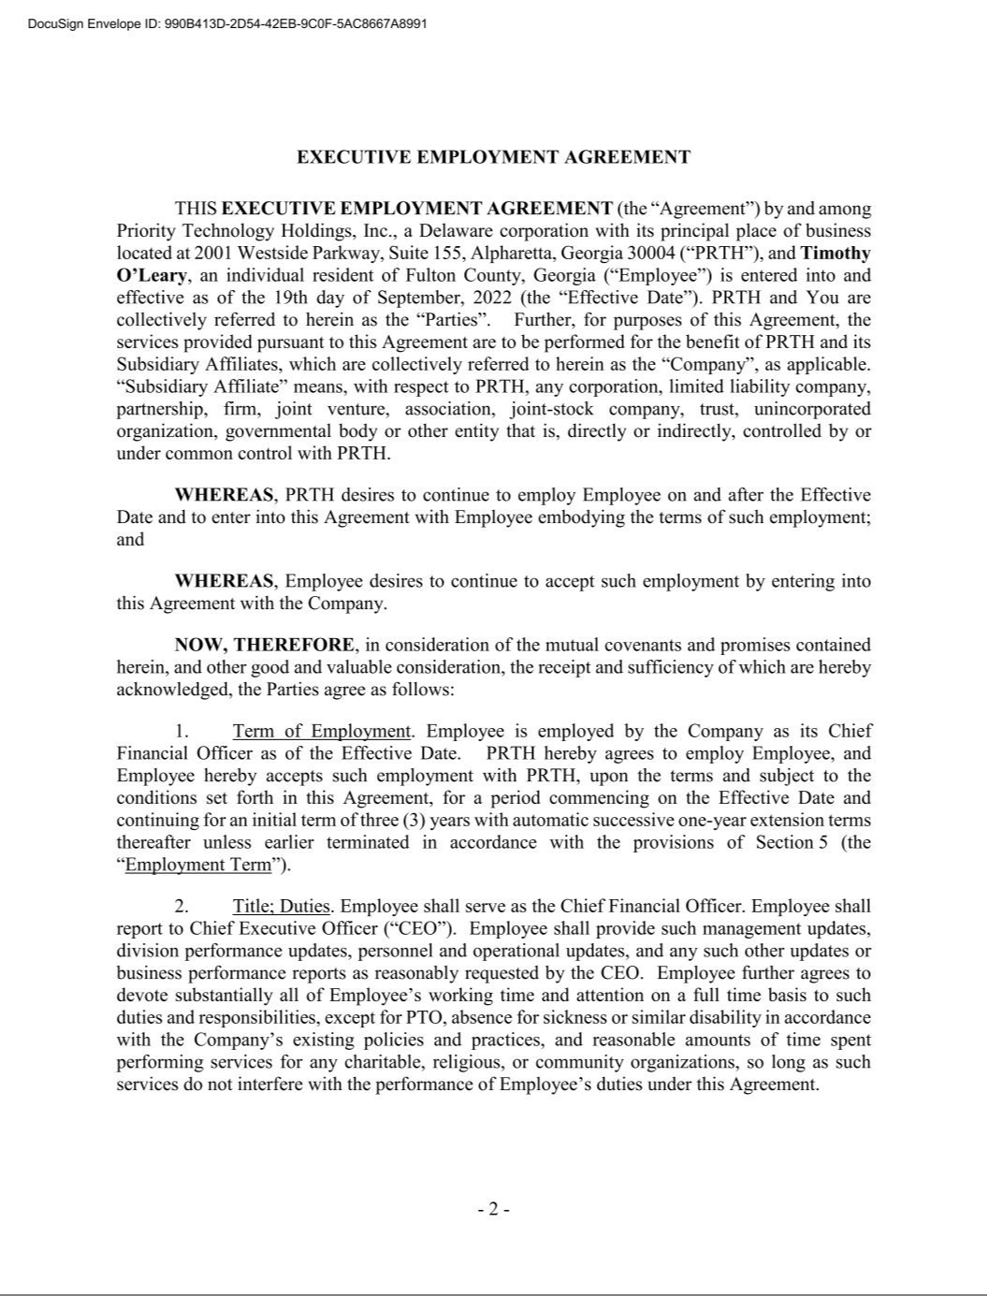

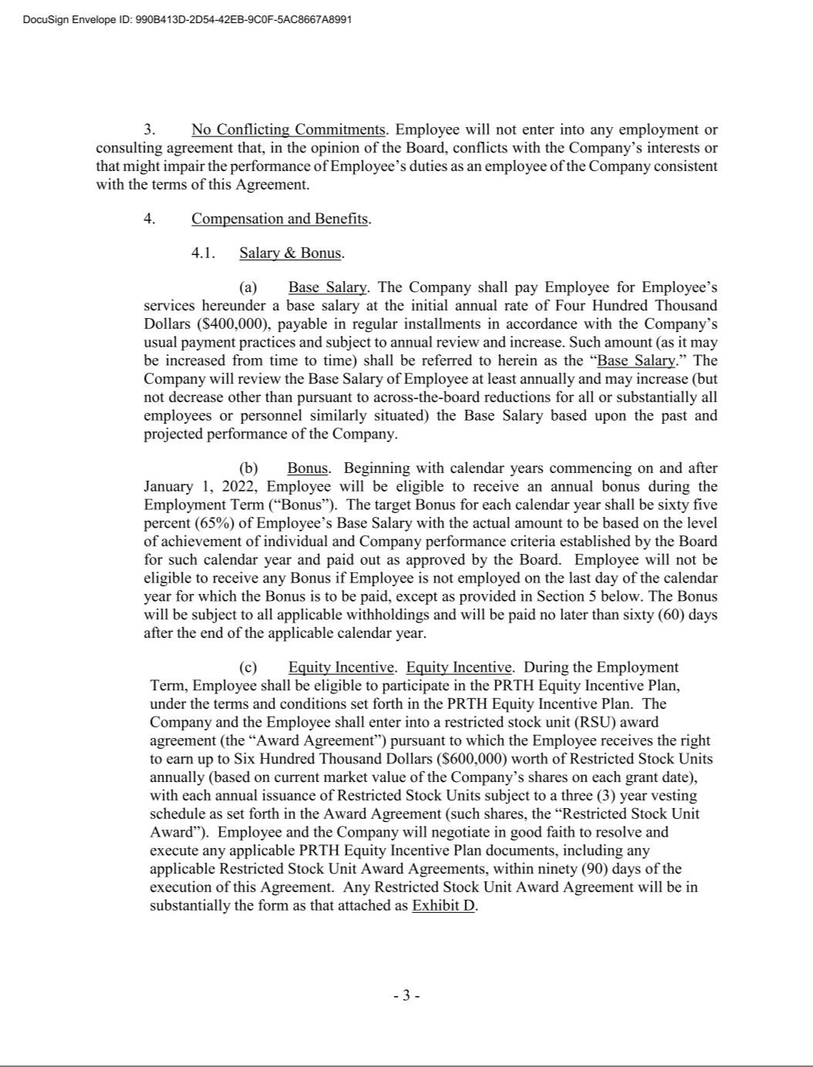

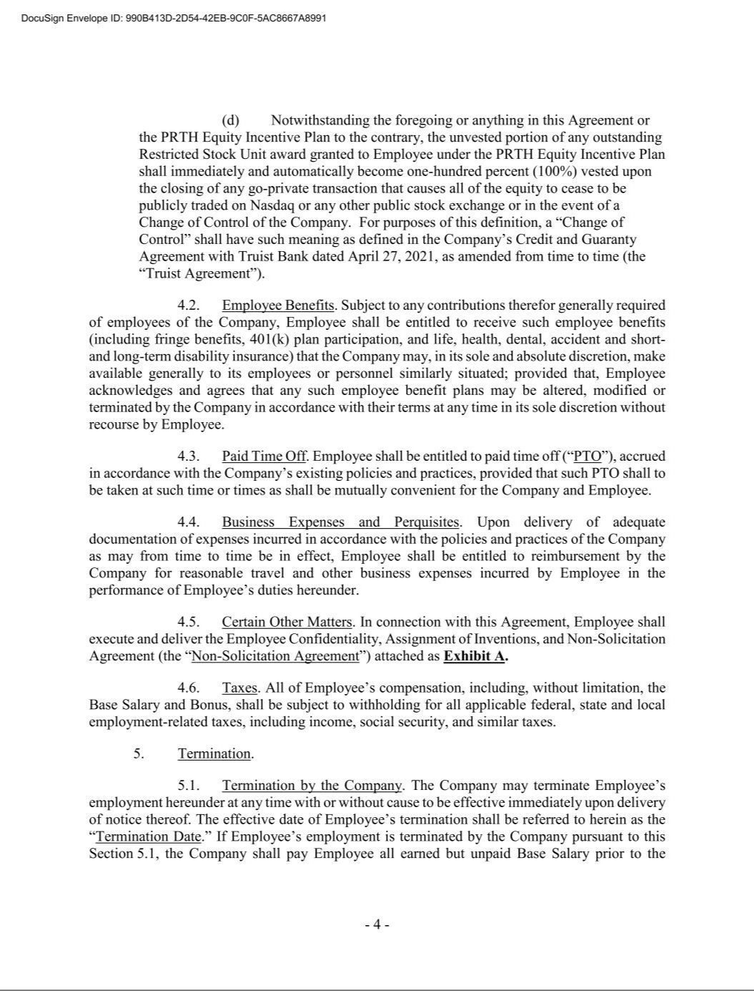

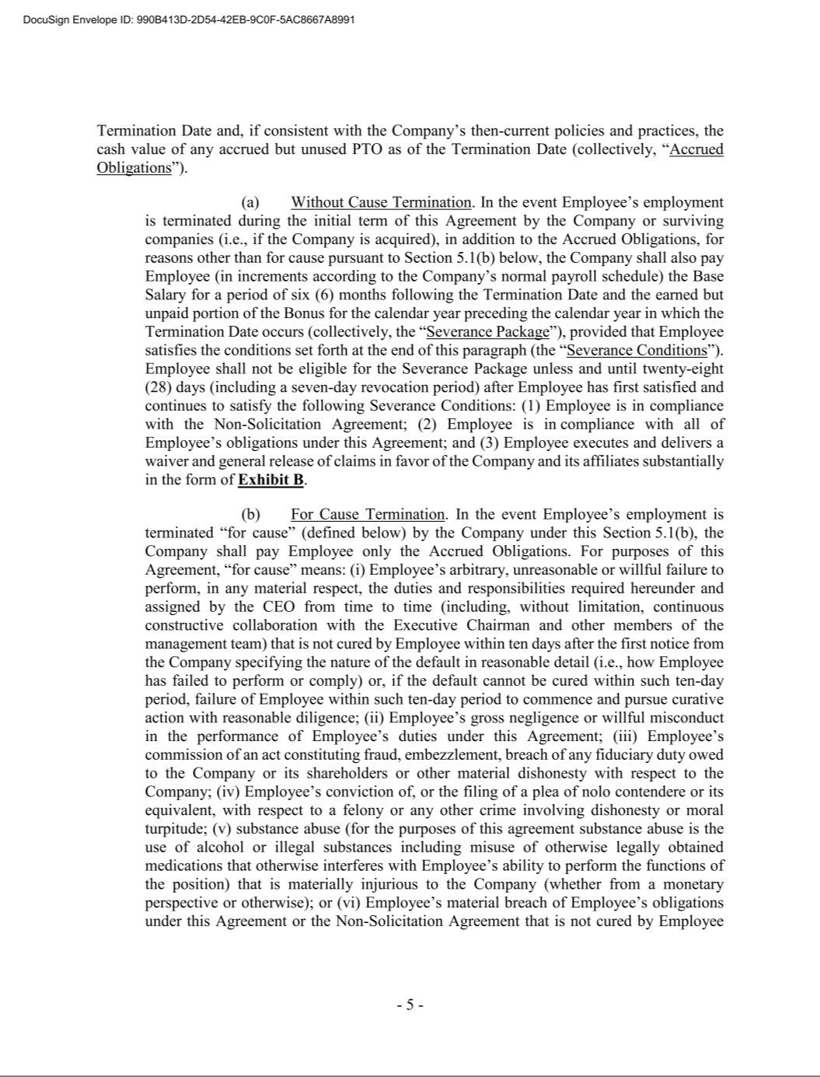

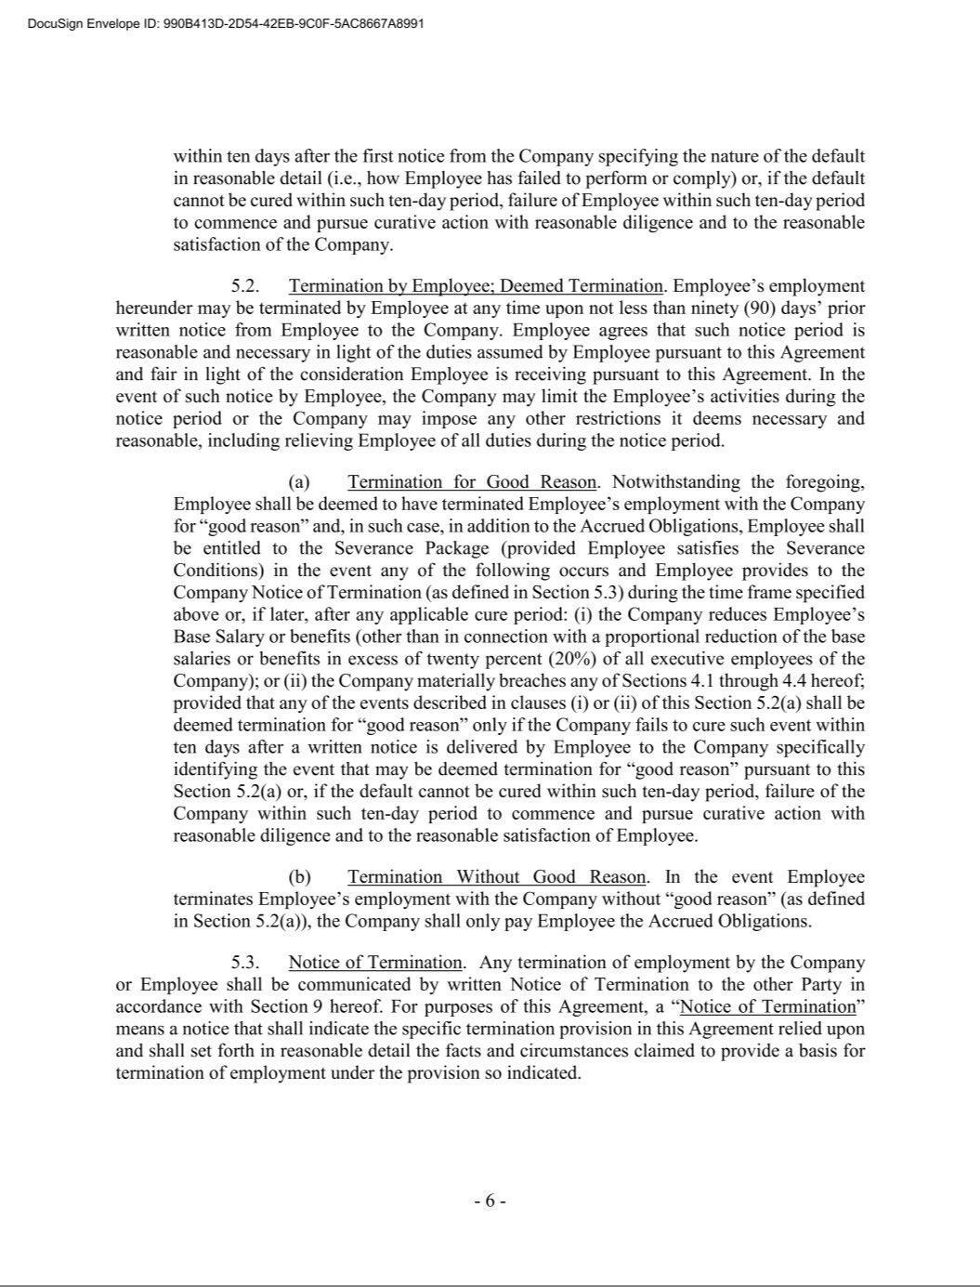

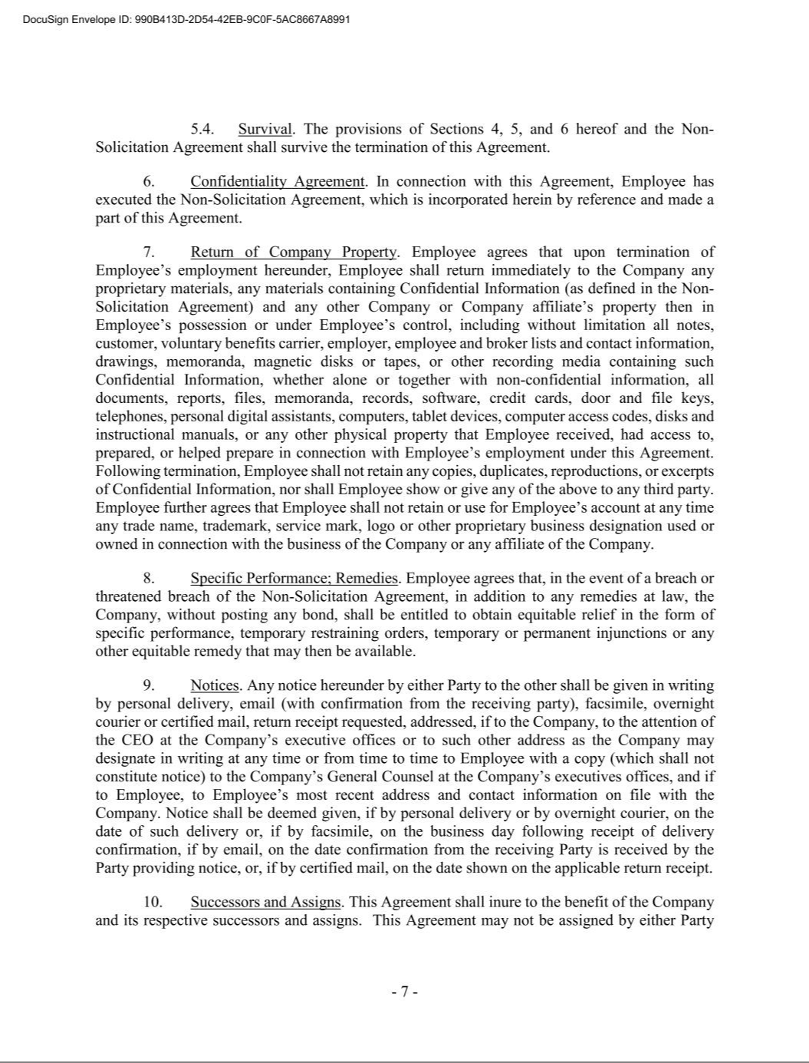

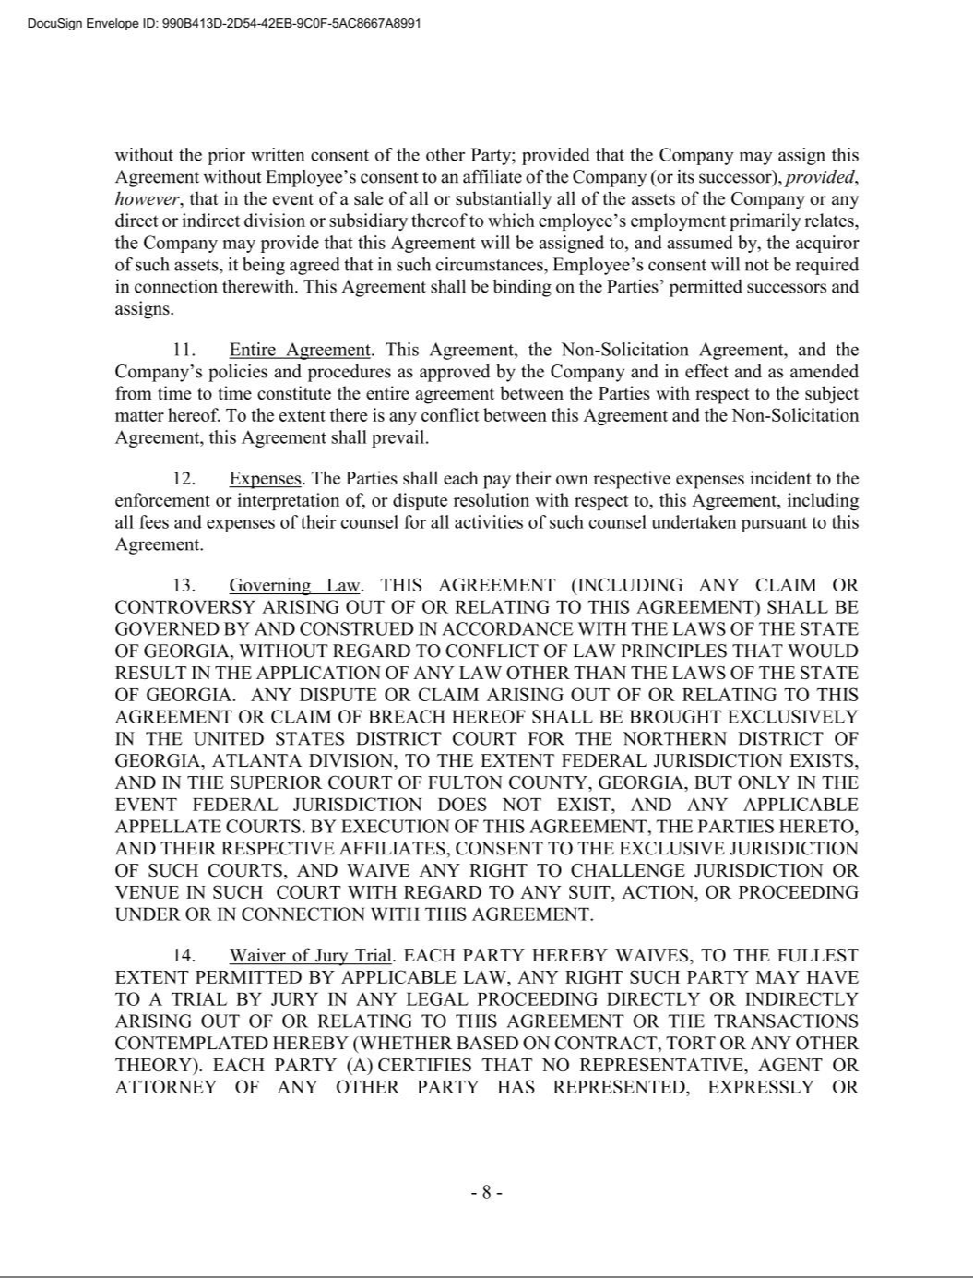

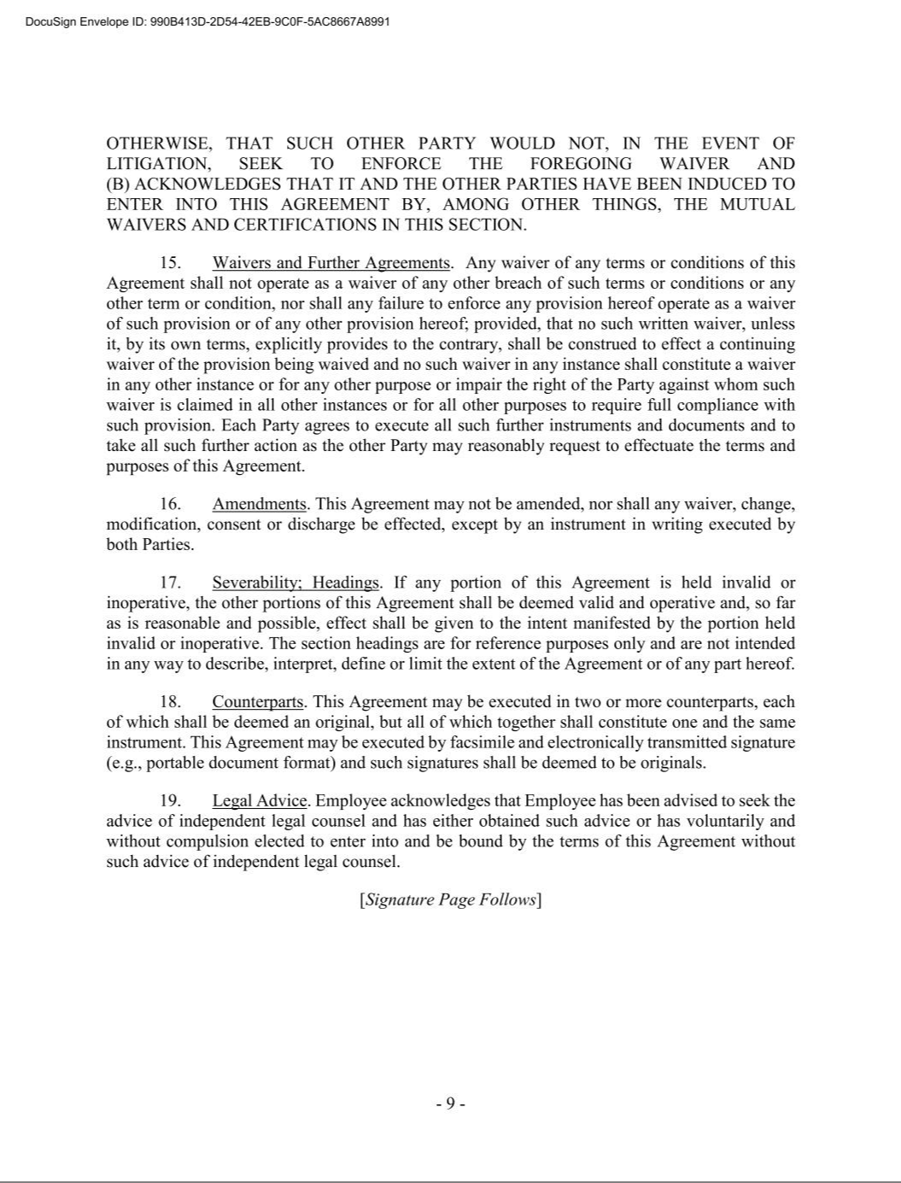

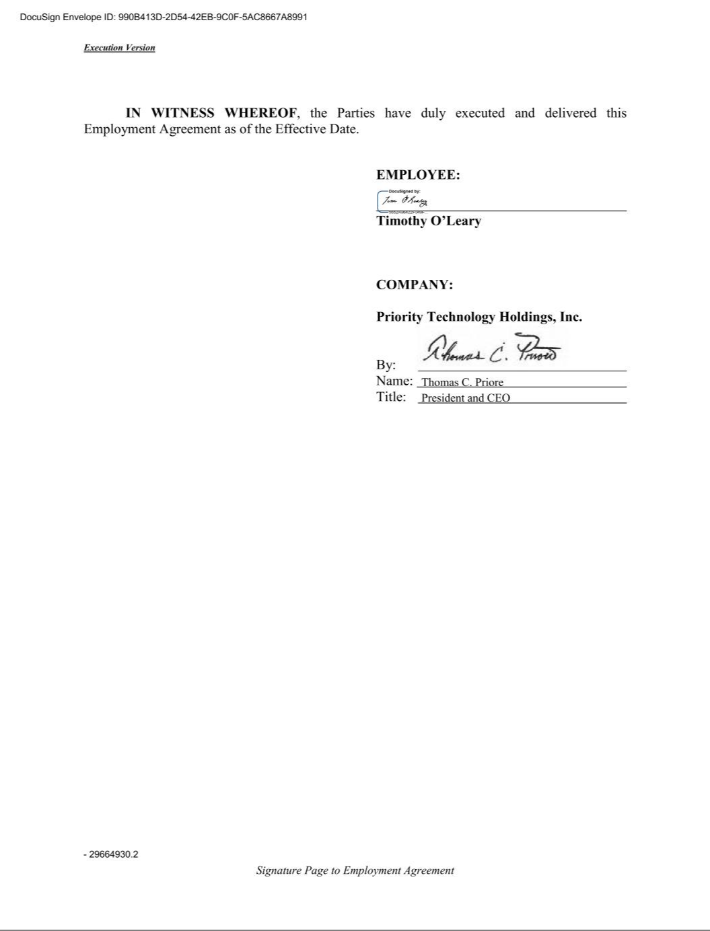

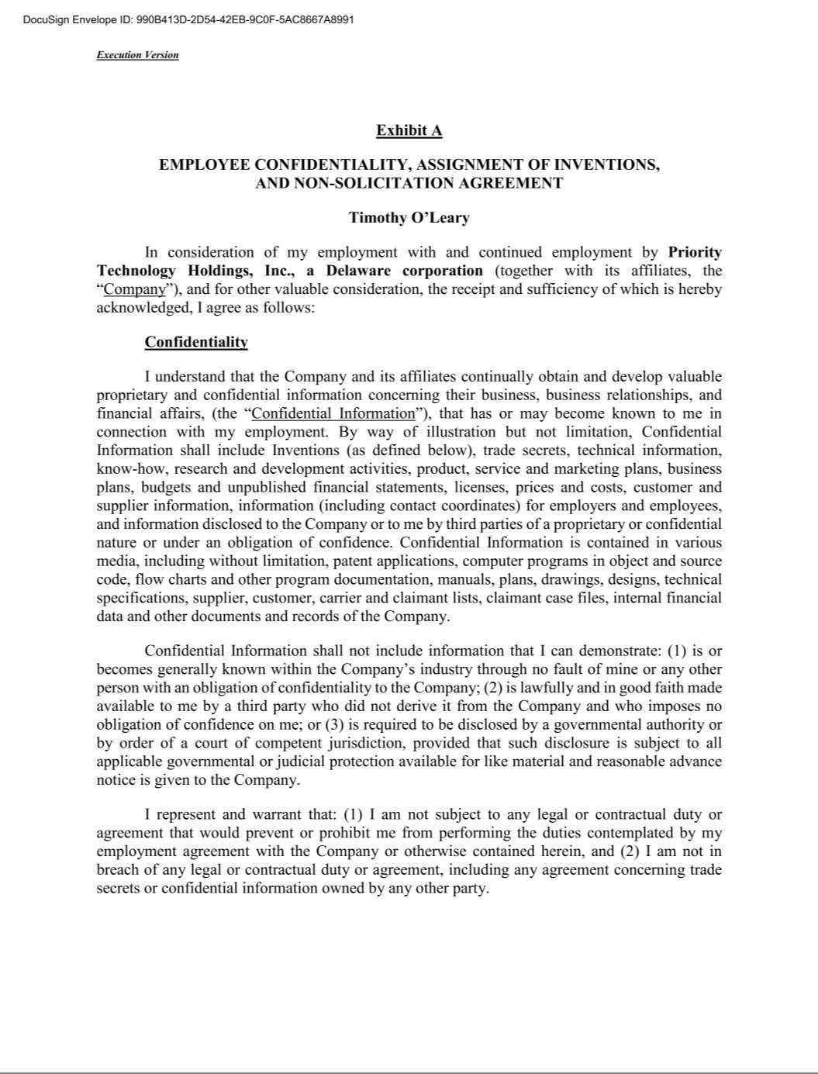

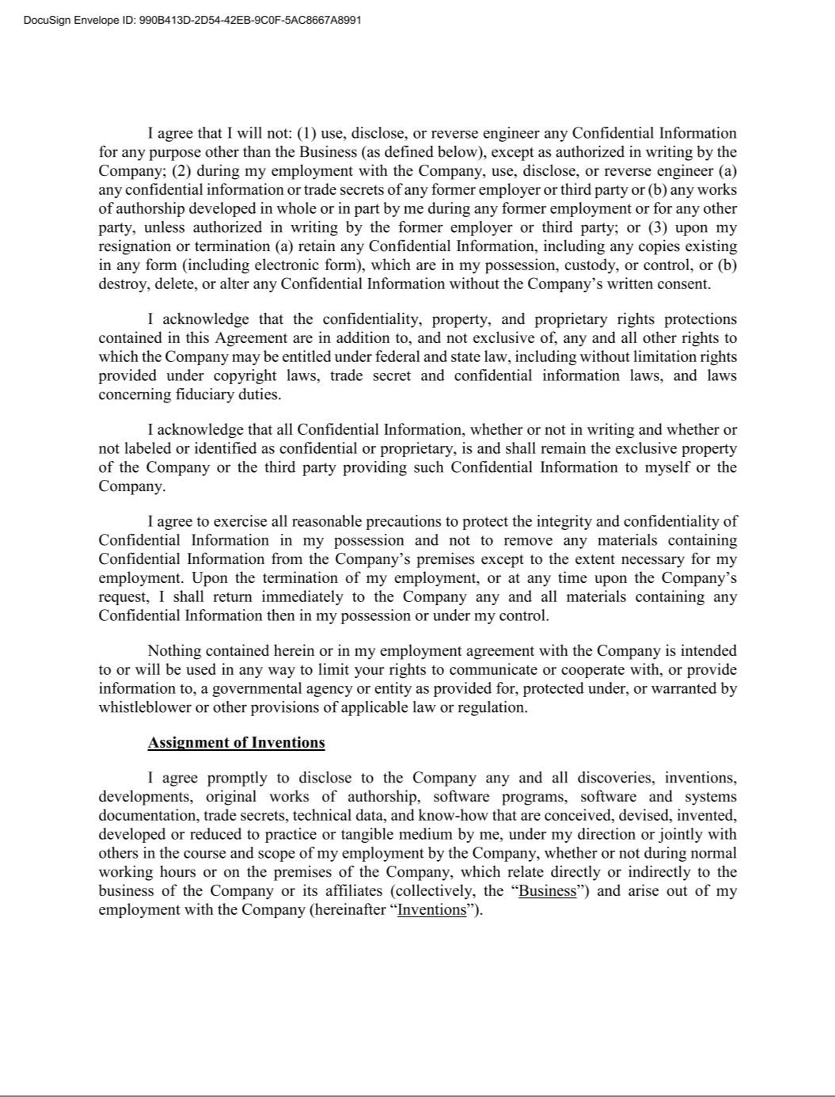

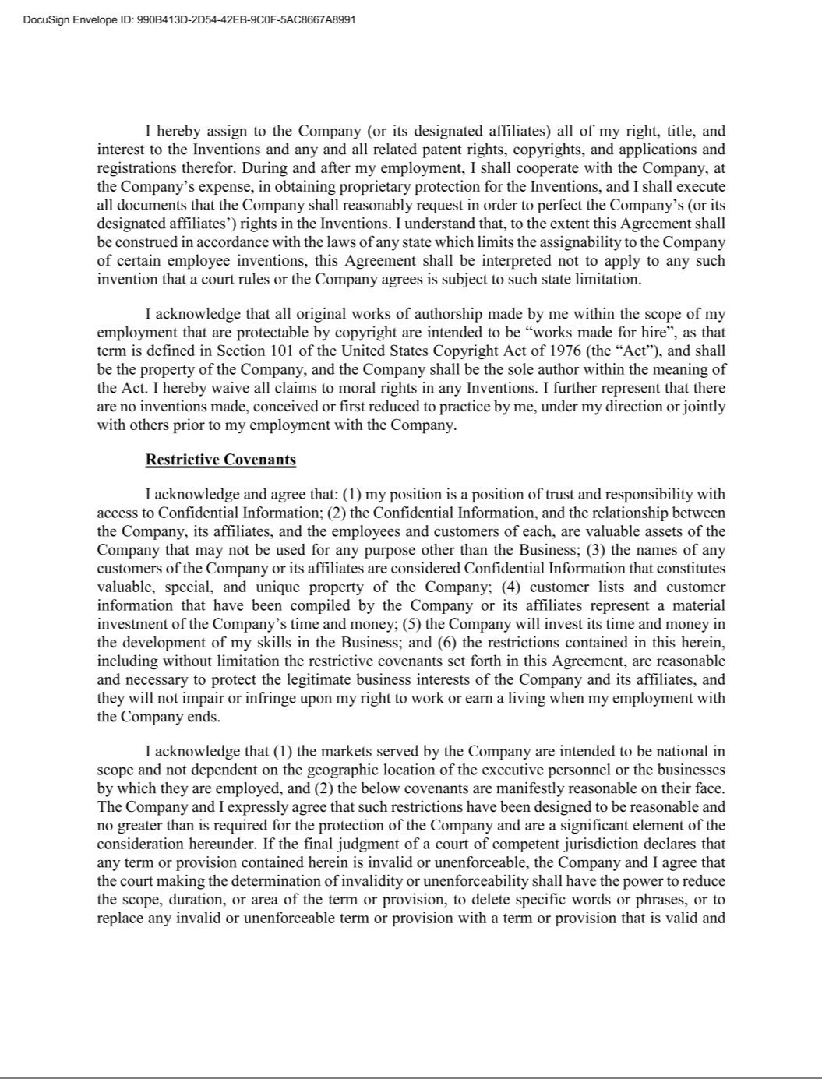

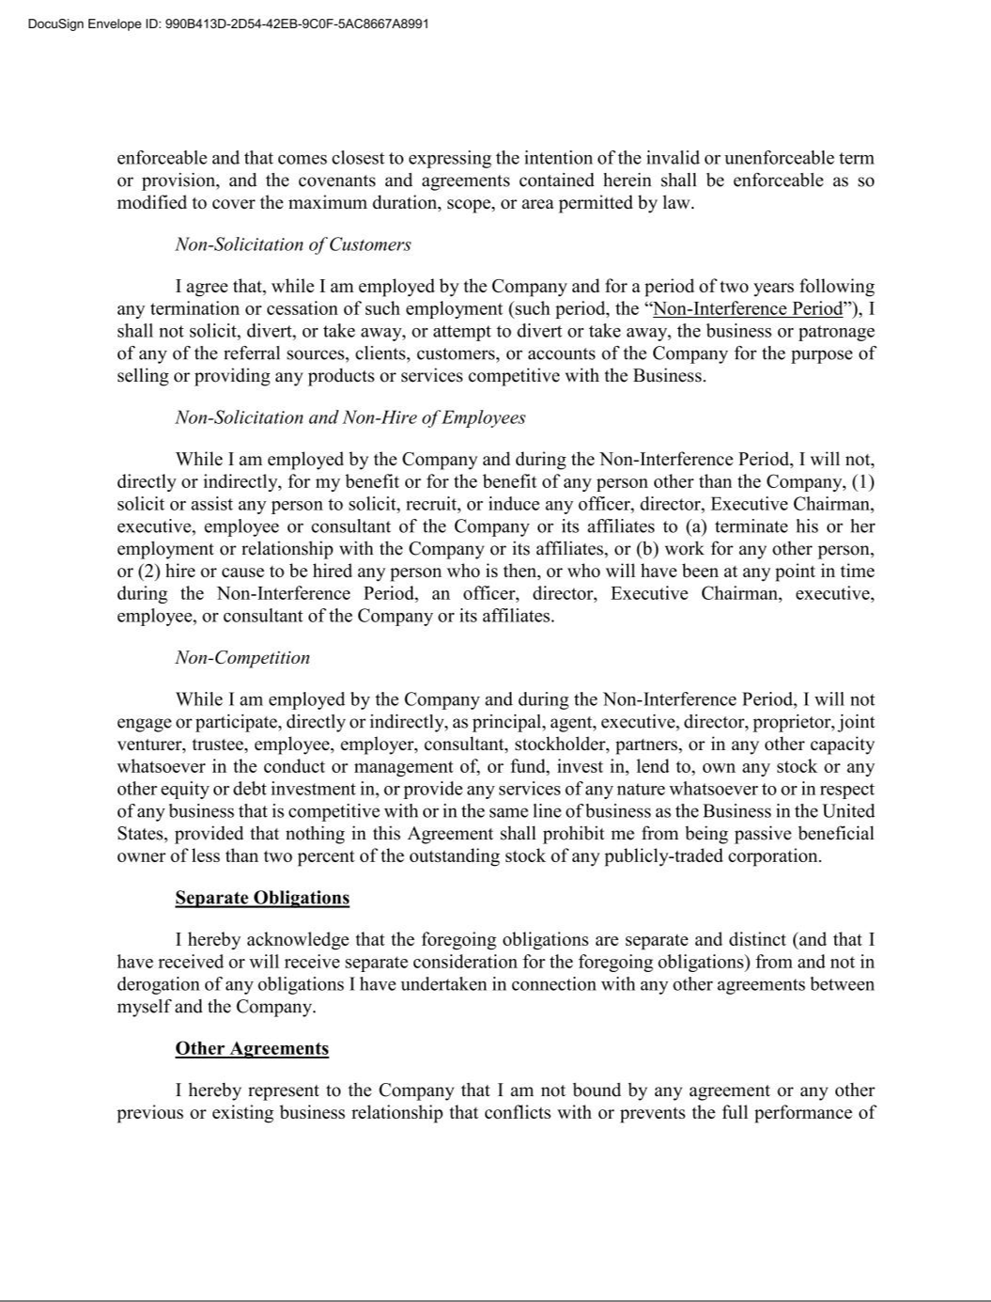

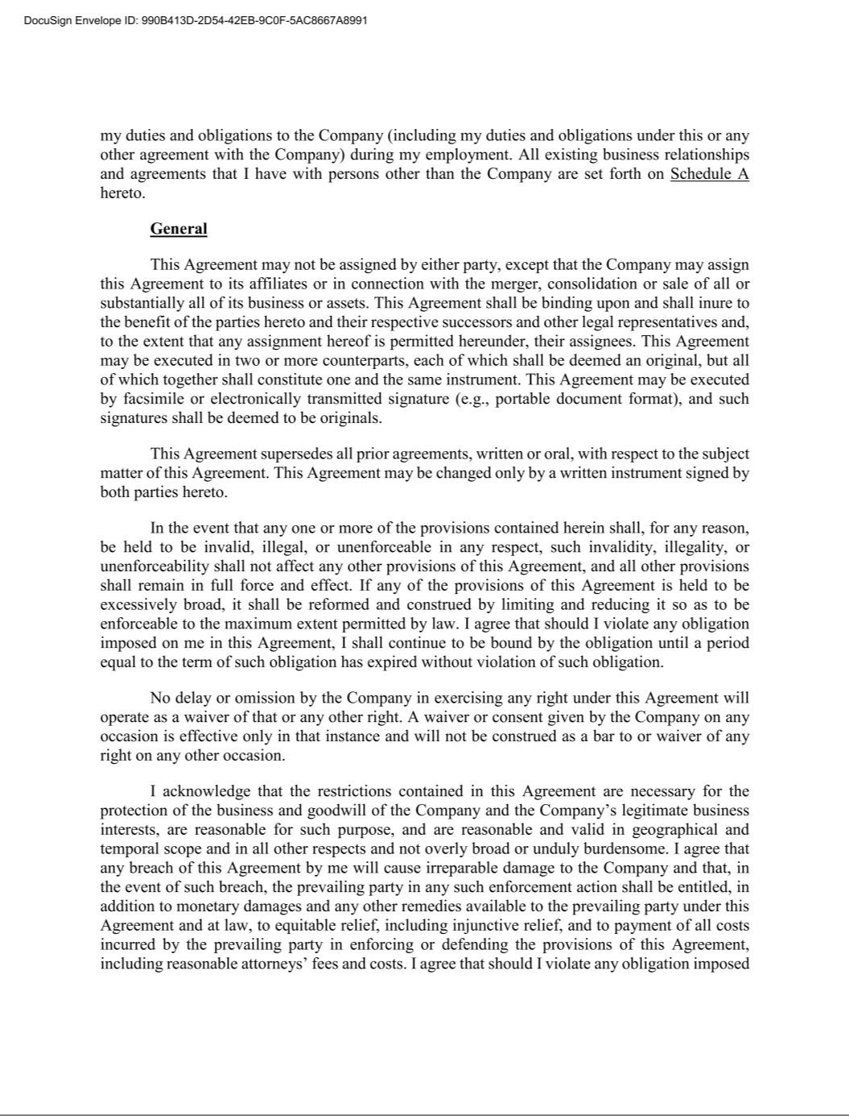

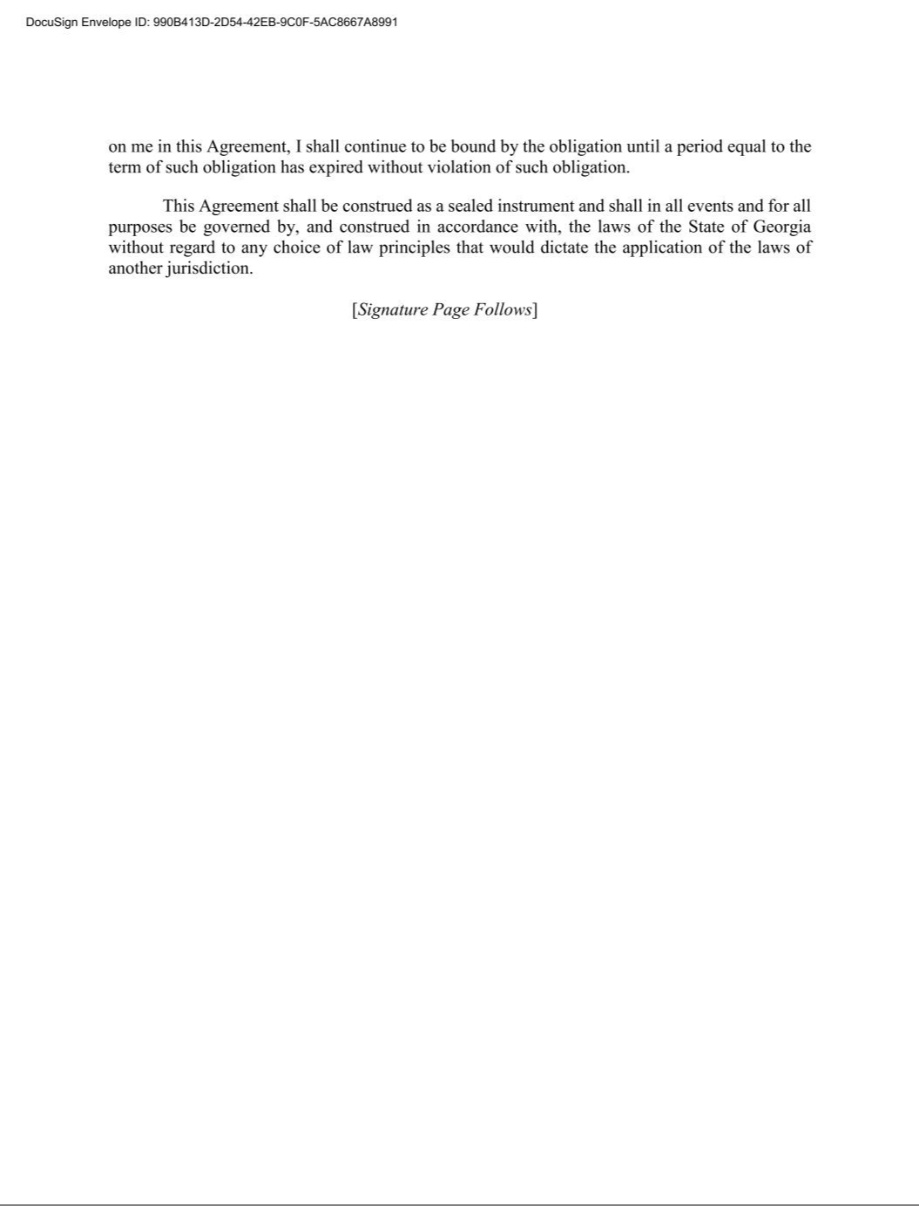

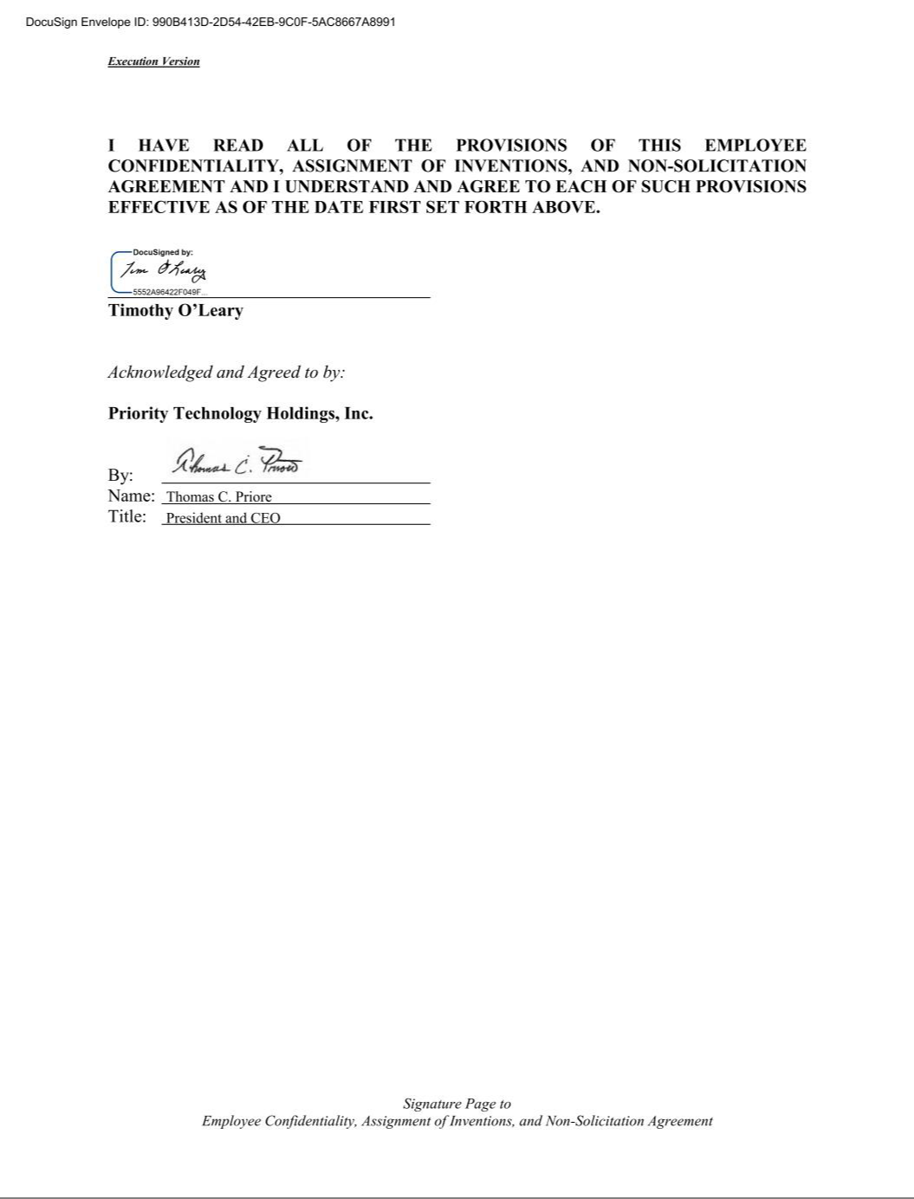

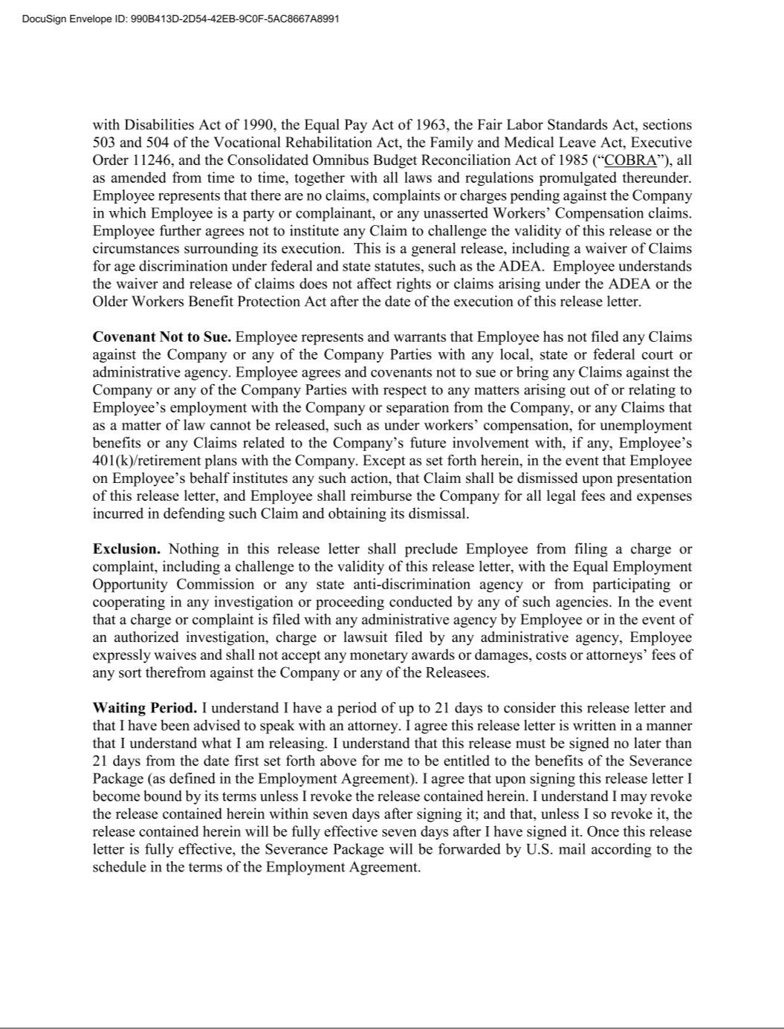





Exhibit 31.1

CERTIFICATION OF PRINCIPAL EXECUTIVE OFFICER PURSUANT TO

EXCHANGE ACT RULE 13a-14(a) AS ADOPTED PURSUANT TO

SECTION 303 OF THE SARBANES-OXLEY ACT OF 2002

I, Thomas C. Priore, certify that:

- I have reviewed this quarterly report on Form 10-Q of Priority Technology Holdings, Inc.;

- Based on my knowledge, this report does not contain any untrue statement of a material fact or omit to state a material fact necessary to make the statements made, in light of the circumstances under which such statements were made, not misleading with respect to the period covered by this report;

- Based on my knowledge, the financial statements, and other financial information included in this report, fairly present in all material respects the financial condition, results of operations and cash flows of the registrant as of, and for, the periods presented in this report;

- The registrant's other certifying officer(s) and I are responsible for establishing and maintaining disclosure controls and procedures (as defined in Exchange Act Rules 13a-15(e) and 15d-15(e)) and internal control over financial reporting (as defined in Exchange Act Rules 13a-15(f) and 15d-15(f)) for the registrant and have:

  - Designed such disclosure controls and procedures, or caused such disclosure controls and procedures to be designed under our supervision, to ensure that material information relating to the registrant, including its consolidated subsidiaries, is made known to us by others within those entities, particularly during the period in which this report is being prepared;
  - Designed such internal control over financial reporting, or caused such internal control over financial reporting to be designed under our supervision, to provide reasonable assurance regarding the reliability of financial reporting and the preparation of financial statements for external purposes in accordance with generally accepted accounting principles;
  - Evaluated the effectiveness of the registrant’s disclosure controls and procedures and presented in this report our conclusions about the effectiveness of the disclosure controls and procedures, as of the end of the period covered by this report based on such evaluation; and
  - Disclosed in this report any change in the registrant’s internal control over financial reporting that occurred during the registrant’s most recent fiscal quarter (the registrant’s fourth fiscal quarter in the case of an annual report) that has materially affected, or is reasonably likely to materially affect, the registrant’s internal control over financial reporting; and

- The registrant's other certifying officer(s) and I have disclosed, based on our most recent evaluation of internal control over financial reporting, to the registrant's auditors and the audit committee of the registrant's board of directors (or persons performing the equivalent functions):

  - All significant deficiencies and material weaknesses in the design or operation of internal control over financial reporting which are reasonably likely to adversely affect the registrant's ability to record, process, summarize and report financial information; and
  - Any fraud, whether or not material, that involves management or other employees who have a significant role in the registrant's internal control over financial reporting.

November 10, 2022 /s/ THOMAS C. PRIORE

Thomas C. Priore

Chief Executive Officer and Chairman

(Principal Executive Officer)

Exhibit 31.2

CERTIFICATION OF PRINCIPAL FINANCIAL OFFICER PURSUANT TO

EXCHANGE ACT RULE 13a-14(a) AS ADOPTED PURSUANT TO

SECTION 303 OF THE SARBANES-OXLEY ACT OF 2002

I, Timothy M. O’Leary, certify that:

- I have reviewed this quarterly report on Form 10-Q of Priority Technology Holdings, Inc.;

- Based on my knowledge, this report does not contain any untrue statement of a material fact or omit to state a material fact necessary to make the statements made, in light of the circumstances under which such statements were made, not misleading with respect to the period covered by this report;

- Based on my knowledge, the financial statements, and other financial information included in this report, fairly present in all material respects the financial condition, results of operations and cash flows of the registrant as of, and for, the periods presented in this report;

- The registrant's other certifying officer(s) and I are responsible for establishing and maintaining disclosure controls and procedures (as defined in Exchange Act Rules 13a-15(e) and 15d-15(e)) and internal control over financial reporting (as defined in Exchange Act Rules 13a-15(f) and 15d-15(f)) for the registrant and have:

  - Designed such disclosure controls and procedures, or caused such disclosure controls and procedures to be designed under our supervision, to ensure that material information relating to the registrant, including its consolidated subsidiaries, is made known to us by others within those entities, particularly during the period in which this report is being prepared;
  - Designed such internal control over financial reporting, or caused such internal control over financial reporting to be designed under our supervision, to provide reasonable assurance regarding the reliability of financial reporting and the preparation of financial statements for external purposes in accordance with generally accepted accounting principles;
  - Evaluated the effectiveness of the registrant’s disclosure controls and procedures and presented in this report our conclusions about the effectiveness of the disclosure controls and procedures, as of the end of the period covered by this report based on such evaluation; and
  - Disclosed in this report any change in the registrant’s internal control over financial reporting that occurred during the registrant’s most recent fiscal quarter (the registrant’s fourth fiscal quarter in the case of an annual report) that has materially affected, or is reasonably likely to materially affect, the registrant’s internal control over financial reporting; and

- The registrant's other certifying officer(s) and I have disclosed, based on our most recent evaluation of internal control over financial reporting, to the registrant's auditors and the audit committee of the registrant's board of directors (or persons performing the equivalent functions):

  - All significant deficiencies and material weaknesses in the design or operation of internal control over financial reporting which are reasonably likely to adversely affect the registrant's ability to record, process, summarize and report financial information; and
  - Any fraud, whether or not material, that involves management or other employees who have a significant role in the registrant's internal control over financial reporting.

November 10, 2022 /s/ TIMOTHY M. O’LEARY

Timothy M. O’Leary

Chief Financial Officer

(Principal Financial Officer)

Exhibit 32

CERTIFICATION OF PRINCIPAL EXECUTIVE OFFICER AND PRINCIPAL FINANCIAL OFFICER PURSUANT TO 18 U.S.C. SECTION 1350, AS ADOPTED PURSUANT TO SECTION 906 OF THE SARBANES-OXLEY ACT OF 2002

In connection with the Quarterly Report on Form 10-Q of Priority Technology Holdings, Inc. (the "Company") for the quarter ended September 30, 2022 as filed with the Securities and Exchange Commission (the "Report"), each of the undersigned, on the dates indicated below, hereby certifies pursuant to 18 U.S.C. Section 1350, as adopted pursuant to Section 906 of the Sarbanes-Oxley Act of 2002, that:

- The Report fully complies with the requirements of Section 13(a) or 15(d) of the Securities Act of 1934; and

- The information contained in the Report fairly presents, in all material respects, the financial condition and results of operation of the Company.

November 10, 2022 /s/ THOMAS C. PRIORE

Thomas C. Priore

Chief Executive Officer and Chairman

(Principal Executive Officer)

November 10, 2022 /s/ TIMOTHY M. O’LEARY

Timothy M. O’Leary

Chief Financial Officer

(Principal Financial Officer)

The foregoing certifications are being furnished solely pursuant to 18 U.S.C. § 1350 and are not being filed as part of the Report on Form 10-Q or as a separate disclosure document.

